Project Management Documents

for

DOST STARBOOKS: Whiz Challenge

By

Kelly Dumbrique
Arcielle Marie Gercan
Shandrae Lois Quianzon
Janice Maxene Salipande
NEXUS

May 2026
Table of Contents
01 INITIATION 4
Project Charter Plan 4
Business Case 7
Business Model Canvas 20
Project Brief 22
Feasibility Study 24
Stakeholder Management Strategy 30
Stakeholder Analysis 35
Statement of Work 36
02 PLANNING 42
Communication Management Plan 42
Risk Management Plan 47
Scope Management Plan 53
Work Breakdown Structure (WBS) 60
Schedule Management Plan 71
Requirements Management Plan 74
Risk Register 79
Quality Management Plan 82
Cost Management Plan 89
Configuration Management Plan 94
Change Management Plan 98
Human Resource Plan 102
03 EXECUTION 107
Sprint 6 Ceremonies 107
Sprint 7 Ceremonies 111
Sprint 8 Ceremonies 115
04 MONITORING AND CONTROLLING 119
Project Status Report for Sprint 6 119
Project Status Report for Sprint 7 124
Project Status Report for Sprint 8 128
05 CLOSING 132
Transition Out Plan 132
Project Acceptance 141
Post Project Review 142
Lessons Learned 148
Agile Team Charter 154
Agile Team Values 158
System Design Document 164
Sponsor Acceptance 173

01 INITIATION

Project Charter Plan
DOST STARBOOKS: Whiz Challenge
This Charter formally authorizes the DOST STARBOOKS: Whiz Challenge Project to design, develop, and implement an enhanced gamified quiz application for integration into the existing STARBOOKS platform managed by the Department of Science and Technology – Science and Technology Information Institute (DOST-STII).
A comprehensive project plan will be developed and submitted to the Project Sponsor for approval. The project plan will include the scope statement, schedule, cost estimate, and provisions for scope, resource, schedule, communications, quality, risk, procurement, stakeholder management, and project control.
All resources will be coordinated in collaboration with the Project Sponsor, Ms. Marievic V. Narquita, Information Services Section (ISS) Head of DOST-STII.
The purpose of the DOST STARBOOKS: Whiz Challenge Project is to enhance the engagement, accessibility, and educational effectiveness of the existing STARBOOKS quiz application for Grade 1 to 12 students.
This project addresses the need for improved interactive learning tools by overcoming limitations of the current system, such as the lack of multiple game modes, absence of player progress tracking, and limited engagement features. It also responds to the need for offline-capable educational platforms, particularly in areas with limited or no internet connectivity.
The project deliverables include the design and development of an offline-first gamified application featuring four game modes (Whiz Challenge, Memory Match, Puzzle, and Battle), implementation of a rewards and badge system, player statistics tracking, an enhanced admin dashboard, and system integration with existing STARBOOKS kiosks. A user guide and supporting documentation will also be provided.
The objectives of the project are to increase student engagement, improve frequency of application use, and enhance understanding of science and mathematics concepts through interactive gameplay.
High-level risks include potential challenges in ensuring seamless offline functionality, and maintaining system performance across varying kiosk environments.
Success will be determined by the Project Sponsor based on successful deployment, positive user engagement metrics, increased utilization of STARBOOKS kiosks, and successful completion of pilot testing and system rollout without critical issues.
The Project Manager, Kelly Dumbrique, is hereby authorized to lead and manage the project from planning through deployment. The Project Manager is empowered to coordinate with stakeholders, assign tasks, manage schedules, and oversee project execution to ensure timely and successful completion.
The Project Manager is responsible for developing the project plan, monitoring scope, schedule, and performance, facilitating communication between the development team and DOST-STII, and ensuring that all deliverables meet the required standards. The Project Manager also has the authority to resolve issues, manage risks, and implement corrective actions as necessary.
The project plan will be submitted and approved in accordance with the milestone schedule below. The Project Sponsor must approve any schedule changes which may impact milestones. A detailed schedule will be included in the project plan. The high-level milestone schedule is:
- Requirements Gathering and Planning (April - August 2025)
- Meet with client and stakeholders
- Define scope and core features
- Gather system requirements
- Create use case and system diagrams
- Draft project timeline
- Design initial wireframes
- Development Phase 1 (September - October 2025)
- Finalize system architecture
- Set up development environment
- Build registration and login
- Develop homepage and profile
- Develop Whiz Challenge, Memory Match, and Puzzle games
- Implement player leaderboard and stats
- Development Phase 2 (November 2025 - March 2026)
- Develop 1v1 Battle game
- Finalize core player-side modules (games, rewards, leaderboard)
- Begin development of admin dashboard (user and content management, and difficulty settings)
- Start development of analytics and leaderboard
- Conduct periodic internal testing of core functionalities
- Soft Deployment, Testing, and Player-Side Optimization (April - June 2026)
- Conduct soft deployment in controlled environments (LAN/kiosk setup)
- Perform system-wide testing (focus on player-side modules)
- Conduct user acceptance testing with actual users
- Fix bugs and optimize performance (especially for kiosk hardware)
- Finalize UI/UX polish for player-side features
- Final Deployment, System Completion, and Turnover (July - October 2026)
- Complete and finalize admin dashboard functionalities
- Perform final system integration and validation
- Conduct final testing and bug fixing across all modules
- Finalize all project documentation (SRS, deployment and user manuals, project management)
- Package the system for deployment (kiosk-ready setup)
- Execute full system deployment in target environments
- Conduct project turnover to DOST-STII
The DOST STARBOOKS: Whiz Challenge Project does not require direct financial funding. The project is supported through collaboration with DOST-STII, which provides technical guidance, resources, and strategic oversight.
Development will utilize free and open-source tools, ensuring compatibility with existing STARBOOKS kiosk infrastructure. No additional costs are expected for hardware, software licenses, or deployment.
The project emphasizes cost-efficiency while maintaining high standards of quality, security, and performance.

Business Case
EXECUTIVE SUMMARY
The STARBOOKS Whiz Challenge is an enhanced gamified educational platform developed to support the mission of the Department of Science and Technology – Science and Technology Information Institute (DOST-STII) in promoting science, technology, engineering, and mathematics (STEM) education across the Philippines. Designed as a complementary application to the STARBOOKS digital library system, the Whiz Challenge aims to make STEM learning more interactive, engaging, and accessible—particularly for students participating in DOST-led exhibits, outreach programs, and events, including those in areas with limited internet connectivity.
While the original version of the STARBOOKS Whiz Challenge successfully introduced quiz-based gamified learning, it presented limitations in terms of replayability, learning diversity, analytics capability, and overall user experience. To address these gaps, this project focuses on redesigning and enhancing the system by introducing multiple game modes, improved visual design, expanded reward mechanics, performance tracking, and administrative monitoring tools.
The enhanced system now includes four game modes—Whiz Challenge, Whiz Memory Match, Whiz Puzzle, and Whiz Battle—along with a structured badge and star reward system, player leaderboard, and difficulty-based progression. On the administrative side, the system provides account management, quiz configuration, reward monitoring, leaderboard tracking, and analytics dashboards for event-based insights. The application remains offline-first to ensure accessibility in underserved communities, aligning with national education goals and the United Nations Sustainable Development Goals, particularly SDG 4 (Quality Education) and SDG 9 (Industry, Innovation, and Infrastructure).
At the time of writing, the project is in its final development phase. All player-side features have been completed, and the majority of the administrative functionalities are operational, with only final analytics refinements remaining. System documentation, including the Software Requirements Specification (SRS), is nearing completion. The next steps involve system polishing, comprehensive testing, user manual preparation, packaging, and deployment.
Through this enhanced version of the STARBOOKS Whiz Challenge, the project aims to provide a scalable, engaging, and data-informed educational tool that strengthens DOST-STII’s advocacy for accessible and innovative STEM learning across the country.
Issue
Despite its success as an introductory gamified platform, the current STARBOOKS Whiz Challenge system presents several operational and educational limitations:
- Limited Engagement and Replayability: The system only supports a single quiz mode, leading to repetitive gameplay and declining user interest over time.
- Lack of Learning Diversity: The platform does not accommodate different learning styles such as visual, experiential, or competitive learning.
- Absence of Analytics and Monitoring Tools: DOST-STII lacks access to player data, engagement trends, and performance insights, limiting evaluation and decision-making.
- Outdated User Experience: The system lacks modern design elements, animations, and intuitive navigation expected in contemporary educational applications.
These challenges reduce the platform’s effectiveness in achieving its goal of promoting STEM education and engagement.
Anticipated Outcomes
The enhanced system will:
- Improved Student Engagement: Multiple game modes and reward systems will increase replayability and sustained interaction.
- Enhanced Learning Experience: Diverse gameplay formats will cater to different cognitive and learning styles.
- Data-Driven Decision Making: Built-in analytics will allow DOST-STII to monitor user behavior and optimize outreach strategies.
- Increased Accessibility: Offline-first functionality ensures continued usability in remote and underserved areas.
- Scalability and Sustainability: The system can be deployed across multiple kiosks and expanded with future enhancements.
The end state is a scalable, engaging, and data-informed educational platform integrated into STARBOOKS kiosks nationwide.
Recommendation
It is recommended to proceed with the full implementation and deployment of the enhanced STARBOOKS Whiz Challenge system. The proposed solution includes:
- Four interactive game modes (Quiz, Memory, Puzzle, Battle)
- Gamified reward system (badges, stars, leaderboard)
- Player tracking and performance monitoring
- Administrative dashboard with analytics and reporting
This approach addresses all identified limitations while aligning with DOST-STII’s mission and operational environment.
Justification
The project is justified as it:
- Supports national and organizational goals for STEM education and digital inclusion
- Utilizes existing infrastructure and open-source technologies
- Improves educational impact and outreach effectiveness
- Supports SDG 4 (Quality Education) and SDG 9 (Innovation)
Failure to implement the project would result in continued low engagement, limited scalability, and lack of measurable impact.
BUSINESS CASE ANALYSIS TEAM
The following individuals comprise the business case analysis team. They are responsible for the analysis and creation of the DOST STARBOOKS: Whiz Challenge business case.
Role | Description | Name/Title
Project Sponsor | Provides project oversight and approval | Marievic V. Narquita, ISS Head (DOST-STII)
Project Manager | Leads project execution and coordination | Kelly Dumbrique
Documentation Lead | Handles documentation and reports | Janice Maxene Salipande
UI/UX Designers/Illustrators | Design UI/UX, visual assets, and ensure usability consistency | Shandrae Lois Quianzon, Arcielle Marie Gercan, Janice Maxene Salipande
Frontend Developers | Develop user interface and interactive features | Kelly Dumbrique, Shandrae Lois Quianzon, Janice Maxene Salipande
Backend Developer | Develop server-side logic and APIs | Arcielle Marie Gercan
QA Lead | Conduct system testing and validation | Janice Maxene Salipande

PROBLEM DEFINITION
Problem Statement
DOST-STII has long advocated for making science and technology education more accessible and engaging, especially for learners in disadvantaged and underserved areas. Through the STARBOOKS initiative and its outreach activities, one of their key efforts to spark interest among students has been the STARBOOKS Whiz Challenge—a gamified quiz application deployed during science fairs, exhibits, and educational events.
While the current version of the Whiz Challenge has successfully introduced fun, interactive STEM learning through a solo quiz game, DOST-STII has observed several limitations that affect the system’s ability to fully meet its engagement and outreach goals:
- Limited replayability and player retention
As the app currently supports only a single game mode (solo quiz), DOST-STII has noted reduced student engagement over time. Once users have earned badges and rewards, the gameplay becomes repetitive, limiting opportunities for deeper learning or continued use.
- Lack of diverse learning strategies
The existing format does not accommodate different types of learners. Students who learn better through collaboration, competition, or visual-based games have fewer options to interact with the content in a way that suits their learning style.
- Difficulty in measuring impact and player insights
Without analytics tools, it is difficult for DOST-STII to gather data about player demographics and behavior, or trends during events. This hinders their ability to refine future outreach strategies or evaluate the educational impact of the app.
- Need for richer, more modern user experience
As digital learning tools continue to evolve, DOST-STII aims to keep the Whiz Challenge visually appealing and competitive with modern educational apps. However, the current system lacks dynamic visuals, animations, and polish that would better capture the attention of today’s learners.
Organizational Impact
The implementation of the enhanced STARBOOKS Whiz Challenge system will introduce several changes across organizational processes, tools, roles, and technological infrastructure within DOST-STII operations. The following outlines the expected impact:
Tools:
The current quiz-only system will be upgraded into a multi-functional gamified learning platform. This includes the introduction of:
- Multiple game modes (Quiz, Memory, Puzzle, Battle)
- Player leaderboard and statistics tracking
- Admin dashboard with analytics and reporting features
These tools will allow administrators to better manage content, monitor engagement, and evaluate system performance during events and deployments.
Processes:
The project will improve and streamline several operational processes:
- Learning Delivery: Transition from static quiz interaction to dynamic, multi-mode gameplay
- Engagement Monitoring: Introduction of analytics for tracking player behavior and trends
- Content Management: More efficient quiz and reward management through enhanced admin tools
- Event Operations: Better facilitation of activities during exhibits through real-time insights and leaderboard tracking
These improvements will enable more interactive, data-driven, and efficient educational outreach.
Roles and Responsibilities:
The enhanced system will refine and expand user roles:
- Players (Students/Visitors): Gain access to multiple learning modes, performance tracking, and rewards, promoting self-paced and competitive learning.
- Administrators (DOST Staff): Will take on additional responsibilities such as monitoring analytics, managing leaderboards, and overseeing player engagement during events.
- Development Team: Responsible for system maintenance, updates, and future enhancements.
Overall, the system empowers both users and administrators while improving operational efficiency.
Hardware/Software:
The project is designed to remain compatible with the existing STARBOOKS kiosk infrastructure while introducing software enhancements:
Hardware:
- No additional hardware investment is required
- Compatible with existing touchscreen kiosk setups
- Supports deployment in schools, and exhibit venues
Software:
- Transition to a modern technology stack (Flutter, Laravel, MongoDB)
- Offline architecture
These improvements ensure scalability, maintainability, and improved system performance without increasing operational costs.
Technology Migration
The STARBOOKS Whiz Challenge enhancement project follows an upgrade and integration approach rather than a complete system replacement. The goal is to improve the existing system by introducing new technologies and features while maintaining compatibility with the current STARBOOKS kiosk infrastructure and ensuring uninterrupted usability in offline environments.
To minimize disruption to ongoing DOST-STII operations and ensure a smooth transition, a phased implementation strategy will be adopted. This approach allows for gradual deployment, testing, and validation of the enhanced system.
Phase I: The enhanced system will be developed using a modern technology stack, including Flutter for the frontend, Laravel for backend services, and MongoDB for data storage.
During this phase, all core functionalities—including multiple game modes, reward systems, player tracking, and admin dashboard features—will be implemented and integrated within a controlled development environment.
Phase II: Once development is completed, the system will undergo rigorous internal testing. This includes:
- Unit testing for individual components
- Integration testing for system modules
- Offline functionality validation
- Performance and usability testing
This phase ensures that all features operate correctly within the offline-first architecture and are optimized for kiosk hardware.
Phase III: Existing quiz content, user data structures, and reward configurations from the current system will be reviewed and prepared for integration into the enhanced platform. System configurations such as difficulty settings, timers, and reward logic will be aligned with the new features. This phase ensures that the enhanced system maintains continuity with existing educational content while enabling new functionalities.
Phase IV: The enhanced system will be deployed in selected STARBOOKS kiosks during controlled environments such as DOST events or exhibits.
During this phase:
- Real users (students and facilitators) will interact with the system
- Feedback on usability, engagement, and performance will be collected
- Minor adjustments and refinements will be implemented
This step ensures that the system meets user expectations and operates effectively in real-world conditions.
Phase V: Following successful pilot testing, the system will be deployed across STARBOOKS kiosks for official use. The deployment process will include:
- Packaging and installation of the system on kiosk devices
- Final system validation and quality assurance checks
- Distribution of user manuals and administrative guidelines
The legacy version of the Whiz Challenge will be replaced or archived, while ensuring that the enhanced system is fully operational.
Phase VI: After deployment, ongoing support and maintenance will be conducted to ensure system stability and performance. This includes:
- Monitoring system usage and performance
- Addressing bugs and technical issues
- Implementing future enhancements based on feedback and analytics
PROJECT OVERVIEW
The project involves redesigning the STARBOOKS Whiz Challenge into a multi-functional gamified learning platform. It introduces interactive gameplay, performance tracking, and administrative tools while maintaining compatibility with existing kiosk systems.
Project Description
The STARBOOKS Whiz Challenge Enhancement Project is an initiative aimed at redesigning and upgrading the existing STARBOOKS Whiz Challenge system developed by DOST-STII. The project focuses on transforming the current single-mode quiz application into a multi-mode, gamified educational platform that enhances student engagement, supports diverse learning styles, and provides data-driven insights for administrators.
The enhanced system introduces four interactive game modes—Whiz Challenge, Whiz Memory Match, Whiz Puzzle, and Whiz Battle—along with an improved reward system, leaderboard functionality, and analytics dashboard. It is designed as an offline-first kiosk-based application, ensuring accessibility for students in remote and underserved areas with limited or no internet connectivity.
Technically, the system utilizes a modern technology stack composed of Flutter (frontend), Laravel (backend), and MongoDB (database), within a local area network (LAN) environment. The solution is compatible with existing STARBOOKS kiosk hardware, enabling seamless integration without requiring major infrastructure changes.
The project supports DOST-STII’s mission of promoting STEM education and aligns with national and global initiatives such as SDG 4 (Quality Education) and SDG 9 (Industry, Innovation, and Infrastructure).
Goals and Objectives
To develop an enhanced, scalable, and engaging gamified learning platform that improves STEM education delivery through the STARBOOKS ecosystem. The following table lists the business goals and objectives that the DOST STARBOOKS: Whiz Challenge Project supports and how it supports them:
Business Goal/Objective | Description
Improve Engagement and Retention | Introduce multiple game modes to reduce repetition and increase replayability  Encourage continuous participation through gamification elements
Support Diverse Learning Styles | Incorporate quiz-based, visual, and interactive learning formats  Enable both individual and competitive learning experiences
Enable Data-Driven Insights | Provide analytics dashboards for monitoring player behavior and trends  Support decision-making for future DOST-STII outreach programs
Enhance User Experience | Redesign the interface with modern UI/UX principles  Improve usability for students across different age groups
Maintain Accessibility | Ensure full offline functionality for both players and administrators  Support deployment in low-connectivity environments

Project Performance
This section outlines the key measures that will be used to evaluate the performance and success of the STARBOOKS Whiz Challenge Enhancement Project. These measures focus on how effectively the system improves engagement, streamlines administrative processes, enhances learning delivery, and supports data-driven decision-making.
The performance indicators are aligned with the system’s core components, including gameplay experience, administrative efficiency, analytics capability, and system reliability. These will be further quantified and validated during system testing and post-deployment evaluation.
The table below presents the key resources, processes, or services along with their corresponding performance measures and expected outcomes:
Key Resource/Process/Service | Performance Measure
Player Engagement (Game Modes) | Increase in average gameplay sessions per user due to the introduction of multiple game modes (Whiz Challenge, Memory Match, Puzzle, Battle), resulting in improved replayability and sustained user interest.
Learning Effectiveness | Improvement in player performance (e.g., higher quiz scores, faster completion times, increased badge acquisition), indicating better knowledge retention and understanding of STEM topics.
Reward System (Badges & Stars) | Increase in reward claims and badge completion rates, demonstrating higher motivation and continued participation among students.
Leaderboard and Competitive Features | Increased participation in leaderboard rankings and Whiz Battle mode, reflecting enhanced competitive engagement and peer interaction.
Admin Data Management | Reduction in manual tracking and monitoring efforts through automated dashboards, eliminating the need for manual consolidation of player data during events.
Analytics and Reporting | Availability of real-time event insights (e.g., player demographics, most played game mode, reward distribution), reducing reliance on manual reporting and enabling faster decision-making after each event.
System Accessibility (Offline Functionality) | 100% availability of core features (games, leaderboard, admin tools) without internet connectivity, ensuring uninterrupted usage in remote or low-connectivity areas.
System Performance and Reliability | Stable system operation during events with minimal downtime or crashes, ensuring smooth gameplay and admin operations across multiple users in a LAN setup.
Administrative Efficiency | Decrease in time required for admin tasks (player management, quiz configuration, reward tracking) due to centralized and user-friendly admin dashboard.
Deployment and Maintenance | Reduced setup and deployment time, ensuring consistent environments and easier system updates across kiosks.
User Experience (UI/UX) | Improved usability and satisfaction based on user feedback, measured through ease of navigation, visual appeal, and interaction responsiveness.

Project Assumptions
The following assumptions were made during project planning and development:
- Existing STARBOOKS kiosk hardware will remain available and functional
- Users (students and visitors) will have basic familiarity with touchscreen interfaces
- DOST-STII will provide and maintain quiz content and educational materials
- The system will primarily be used in controlled environments (e.g., exhibits, schools, libraries)
- Local area network (LAN) setup will be available for multi-client communication
- Minimal internet connectivity may be available for optional features (e.g., battle mode)
- Admin users will have basic technical knowledge to operate the dashboard
Project Constraints
The following constraints currently apply to the project:
- Limited IT Resources – The project must share IT staff, hardware, and network resources with other ongoing school technology initiatives, limiting the availability of technical support during development and deployment.
- Internal Implementation – All development, configuration, and deployment will be conducted internally by the project team, without direct support from software vendors or third-party developers, which may affect troubleshooting and system optimization.
- Hardware Constraints – The deployment will rely on existing kiosks with fixed specifications, limiting flexibility in system performance and potential upgrades.
- Connectivity Limitations – The system must function in offline mode for areas with limited internet access, which may restrict certain real-time features or cloud-dependent analytics.
- Budget Limitations – Funding is restricted to the resources currently allocated, which constrains the ability to purchase additional software licenses, hardware, or external support.
- Time Constraints – The project must be completed in alignment with the academic calendar, limiting the window for testing, training, and deployment before school events or competitions.
Major Project Milestones
This section outlines the major milestones for the STARBOOKS Whiz Challenge Enhancement Project along with their preliminary target completion dates. These dates are general estimates for planning purposes and will be refined as the detailed project schedule is developed. Milestones may be adjusted to reflect changes in project scope, resources, or unforeseen challenges.
Milestones/Deliverables | Target Date
Requirements Gathering and Planning | April – August 2025
Development Phase 1: player profile, Whiz Challenge, Memory Match, Puzzle | September – October 2025
Development Phase 2: admin dashboard | November 2025 – March 2026
Soft Deployment, Testing, and Player-Side Optimization | April – June 2026
Final Deployment, System Completion, and Turnover | July – October 2026

STRATEGIC ALIGNMENT
The DOST STARBOOKS: Whiz Challenge supports multiple strategic initiatives by improving student engagement, promoting learning through gamification, and providing actionable analytics for administrators.
Plan | Goals/Objectives | Relationship to Project
2026 Student Learning & Engagement Plan | Enhance student learning and participation | The Whiz Challenge motivates students to actively engage with learning materials through gamified quizzes, rewards, and competitions, reinforcing knowledge retention.
2026 Technology-Driven Education Plan | Utilize digital platforms to improve learning outcomes | The project leverages a web-based quiz platform to deliver real-time challenges, track progress, and provide instant feedback, improving access and responsiveness.
2026 Performance Analytics & Reporting Plan | Improve insights into student performance and program effectiveness | Administrators can monitor participation, track performance trends, and measure engagement metrics, enabling data-driven decisions to improve educational programs.

ALTERNATIVES ANALYSIS
While the selected option is the student-led DOST STARBOOKS: Whiz Challenge platform, other alternatives were considered. The reasons for not selecting them are summarized below.
No Project (Status Quo) | Reasons For Not Selecting Alternative
Keep the mainframe legacy system in place | - Student engagement remains low  - No improvements in learning outcomes  - Manual tracking of quiz performance continues  - Limited outreach and data analysis
Alternative Option | Reasons For Not Selecting Alternative
Minor Updates Only | - Small improvements do not address core issues like gamified participation or real-time feedback  - Existing system limitations remain
Fully Online System | - Not all students have stable internet connectivity  - Access equity issues; may exclude students without personal devices
Third-party Platform | - High cost of subscription or licensing  - Limited customization to fit STARBOOKS library activities and branding  - Less student ownership and involvement in development

Business Model Canvas
KEY PARTNERS  DOST-STII (Sponsor)  STARBOOKS Team  Schools and Academic Institutions (Educators, Administrators, Facilitators)  Students and Visitors (Players)  Project Team (Developers) | KEY ACTIVITIES  Design and development of the Whiz Challenge system (UI/UX, backend, and games)  Development of core features (Whiz Challenge, Memory Match, Puzzle, 1v1 Battle)  Implementation of leaderboard and analytics system  Development of admin dashboard (users, content, and difficulty management)  System testing (internal testing and user acceptance testing)  Soft deployment in kiosk/LAN environments  System documentations and diagrams, user manuals  Final system deployment and turnover to DOST-STII | VALUE PROPOSITIONS  Providing an interactive and gamified learning platform integrated with STARBOOKS content to increase student engagement in science and technology.  Enabling offline-accessible, kiosk-based educational experiences suitable for low-connectivity environments.  Delivering data-driven insights through analytics to support decision-making and program improvement. | CUSTOMER RELATIONSHIPS  Combination of facilitated interaction (through educators and event organizers) and self-service system usage (via kiosks)  Feedback gathered through user testing, surveys, and stakeholder consultations  Continuous improvement through iterative updates based on user engagement data | CUSTOMER SEGMENTS  Students and Visitors (Primary Users)  -Engage in interactive learning  -Seek fun, competitive educational experiences  Educators and Administrators  -Require innovative tools to enhance teaching  -Need accessible offline learning solutions  DOST-STII / STARBOOKS Program  -Aim to increase outreach and utilization of STARBOOKS  -Require analytics and engagement insights  Model: B2G2C (Business to Government to Customer)
 | KEY RESOURCES  Development Team (Frontend, Backend, UI/UX, QA, Documentation)  Existing STARBOOKS kiosk infrastructure  Development tools and platforms (open-source technologies)  Educational content from STARBOOKS database  Project management and documentation resources |  | CHANNELS  STARBOOKS kiosks deployed in schools and communities  School events and competitions (e.g., Whiz Challenge event)  Partnerships with educational institutions  Social media and school announcements for promotion  On-site kiosk interaction (primary delivery channel)
COST STRUCTURE  Human resources (student-led development team – no financial cost)  Development tools and software (open-source – no cost)  Infrastructure (existing STARBOOKS kiosks – no additional cost)  Model is value-driven, focusing on maximizing educational impact with minimal financial resources. |  | REVENUE STREAMS  No direct revenue generation (non-profit, government-supported initiative)  Value is generated through:  - Increased STARBOOKS engagement and usage  - Improved learning outcomes  - Expanded outreach and program effectiveness  Indirect return through strengthened educational initiatives and public service impact

Project Brief
PROJECT NAME | DOST STARBOOKS: Whiz Challenge
PROJECT MANAGER | Kelly Dumbrique,  NEXUS | EMAIL | ksdumbrique2@student.apc.edu.ph
START DATE  END DATE | 04/22/2025  10/xx/2026 | BUDGET | $xxxxxx.xx
PROJECT OVERVIEW | The Department of Science and Technology (DOST) STARBOOKS Whiz Challenge is an interactive digital quiz platform designed to enhance user engagement with STARBOOKS content. The system enables users to participate in gamified quizzes based on science and technology topics, promoting learning through competition, rewards, and real-time feedback.  It also provides administrators with tools to monitor participation, track performance analytics, and manage rewards efficiently.
OBJECTIVES | - Develop an interactive and user-friendly quiz platform  - Increase engagement with STARBOOKS content through gamification  - Implement leaderboards, rewards, and performance tracking  - Provide analytics dashboard for monitoring user activity and trends
SCOPE | Design and develop a web-based or kiosk-compatible quiz system integrated with STARBOOKS content, including user participation features, admin controls, leaderboard systems, and analytics tracking.
DELIVERABLES | Fully functional kiosk-based gamified learning system  Admin dashboard with analytics and content management tools  A backend API and database system  Deployment setup for LAN environments  Complete project documentation and testing reports
SUCCESS CRITERIA | Achieve high user participation and engagement rates  Increase frequency of STARBOOKS usage  Positive user feedback and usability ratings  Accurate tracking of scores, rewards, and analytics
TARGET AUDIENCE | Students (Grade 1 to 12 students)  Event/Exhibit visitors  Educators and Event Facilitators

Feasibility Study
Executive Summary
The STARBOOKS Whiz Challenge is a gamified educational kiosk-based platform developed to enhance the existing DOST-STII STARBOOKS initiative by making Science, Technology, Engineering, and Mathematics (STEM) learning more interactive, engaging, and accessible. It is designed primarily for deployment in DOST events, science fairs, and educational exhibits where students from elementary to senior high school can participate in short learning game sessions.
The system addresses limitations in the current Whiz Challenge application such as low replayability, limited game variation, lack of engagement mechanisms, and insufficient data tracking for educational insights. To solve these issues, the proposed system introduces multiple game modes, including Whiz Challenge, Whiz Memory Game, Whiz Puzzle, and Whiz Battle (1v1 quiz mode), each designed to support different learning styles and encourage repeated participation.
A reward system is also integrated where players earn stars and badges based on performance. Completing three badges allows players to redeem physical rewards at the venue, strengthening motivation and engagement. Additionally, the system includes a leaderboard and aggregated analytics dashboard for DOST-STII to evaluate participation trends and educational impact.
The platform operates as a web-based kiosk application running on local browsers with LAN-based deployment. It requires internet connectivity only during initial setup for data synchronization and configuration, after which it functions offline. The system uses Flutter for the frontend, Laravel for backend API handling, and MongoDB for data storage.
Overall, the STARBOOKS Whiz Challenge aims to improve STEM learning engagement, provide measurable insights for DOST-STII, and support nationwide science literacy through an accessible and gamified learning environment.
Description of Products and Services
The STARBOOKS Whiz Challenge is a kiosk-based gamified learning system designed to supplement the DOST-STII STARBOOKS digital library initiative. It transforms STEM learning content into interactive games to improve student engagement and retention.
The system provides four main game modes:
- Whiz Challenge (timed quiz game)
- Whiz Memory Game (matching concepts)
- Whiz Puzzle (jigsaw-style learning activity)
- Whiz Battle (1v1 competitive quiz using game codes)
The platform supports Science and Mathematics subjects with three difficulty levels: Easy, Average, and Difficult. Each session is designed for short, high-engagement gameplay suitable for exhibit environments.
Players use simple username-based accounts to track progress without collecting personal data, ensuring privacy compliance. Users earn stars and badges based on performance, and completing three badges allows them to redeem physical rewards at the venue, creating a tangible incentive for participation.
On the administrative side, DOST-STII staff manage system content, including quiz questions imported via CSV files, reward settings, and game configurations. The admin dashboard also provides aggregated analytics such as total players, game mode popularity, demographic distributions, and session behavior trends.
Technology Considerations
The system is implemented as a kiosk-based web application running in a browser environment (kiosk mode). It is designed for LAN-based deployment to ensure reliability in exhibit environments with limited or no internet access.
The technology stack includes:
- Flutter (Frontend): Used to build a responsive and interactive web-based user interface with smooth animations for kiosk interaction.
- Laravel (Backend): Handles API requests, business logic, and data processing between the frontend and database.
- MongoDB (Database): Stores user sessions, gameplay records, and aggregated analytics using a flexible NoSQL structure.
- Laragon (Local Server): Used for local hosting and simulation during development and deployment within a LAN environment.
The system requires internet connectivity only during initial setup for configuration and data preparation. After setup, all core functionalities operate offline within a local network environment.
The kiosk hardware runs on Windows 11 Pro systems with Intel i5 12th Gen processors, 8GB RAM, and sufficient storage capacity, ensuring smooth execution of multiple game modes and animations without performance issues.
No artificial intelligence or machine learning components are included in the system, simplifying deployment and maintenance requirements.
Product/Service Marketplace
The STARBOOKS Whiz Challenge operates within the educational technology and gamified learning market, specifically targeting STEM education in public learning environments.
The primary users are students from Grades 1 to 12 who participate in DOST-STII events, science fairs, and STARBOOKS exhibit visits. The system is designed for short-term engagement sessions in public kiosks rather than continuous classroom use.
Competitor platforms include Kahoot, Quizizz, and Koobits, which provide online quiz-based learning experiences. However, unlike these platforms, STARBOOKS Whiz Challenge is uniquely designed for offline kiosk deployment, making it suitable for areas with limited or no internet access.
The system’s main advantage is its integration into physical learning exhibits and its ability to function without continuous internet connectivity. This makes it more accessible in rural or infrastructure-limited areas compared to cloud-based competitors.
Distribution is handled directly by DOST-STII through kiosk installations in schools, public exhibits, and government-led educational events.
Marketing Strategy
The STARBOOKS Whiz Challenge is primarily distributed through DOST-STII-managed kiosks in educational events, science fairs, and learning centers. As such, its marketing strategy focuses on institutional deployment rather than commercial advertising.
The system differentiates itself through:
- Offline-first accessibility
- Gamified STEM learning experience
- Physical reward redemption system
- Multi-mode gameplay designed for different learning styles
Engagement is driven through interactive gameplay, leaderboards, and a reward system where students earn badges and can redeem physical tokens after completing three achievements. This encourages repeat participation during events.
Since the system is government-supported, its adoption is driven by educational outreach programs rather than traditional market competition.
Organization and Staffing
The development team consists of students organized into functional roles:
- Project Manager: Kelly Dumbrique
- Documentation Lead: Janice Maxene Salipande
- UI/UX Designers: Shandrae Lois Quianzon, Arcielle Marie Gercan, Janice Maxene Salipande
- Frontend Developers: Kelly Dumbrique, Arcielle Marie Gercan, Shandrae Lois Quianzon, Janice Maxene Salipande
- Backend Developer: Arcielle Marie Gercan
- QA Lead: Janice Maxene Salipande
The system is designed for long-term sustainability under DOST-STII, which is expected to assume maintenance and operational control after deployment.
Schedule
The project follows a structured development timeline:
- Requirements Gathering and Planning (April - August 2025)
  - Meet with client and stakeholders
  - Define scope and core features
  - Gather system requirements
  - Create use case and system diagrams
  - Draft project timeline
  - Design initial wireframes
- Development Phase 1 (September - October 2025)
  - Finalize system architecture
  - Set up development environment
  - Build registration and login
  - Develop homepage and profile
  - Develop Whiz Challenge, Memory Match, and Puzzle games
  - Implement player leaderboard and stats
- Development Phase 2 (November 2025 - March 2026)
  - Develop 1v1 Battle game
  - Finalize core player-side modules (games, rewards, leaderboard)
  - Begin development of admin dashboard (user and content management, and difficulty settings)
  - Start development of analytics and leaderboard
  - Conduct periodic internal testing of core functionalities
- Soft Deployment, Testing, and Player-Side Optimization (April - June 2026)
  - Conduct soft deployment in controlled environments (LAN/kiosk setup)
  - Perform system-wide testing (focus on player-side modules)
  - Conduct user acceptance testing with actual users
  - Fix bugs and optimize performance (especially for kiosk hardware)
  - Finalize UI/UX polish for player-side features
- Final Deployment, System Completion, and Turnover (July - October 2026)
  - Complete and finalize admin dashboard functionalities
  - Perform final system integration and validation
  - Conduct final testing and bug fixing across all modules
  - Finalize all project documentation (SRS, deployment and user manuals, project management)
  - Package the system for deployment (kiosk-ready setup)
  - Execute full system deployment in target environments
  - Conduct project turnover to DOST-STII
Financial Projections
The STARBOOKS Whiz Challenge is a non-commercial, government-supported educational system developed using free and open-source technologies. As such, direct monetary revenue generation is not applicable.
However, cost efficiency is achieved through:
- Use of free frameworks (Flutter, Laravel, MongoDB Community Edition)
- Local LAN-based deployment (no cloud hosting fees)
- Existing DOST-STII hardware infrastructure for kiosks
The primary value of the system is educational rather than financial. Benefits include:
- Increased student engagement in STEM education
- Improved outreach efficiency for DOST-STII programs
- Data-driven insights for educational impact assessment
- Scalable deployment across multiple events without additional licensing costs
The return on investment is measured in educational impact, participation rates, and improved learning engagement rather than monetary gain.
Findings and Recommendations
Based on the analysis, the STARBOOKS Whiz Challenge is technically and operationally feasible under the current constraints and resources provided by DOST-STII.
The system demonstrates strong advantages in terms of:
- Offline functionality suitable for exhibit environments
- Engaging multi-game learning structure
- Simple user tracking without personal data collection
- Scalable architecture using open-source technologies
However, limitations include:
- Dependency on kiosk hardware availability
- No real-time online competition features
- Limited personalization due to privacy constraints
Despite these limitations, the project is highly recommended for implementation due to its alignment with DOST-STII’s mission of promoting accessible STEM education. Its gamified structure and reward system significantly increase learner engagement, making it a strong enhancement to the existing STARBOOKS initiative.
Overall, the project is feasible, scalable, and highly suitable for deployment in controlled educational environments such as science exhibits and learning centers.

Stakeholder Management Strategy
INTRODUCTION
This Stakeholder Management Strategy outlines the approach for identifying, analyzing, and managing stakeholders involved in the DOST STARBOOKS Whiz Challenge. Effective stakeholder management is essential to ensure project success by gaining support, minimizing resistance, and aligning expectations among all involved parties.
This strategy will be used to:
- Identify and classify project stakeholders
- Assess stakeholder power, interest, and influence
- Define appropriate communication and engagement approaches
Early and consistent stakeholder engagement is critical to the success of the project. The Whiz Challenge introduces a gamified system that may affect how users interact with STARBOOKS, requiring proper alignment of expectations among users, administrators, and partner institutions.
By proactively managing stakeholders, the project team aims to:
- Maximize engagement and adoption
- Address concerns early
- Ensure availability of resources and support
- Minimize risks related to resistance or miscommunication
IDENTIFY STAKEHOLDERS
The project team will conduct structured brainstorming sessions to identify all stakeholders associated with the Whiz Challenge. These sessions will include the project team, advisors, and representatives from the Department of Science and Technology (DOST).
Stakeholder Identification Approach
The process will be divided into:
- Internal Stakeholders – Project team, advisers, DOST-STII team
- External Stakeholders – Students, visitors, educators, partner institutions
Stakeholder Identification Criteria
An individual or group will be considered a stakeholder if they meet one or more of the following:
- Directly or indirectly affected by the system
- Has influence over project decisions or outcomes
- Impacts project resources (technical, financial, or operational)
- Possesses expertise required for the project
- Benefits from or may resist the system implementation
All identified stakeholders will be grouped logically (e.g., students, administrators, educators) to streamline communication and management.
KEY STAKEHOLDERS
Key stakeholders are those with high influence, high interest, or significant impact on the project’s success.
Identified Key Stakeholders
- DOST-STII Representatives / STARBOOKS Team
- School Administrators and Facilitators
- Students
- Event/Exhibit visitors
- Project Development Team
Management Approach
The Project Manager will:
- Gather stakeholder expectations and concerns
- Determine preferred communication methods and frequency
- Involve key stakeholders in major decisions, testing, and feedback cycles
Key stakeholders may participate in:
- System testing and validation
- Feedback sessions and usability reviews
- Progress meetings and milestone evaluations
Continuous engagement ensures alignment with project goals and user needs.
STAKEHOLDER ANALYSIS
This section describes how the project team will analyze its list of identified stakeholders for the DOST STARBOOKS Whiz Challenge. This discussion includes how stakeholders will be categorized or grouped as well as the level of impact they may have based on their power, influence, and involvement in the project. Various tools and techniques will be used to quantify stakeholders and determine appropriate engagement strategies.
Once all Whiz Challenge project stakeholders have been identified, the project team will categorize and analyze each stakeholder. The purpose of this analysis is to determine the stakeholders’ level of power or influence, plan the management approach for each stakeholder, and determine the appropriate levels of communication and participation each stakeholder will have throughout the project.
The project team will categorize stakeholders based on their organization or role, such as users, administrators, technical teams, and partner institutions. Once all stakeholders have been categorized, the project team will utilize a power/interest matrix to illustrate the potential impact each stakeholder may have on the project. Based on this analysis, the project team will also complete a stakeholder analysis matrix which illustrates the concerns, level of involvement, and management strategy for each stakeholder.
The chart below will be used to establish stakeholders and their levels of power and interest for use on the power/interest chart as part of the stakeholder analysis.
Key | Organization | Name | Power (1-5) | Interest (1-5)
A | Students | A. End Users | 2 | 5
B | Department of Science and Technology / STARBOOKS | B. Program Management | 5 | 5
C | Educators | C. Teachers/Facilitators | 3 | 4
D | School Administration | D. School Heads/Admins | 4 | 4
E | Project Team | E. Developers | 5 | 5
F | IT Support | F. Technical Staff | 4 | 2
G | Partner Institutions | G. External Partners | 2 | 2

Below is the power/interest chart for the stakeholders. Each letter represents a stakeholder in accordance with the key in the chart above.
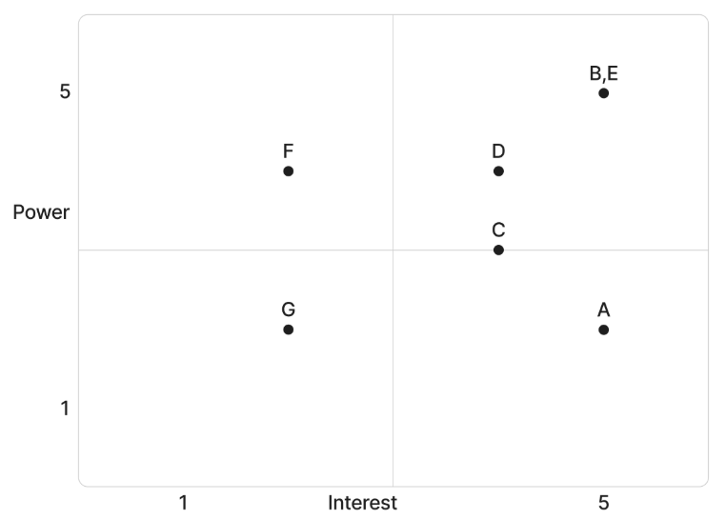
Based on the power and interest analysis and chart above, stakeholders G will require minimal management effort as they reside in the lower left quadrant of the matrix. Stakeholder F, in the upper left quadrant, must be kept satisfied by ensuring concerns and technical requirements are addressed adequately. Stakeholder A, in the lower right quadrant, must be kept informed through frequent communication, user support, and system updates. Stakeholders B, C, D, and E, in the upper right quadrant, are key players and must be involved in all levels of project planning and change management. Additionally, these stakeholders should be participatory members in project status meetings, testing phases, and milestone reviews as required.
The stakeholder analysis matrix will be used to capture stakeholder concerns, level of involvement, and management strategy based on the stakeholder analysis and power/interest matrix above. The stakeholder analysis matrix will be reviewed and updated throughout the project’s duration in order to capture any new concerns or stakeholder management strategy efforts.
Stakeholder | Concerns | Quadrant | Strategy
A | Ease of use, engagement, rewards | Keep Informed | Provide user-friendly interface, tutorials, and regular updates
B | Adoption rate, system effectiveness | Key Player | Involve in decision-making, provide frequent reports and updates
C | Integration into teaching activities | Key Player | Provide training, gather feedback, and ensure usability
D | Implementation and monitoring | Key Player | Share analytics dashboards and progress reports
E | System performance and deadlines | Key Player | Conduct regular meetings and agile coordination
F | Technical maintenance and workload | Keep Satisfied | Provide documentation and early communication of requirements
G | Awareness and participation | Minimal Effort | Provide occasional updates and outreach efforts

Stakeholder Analysis
Name | Department / Company | Position | Advisers | Objectives, Requirements, Interests | Influence | Project Contribution | Resistance
Department of Science and Technology Representatives | Management | Program Managers | STARBOOKS Team, Project Lead | Increase user engagement, improve learning outcomes, ensure system effectiveness | High | Funds project, approves deliverables, provides direction | Concerned about adoption rate and system effectiveness
STARBOOKS Management | Operations | System Administrators | DOST Representatives | Increase platform usage, ensure smooth operations | High | Manages system, provides requirements, monitors performance | Concerned about system reliability
School Administrators | Education | School Heads | DOST, Educators | Ensure successful implementation, monitor student participation | High | Approves deployment, oversees usage | Concerned about implementation and monitoring
Educators / Teachers | Education | Facilitators | School Admin | Enhance teaching methods, integrate quizzes into lessons | Medium | Supports student learning and classroom integration | Concerned about budget
Students / Visitors | End Users | Participants | Educators | Engaging learning experience, rewards, ease of use | Low | Primary users, generate engagement data | Concerned about usability and interest level
Project Development Team | Technical | Developers | Project Manager | Deliver functional system, meet deadlines, ensure performance | High | Designs, develops, and tests the system | Concerned about time constraints and scope changes
IT Support Staff | Technical | Support Personnel | Developers | Maintain system, ensure uptime and support | Medium | Provides technical support and maintenance | Concerned about maintenance workload
Partner Institutions | External | DOST | DOST | Expand participation, access to platform | Low | Supports outreach and adoption | Concerned about relevance and participation

Statement of Work
Introduction/Background
The Statement of Work (SOW) is a document which describes the scope of work required to complete a specific project. It is a formal document and must be agreed upon by all parties involved. In order to be effective, the SOW must contain an appropriate level of detail so all parties clearly understand what work is required, the duration of the work involved, what the deliverables are, and what is acceptable. This section provides a general description of the project as well as highlights the project’s background and what is to be gained by the project.
The DOST STARBOOKS Whiz Challenge has been approved in support of enhancing user engagement and promoting interactive learning through the STARBOOKS platform under the Department of Science and Technology – Science and Technology Information Institute (DOST-STII). In order to provide a more engaging and user-friendly experience for students and users, the Whiz Challenge Project will focus on developing an interactive quiz system which incorporates gamification elements such as leaderboards, rewards, and performance tracking.
It is imperative that DOST-STII utilizes the STARBOOKS platform as a tool for promoting science and technology knowledge while increasing user participation. The Whiz Challenge will allow users to interact with content in a more dynamic way while providing administrators with the ability to monitor performance and engagement. In order to accomplish this, the project will involve the design, development, testing, implementation, and training for the quiz platform. DOST-STII anticipates that this system will improve user engagement and strengthen the educational impact of STARBOOKS.
Scope of Work
The scope of work for the STARBOOKS Whiz Challenge Project includes all planning, execution, implementation, and training required for the development of an interactive quiz system integrated within the STARBOOKS platform.
The project team will be responsible for the design and development of the quiz system based on requirements provided by DOST-STII. Each stage of the project will require approval from DOST-STII management before moving on to the next stage. The project team must ensure it has adequate resources for designing, building, testing, and implementing the system and is also prepared to conduct training for users and administrators.
Specific deliverables and milestones will be listed in the Work Requirements and Schedules and Milestones sections of this SOW.
Not included in the scope of work is any major modification to existing STARBOOKS hardware or unrelated system components outside the quiz platform.
Period of Performance
The period of performance for the Whiz Challenge Project is one (1) year and six (6) months beginning on April 2025 through October 2026. All work must be scheduled to complete within this timeframe. Any modifications or extensions will be requested through DOST-STII and the project team for review and discussion.
Place of Performance
The project team will perform a majority of the work at their own facilities. The team will be required to meet with DOST-STII representatives once every three months. Additionally, all project reviews will be conducted with DOST-STII and attended by the project team.
DOST-STII will provide access to necessary STARBOOKS environments for testing and deployment. Once the project reaches the training phase, training sessions will be conducted either at designated institutions or through virtual platforms.
Work Requirements
As part of the STARBOOKS Whiz Challenge Project, the project team will be responsible for performing tasks throughout various stages of the project. The following is a list of these tasks which will result in the successful completion of this project:
Kickoff:
- Project team will create and present a detailed project plan including schedule, WBS, testing plan, implementation plan, training plan, and transition plan
- Project team will present project plan to DOST-STII for review and approval
Design Phase:
- Work with DOST-STII to gather requirements and establish system metrics
- Create system design based on collected requirements
- Develop design proposal for DOST-STII review and approval
- Present written status at weekly meetings
Build Phase:
- Project team will complete development of the quiz system based on approved design
- Project team will provide a detailed testing plan
- Implement features such as quizzes, leaderboard, rewards, and analytics
- Conduct testing in controlled and pilot environments
- Resolve any system issues identified during testing
- Compile a testing report to present to DOST-STII for review/approval
- Present written status at weekly meetings
Implementation Phase:
- Project team will deploy the system within the STARBOOKS platform
- Project team will begin providing system support from this point forward until the end of the period of performance
- Present written status at weekly meetings
Training Phase:
- Project team will provide training in accordance with the approved training plan
- Provide documentation and user guides
- Present written status at weekly meetings
Project Handoff/Closure:
- Project team will provide DOST-STII with all documentation in accordance with the approved project plan
- Project team will present project closure report for review and approval
- Project team will complete the project requirements checklist
- Project team will conclude system support at the end of the period of performance
- Present written status at weekly meetings
Schedule/Milestones
Phase | Timeline | Activities
Requirements  Gathering and  Planning | April – August 2025 | - Meet with client and  Stakeholders  - Define scope and core features  - Gather system requirements  - Create use case and system diagrams  - Draft project timeline  - Design initial wireframes
Development Phase 1 | September – October 2025 | - Finalize system architecture  - Set up development environment  - Build registration and login  - Develop homepage and profile  - Develop Whiz Challenge, Memory Match, and Puzzle games  - Implement player leaderboard and stats
Development Phase 2 | November 2025 – March  2026 | - Develop 1v1 Battle game  - Finalize core player-side modules (games, rewards, leaderboard)  - Begin development of admin dashboard (user and content management, and difficulty settings)  - Start development of analytics and leaderboard  - Conduct periodic internal testing of core functionalities
Soft Deployment, Testing, and Player-Side Optimization | April – June 2026 | - Conduct soft deployment in controlled environments (LAN/kiosk setup)  - Perform system-wide testing (focus on player-side modules)  - Conduct user acceptance testing with actual users  - Fix bugs and optimize performance (especially for kiosk hardware)  - Finalize UI/UX polish for player-side features
Final Deployment, System Completion, and Turnover | July – October 2026 | - Complete and finalize admin dashboard functionalities  - Perform final system integration and validation  - Conduct final testing and bug fixing across all modules  - Finalize all project documentation (SRS, deployment and user manuals, project management)  - Package the system for deployment (kiosk-ready setup)  - Execute full system deployment in target environments  - Conduct project turnover to DOST-STII

Acceptance Criteria
For the STARBOOKS Whiz Challenge Project, the acceptance of all deliverables will reside with DOST-STII management. A designated review team will ensure the completeness of each stage of the project and that the scope of work has been met.
Once a project phase is completed and the project team provides their report or presentation for review and approval, DOST-STII will either approve the phase for continuation or provide written feedback outlining any remaining tasks.
Upon completion of all project tasks, the project will enter the handoff/closure stage. During this stage, the project team will provide a project closure report and task checklist. Acceptance of this documentation by DOST-STII will acknowledge that all deliverables have been completed.
Any discrepancies involving completion of project tasks or disagreements will be reviewed and resolved through coordination between DOST-STII and the project team.
Other Requirements
All project team members will comply with DOST-STII security and access requirements. Access to STARBOOKS systems will be granted only for project-related activities.
All development and testing will be conducted in controlled environments to ensure system stability and security. Any required system downtime during implementation will be scheduled in advance, and notifications will be provided to stakeholders.
Upon completion of the project, all temporary access granted to the project team will be revoked.

02 PLANNING

Communication Management Plan
INTRODUCTION
This Communications Management Plan sets out the communications framework for the DOST STARBOOKS Whiz Challenge. It will serve as a guide for communications throughout the life of the project and will be updated as communication needs change. This plan identifies and defines the roles of people involved in this project. It also includes a communications matrix which maps the communication requirements of this project. An in-depth guide for conducting meetings details both the communications rules and how the meetings will be conducted, ensuring successful meetings. A project team directory is included to provide contact information for all stakeholders directly involved in the project.
COMMUNICATIONS MANAGEMENT APPROACH
The Project Manager will take a proactive role in ensuring effective communications on this project. The communications requirements are documented in the Communications Matrix presented in this document. The Communications Matrix will be used as the guide for what information to communicate, who is to communicate, when to communicate it, and to whom to communicate.
As the project progresses, updates or changes to the communication plan may be required due to changes in personnel, scope, or stakeholder needs. The Project Manager is responsible for managing all proposed and approved changes to the communications management plan. Once changes are approved, updates will be distributed to all stakeholders.
This methodology aligns with the project’s change management approach and ensures that all stakeholders, including representatives from the Department of Science and Technology – Science and Technology Information Institute (DOST-STII), remain informed throughout the project lifecycle.
COMMUNICATIONS MANAGEMENT CONSTRAINTS
All project communication activities will occur within the approved budget, schedule, and resource allocations. The Project Manager is responsible for ensuring that communication activities do not exceed allocated resources.
Communication activities will follow the frequencies defined in the Communication Matrix. Any deviation must be approved by DOST-STII.
Organizational policies require that standardized templates and formats be used for all formal communications. Additionally, only authorized personnel from DOST-STII may approve the release of sensitive or confidential information. The Project Manager must ensure proper authorization is obtained prior to distribution.
STAKEHOLDER COMMUNICATION REQUIREMENTS
The project includes a diverse group of stakeholders such as DOST-STII representatives, school administrators, educators, students, and the project team. The Project Manager will coordinate with stakeholders to determine their preferred communication methods and frequency.
Stakeholder communication preferences will be documented and maintained in the Stakeholder Register. Standard communication will follow the Communication Matrix, but additional communication may be conducted as needed.
All stakeholders will be provided access to communication platforms used in the project. Secure communication channels will be used when necessary to ensure data confidentiality.
ROLES
Project Sponsor
The Project Sponsor is the Department of Science and Technology – Science and Technology Information Institute (DOST-STII). The Project Sponsor is the champion of the project and has authorized it through approval of the project charter. This role is responsible for funding the project and is ultimately accountable for its success. Communications with the Project Sponsor will be presented in summary format unless more detailed information is requested.
Key Stakeholders
Key Stakeholders include DOST-STII representatives, STARBOOKS administrators, school administrators, and educators who have a direct interest in the project. These stakeholders may influence project decisions and are actively involved in providing feedback, reviewing deliverables, and ensuring successful implementation. Regular communication and engagement are required to manage expectations and ensure alignment.
Customer
The customer for this project is Department of Science and Technology – Science and Technology Information Institute (DOST-STII). As the customer who will be accepting the final deliverable of this project they will be informed of the project status including potential impacts to the schedule for the final deliverable or the product itself.
Project Manager
The Project Manager has overall responsibility for the execution of the project. The Project Manager manages day to day resources, provides project guidance and monitors and reports on the projects metrics as defined in the Project Management Plan. As the person responsible for the execution of the project, the Project Manager is the primary communicator for the project distributing information according to this Communications Management Plan.
Project Team
The Project Team is comprised of all persons who have a role performing work on the project. The project team needs to have a clear understanding of the work to be completed and the framework in which the project is to be executed. Since the Project Team is responsible for completing the work for the project they played a key role in creating the Project Plan including defining its schedule and work packages. The Project Team requires a detailed level of communications which is achieved through day to day interactions with the Project Manager and other team members along with weekly team meetings.
PROJECT TEAM DIRECTORY
The following table presents contact information for all persons identified in this communications management plan. The email addresses and phone numbers in this table will be used to communicate with these people.
Role | Name | Title | Organization/ Department | Email
Project Sponsor | Marievic V. Narquita | Head of DOST-STII | Information Services Section (ISS) | mavie.narquita@stii.dost.gov.ph
Project Manager | Kelly Dumbrique | Project Manager | NEXUS | ksdumbrique2@student.apc.edu.ph
Backend Developer | Arcielle Marie Gercan | Backend Developer | NEXUS | acgercan@student.apc.edu.ph
Frontend Developers | Shandrae Lois Quianzon  Kelly Dumbrique  Janice Maxene Salipande | Frontend Developer | NEXUS | saquianzon@student.apc.edu.ph  ksdumbrique2@student.apc.edu.ph  jdsalipande2@student.apc.edu.ph
UI/UX Designers/Illustrators | Shandrae Lois Quianzon  Arcielle Marie Gercan  Janice Maxene Salipande | UI/UX Designers/Illustrators | NEXUS | saquianzon@student.apc.edu.ph  acgercan@student.apc.edu.ph  jdsalipande2@student.apc.edu.ph
QA Lead | Janice Maxene Salipande | QA Lead | NEXUS | jdsalipande2@student.apc.edu.ph
Documentation Lead | Janice Maxene Salipande | Documentation Lead | NEXUS | jdsalipande2@student.apc.edu.ph
Key Stakeholders | See Stakeholder Register | Various Roles | Schools / Educators / Admins | See Stakeholder Register
Customer | DOST-STII | Management | Department of Science and Technology – Science and Technology Information Institute (DOST-STII) | dost@dost.gov.ph

GUIDELINES FOR MEETINGS
All project meetings, including sprint reviews, team standups, technical design sessions, and stakeholder meetings, will be documented using Group NEXUS's standardized Minutes of the Meeting (MOTM) template. The MOTM serves as the official record for all project meetings and must be completed for every session, regardless of format or duration.
Meeting Documentation
Each MOTM record captures the following:
- Activity Details — Control number, meeting date, venue or platform, time start and end, and video recording link where applicable
- Attendees — Screenshots of the start and end of the meeting, the Meeting Facilitator, Secretary, and a complete list of attendees
- Agenda — Itemized discussion topics with corresponding key discussions, decisions made, and next steps for each item
- Action Items — A log of all tasks arising from the meeting, with the assigned person responsible and the due date for each item
Meeting Agenda
The Meeting Facilitator is responsible for preparing and distributing the meeting agenda prior to each session. The agenda must identify all discussion items to be covered and should be shared with all attendees in advance to allow adequate preparation.
Meeting Facilitation
The Meeting Facilitator is responsible for opening the meeting, guiding discussion through all agenda items, ensuring the meeting starts and ends on time, and capturing the required start and end screenshots for the MOTM record.
Secretary / Note Taker
The designated Secretary is responsible for documenting key discussions, decisions made, and next steps for each agenda item during the meeting. The Secretary is also responsible for logging all action items, including the person responsible and the due date. The completed MOTM must be finalized and distributed to all attendees within 2 business days following the meeting.
Action Items
Action items are formally recorded in the Action Items section of the MOTM. Each item must have a clearly identified owner and a defined due date. Open action items from previous meetings will be reviewed at the start of the immediately following session to confirm resolution status before proceeding to the current agenda.
Meeting Records and Archiving
All completed MOTM documents will be archived on the SharePoint platform. Control numbers must follow the NEXUS-MOTM[XX] format to ensure traceability across the project lifecycle. Video recording links, where available, must be included in the MOTM record prior to archiving.

Risk Management Plan
INTRODUCTION
Every project undertaken in an environment of uncertainty carries inherent risk, which is the possibility that something unforeseen will affect the project's ability to deliver on its scope, schedule, cost, or quality commitments. As a ground-up redevelopment of the existing DOST-STII Whiz Challenge application, the project operates across multiple areas of uncertainty: a student development team with constrained capacity, a government client with evolving requirements, a novel offline-first deployment architecture, and a fixed 2026 deadline. The purpose of this Risk Management Plan is to establish the framework within which the project team identifies these risks, assesses their likelihood and potential impact, and develops strategies to mitigate or avoid them before they affect project outcomes.
This project is assessed as a medium risk project with an overall risk score of 40.9 on a scale of 0 to 100. The project risk score is the average of the risk scores of all identified risks, computed by multiplying each risk's probability rating (0–10) by its impact rating (0–10). A risk score below 16 is a low-risk project, a score between 16 and 45 is a medium risk project, and a score above 45 is a high-risk project.
Before risk management could begin, the following foundational project elements were completed and documented:
Work scope, schedule, resources, and cost elements:
- Work Breakdown Structure and WBS Dictionary developed and maintained in OpenProject across all five project phases
- Sprint-based schedule established with two-week sprints, 10 hours per member per week, 80 total team hours per sprint
- Total project budget of PHP 1,810,000 finalized and baselined across five phases in OpenProject
- All four team members identified and assigned to work packages with defined hourly rates (PHP 500/hour)
- EVM performance measurement metrics established (PV, EV, AC, CV, SV, CPI, SPI) with yellow and red thresholds defined
Minimum and maximum baseline thresholds defined:
- Schedule: SPI yellow at 0.9–0.8 or 1.1–1.2; red at below 0.8 or above 1.2
- Cost: CPI yellow at 0.9–0.8 or 1.1–1.2; red at below 0.8 or above 1.2
- Resources: 10 hours per member per week maximum sustainable allocation
Baseline reporting requirements:
- Format: Sprint Status Reports including EVM metrics, cost variance narrative, and risk status updates
- Frequency: End of each two-week sprint, with phase-level consolidated reports at phase boundaries
- Distribution: Project Sponsor (DOST-STII), Faculty Adviser, full project team
Risk Management Roles and Responsibilities:
- The Project Manager chairs all risk assessment discussions during sprint planning and retrospectives
- All four team members participate in risk identification and serve as risk managers for risks within their functional area
- The Faculty Adviser participates in risk review during weekly Tuesday meetings when risk status updates are warranted
- The Project Sponsor is informed of high-scoring risks and participates in decisions requiring budget or scope changes as risk responses
TOP THREE RISKS
The following three risks carry the highest risk scores and represent the most significant threats to the successful delivery of the STARBOOKS Whiz Challenge project:
Scope Creep from Continuous Client Feature Additions (R01 — Score: 64)
DOST-STII representatives have consistently introduced new feature requests during sprint reviews and documented during Sprint retrospectives as "scope getting bigger and bigger with every meeting the client adds more features." With a probability of 8 and impact of 8, this is the highest-scoring risk in the register. Left unmanaged, uncontrolled scope additions will destabilize the sprint schedule, exhaust team capacity, and threaten the deployment deadline. The Project Manager will mitigate this risk by enforcing the formal Change Request process for all new feature requests. Any item raised by DOST-STII that falls outside the approved WBS baseline must be submitted as a Change Request, impact-assessed within five business days, and approved by the Project Sponsor before any development work begins. The team will clearly communicate feature priorities to DOST-STII at the start of each sprint review to manage expectations.
Docker / Laragon Deployment Failure on DOST Kiosk Hardware (R05 — Score: 54)
The system's final deployment relies on Laragon and Docker containerization running on DOST-STII's existing kiosk hardware via a LAN configuration. If the kiosk hardware specs are rendered incompatible, if network configuration at event venues does not support the required LAN setup, or if container initialization fails under event conditions, the system will be unusable at its intended deployment environment. With a probability of 3 and impact of 5, this risk is particularly dangerous because it manifests at the very end of the project — in the Closing Phase — where recovery time is minimal. The Project Manager will mitigate this risk by scheduling a full end-to-end deployment rehearsal on DOST-STII hardware at least three weeks before the target deployment date. Laragon is maintained as a fallback deployment stack should Docker-based deployment encounter unresolvable issues on the target hardware.
Project Deadline Not Met Due to Accumulated Delays (R10 — Score: 54)
The project has a fixed deployment target of 2026, driven by academic course deadlines and DOST-STII's event calendar. With a probability of 6 and impact of 9, a missed deadline would constitute a critical project failure — leaving DOST-STII without the promised platform and the team without a completed deliverable for academic evaluation. The primary drivers of this risk are scope creep, team burnout, and high code error volume — all of which compound to erode sprint velocity. The Project Manager will mitigate this risk by maintaining a sprint velocity baseline in OpenProject, monitoring cumulative schedule variance at each sprint boundary, and initiating corrective action, including scope reduction or task reallocation, whenever the SPI drops below 0.9.
RISK MANAGEMENT APPROACH
The approach taken to manage risks for the STARBOOKS Whiz Challenge is a continuous, sprint-integrated process embedded directly into the team's Agile/Scrum workflow. Rather than treating risk management as a one-time exercise at project initiation, the team incorporates risk identification and status review into every sprint cycle consistent with PMBOK's emphasis on ongoing risk monitoring throughout the project lifecycle.
Risk identification was conducted through three complementary methods: expert interviews with DOST-STII technical staff during the Empathize stage of Design Thinking, structured risk assessment discussions during sprint retrospectives where the team reflected on what went wrong and what could go wrong, and a systematic review of documented issues from Sprints 3 through 5 including the burnout items, code error volume, scope creep incidents, and deployment concerns surfaced in retrospective records. All identified risks were scored using a Probability × Impact matrix on a 1–5 scale for each dimension, yielding individual risk scores from 1 to 25. Risks scoring 13 or above are classified as High and assigned a dedicated Risk Manager from the project team. Risk Managers provide status updates during sprint reviews when their risk's planned exposure window is active. At project closure, the Project Manager will conduct a retrospective analysis of each risk — whether it materialized, how effective the mitigation was, and what improvements should be captured in the lessons learned register for future projects.
RISK IDENTIFICATION
Risks for the STARBOOKS Whiz Challenge were identified through the following three methods, conducted across the project's initiation and planning phases and updated continuously through sprint retrospectives:
Expert Interview
Two expert interviews were conducted as part of the Design Thinking Stage 1 (Empathize) on April 30, 2025, with Ms. Marievic V. Narquita (STARBOOKS Unit Head) and Mr. McGyver C. Basaya (STARBOOKS Lead Programmer) at DOST-STII. These interviews revealed risks related to hardware compatibility, content provision dependencies, and data privacy compliance requirements under RA 10173. Several of these risks were mitigated at the planning stage by embedding specific requirements into the SRS and system architecture design.
Risk Assessment through Sprint Retrospectives
The project team conducted structured sprint retrospectives using the Glad / Sad / Mad format in Kollabe at the end of each sprint. These sessions surfaced the following risks through documented participant feedback: scope creep (R01), team burnout (R02), high code error volume (R07), and misaligned expectations between client and panel reviewers. Retrospective findings were transcribed into the Group Log and translated into formal risk register entries by the Project Manager.
Historical Review of Similar Projects
The project team reviewed the documented challenges of similar student-developed government-client projects within the SoCIT program, as referenced during weekly adviser meetings with the project adviser. This review informed risks related to schedule pressure (R10), client availability constraints (R15), and real-time technical feature complexity (R03); risks that commonly recur in comparable project contexts.
Risk Qualification and Prioritization
All identified risks were qualified using a Probability × Impact scoring matrix on a 1–5 scale for each dimension. Probability reflects the likelihood of the risk occurring within the project's timeframe. Impact reflects the severity of its effect on project objectives — scope, schedule, cost, or quality — if it does occur. The resulting risk score (1–25) determines the risk's priority level and the intensity of monitoring and response required.
Score Range | Priority Level
0-15 | Low — Monitor passively; no dedicated mitigation plan required
16-45 | Medium — Active monitoring; mitigation plan defined and documented in Risk Register
46-100 | High — Dedicated Risk Manager assigned; mitigation actions added to sprint backlog

The probability-impact assessment was conducted collectively during sprint planning and retrospective sessions, with all four team members contributing ratings and the Project Manager facilitating consensus. Once scored, risks were ranked from highest to lowest score to produce the prioritized Risk Register. All seven high-scoring risks (R01, R02, R03, R04, R05, R07, R10) were immediately assigned risk managers, and their mitigation actions incorporated into active sprint planning.
RISK MONITORING
Risk monitoring for the STARBOOKS Whiz Challenge is a continuous process embedded into the sprint cadence. All seven High-scoring risks have been added to the OpenProject project plan with assigned Risk Managers, ensuring their status is visible alongside all other project work in the same system.
At each sprint review, the Risk Manager for any risk whose planned exposure window falls within the current sprint will provide a brief status update covering three elements: current risk status (active / watch / closed), whether any trigger conditions have been observed, and whether the planned mitigation remains adequate or requires adjustment.
Trigger conditions have been defined for each high-priority risk to give the Project Manager early warning before a risk becomes an active issue:
- Scope Creep: Trigger — any new feature request from DOST-STII that is not present in the approved WBS baseline. Risk Manager: Groupmate 1 (Project Manager/Product Owner).
- Deployment Failure: Trigger — any compatibility error encountered during pre-deployment testing on DOST hardware, or confirmation that Docker Engine is unsupported on kiosk OS version. Risk Manager: Groupmate 2 (Backend Developer/Technical Lead).
- Deadline Miss: Trigger — SPI drops below 0.9 at any sprint boundary, or cumulative sprint velocity falls more than 15% below the baseline for two consecutive sprints. Risk Manager: Groupmate 1 (Project Manager).
All risk status updates are documented in the Sprint Status Report and archived on SharePoint. If a risk transitions from Watch to Active, the Project Manager escalates the response process within 24 hours — notifying the Faculty Adviser and, if the risk threatens scope, schedule, or budget, the Project Sponsor.
RISK MITIGATION AND AVOIDANCE
The Project Manager, with the participation of the full project team, has developed a response strategy for each identified risk. Responses follow four standard PMBOK risk response strategies: Avoid (eliminate the risk by changing the plan), Mitigate (reduce the probability or impact), Transfer (shift the risk to a third party), and Accept (acknowledge the risk and monitor without active response).
The risks for this project will be managed within the triple constraint of scope, schedule, and cost. Of these three constraints, cost is the only one with limited flexibility as a last resort. Time (2026 deployment deadline) and scope (the approved WBS baseline agreed with DOST-STII) are firm constraints. In extreme circumstances, additional budgets may be requested from DOST-STII to bring in supplemental resources or extend the working hours of team members, but only after all other mitigation strategies have been exhausted.
RISK REGISTER
The link to the Risk Register attached below is the complete log of all 15 identified risks for the STARBOOKS Whiz Challenge project. It captures each risk category, probability, impact, risk score, ranking, risk response strategy, trigger condition, and assigned Risk Manager. The register was developed through the initial project risk assessment process and will be updated throughout the project lifecycle as new risks are identified or existing risk statuses change.
Risk Register link

Scope Management Plan
INTRODUCTION
The STARBOOKS Whiz Challenge is a gamified, offline-first educational platform developed for the Department of Science and Technology – Science and Technology Information Institute (DOST-STII). The project involves the full design, development, testing, and deployment of an improved version of the existing DOST-STII Whiz Challenge application, addressing its identified limitations, most notably its single game format, lack of diverse learning strategies, and absence of an administrative management interface.
This Scope Management Plan was created to establish how the project's scope will be defined, managed, and controlled throughout its entire lifecycle. It documents the approach and processes Group NEXUS will follow to ensure that all work necessary to deliver the STARBOOKS Whiz Challenge is included in the project, and that no unnecessary work outside the agreed boundaries is performed. Managing scope with discipline is especially critical for this project given the team's time constraints as student developers, the fixed October 2026 deployment deadline, and the risk of scope creep identified in the sprint retrospectives.
The plan follows the five-step Project Scope Management process defined by PMBOK — Collect Requirements, Define Scope, Create WBS, Verify Scope, and Control Scope — applied within the Agile/Scrum methodology used to manage the project. Requirements were collected through stakeholder consultation with DOST-STII across multiple sprint reviews, analysis of the legacy application's shortcomings, expert judgment from the development team, and facilitated group workshops. These inputs were formalized into the project's Scope Statement, Work Breakdown Structure in OpenProject, and the WBS Dictionary documented in this plan. Any project communication, decision, or change that pertains to what work is or is not included in the STARBOOKS Whiz Challenge must reference and adhere to this Scope Management Plan.
SCOPE MANAGEMENT APPROACH
For the STARBOOKS Whiz Challenge project, scope management is the primary responsibility of the Project Manager. The scope for this project is defined by the Scope Statement, the Work Breakdown Structure (WBS) managed in OpenProject, and the WBS Dictionary included in this plan. The scope is measured and verified through sprint review meetings with DOST-STII at the conclusion of each sprint, deliverable acceptance checklists, and work performance measurements tracked in OpenProject (including work hours logged, task status, and budget consumption per phase).
Proposed scope changes may be initiated by the Project Manager, any team member, or DOST-STII stakeholders. All change requests must be submitted to the Project Manager, who will evaluate the requested change, perform an initial impact assessment, and convene a review meeting with the team and the Project Sponsor (DOST-STII) before escalating to formal acceptance. Upon approval, the Project Manager will update all project documents in OpenProject and communicate the scope change to all stakeholders. The Project Sponsor (DOST-STII) is responsible for the final acceptance of all project deliverables and the overall project scope, as evidenced by their sign-off during sprint reviews and at final project handover.
ROLES AND RESPONSIBILITIES
The Project Manager, Project Sponsor, faculty adviser, and all team members play key roles in managing the scope of the STARBOOKS Whiz Challenge. The table below defines the roles and responsibilities for scope management throughout the project lifecycle.
Name | Role | Responsibilities
DOST-STII Representatives | Project Sponsor | Accept or reject scope change requests; evaluate alignment of deliverables with DOST-STII educational goals; provide formal acceptance of project deliverables at each sprint review and at project closure
Kelly Dumbrique | Project Manager / Product Owner / Frontend Developer | Measure and verify project scope against the WBS; facilitate and document scope change requests; perform impact assessments of proposed changes; organize and lead sprint review and change control meetings; update all project documents upon approval of scope changes; communicate scope decisions to all stakeholders
Mr. Jose Eugenio Quesada | Faculty Adviser | Review project scope for technical rigor and feasibility; validate scope change requests; provide guidance on scope decisions during weekly adviser meetings
Arcielle Marie Gercan | Lead Developer / Backend Developer | Perform work within the defined WBS scope; identify and communicate scope gaps or required changes to the Project Manager; participate in impact assessments and sprint reviews
Shandrae Lois Quianzon | Frontend Developer / UX/UI Designer / Illustrator | Perform work within the defined WBS scope; identify and communicate scope gaps or required changes to the Project Manager; participate in impact assessments and sprint reviews
Janice Maxene Salipande | Scrum Master / QA Lead / Frontend Developer | Perform work within the defined WBS scope; maintain OpenProject tracking and WBS updates; identify and communicate scope gaps or required changes to the Project Manager; participate in impact assessments and sprint reviews

SCOPE DEFINITION
The scope for the STARBOOKS Whiz Challenge was defined through a comprehensive, multi-stage requirements collection and analysis process aligned with the Agile/Scrum methodology used to manage the project. The process began with a thorough analysis of the limitations of the existing DOST-STII Whiz Challenge application, which was documented and validated through direct consultation with DOST-STII technical staff and content specialists. Key deficiencies identified included limited replayability (single quiz format), absence of diverse learning strategies, insufficient player performance tracking, and lack of an administrative management interface.
From this analysis, the project team — in collaboration with DOST-STII — developed the foundational requirements by conducting structured interviews and stakeholder feedback sessions across multiple sprint reviews. Input was also gathered from the Faculty Adviser to ensure technical completeness and feasibility. Expert judgment from the team's frontend (Flutter/Dart) and backend (Laravel/MongoDB) developers was used to assess the feasibility of each requirement and translate stakeholder needs into concrete system features. Product analysis was applied to the existing STARBOOKS platform to identify integration boundaries and establish what the new system should and should not include.
The scope definition was formalized through the Scope Statement document (developed using the Project Management Foundations framework), which captures the project goals, boundaries, deliverables, success criteria, assumptions, and constraints. This document, along with the Work Breakdown Structure in OpenProject and the WBS Dictionary in this plan, constitutes the official scope baseline for the project.
PROJECT SCOPE STATEMENT
Product Scope Description
The STARBOOKS Whiz Challenge Version 1.0 is an improved, gamified educational platform developed for DOST-STII, designed to make Science and Mathematics learning more interactive, accessible, and engaging for students ranging from elementary to senior high school who attend DOST events and science fairs. The system is an offline-first application deployed on existing DOST kiosks via a LAN-based client-server architecture, requiring no internet connectivity for core gameplay.
The platform consists of four game modes (Whiz Challenge, Whiz Memory Match, Whiz Puzzle, and Whiz Battle), a badge and reward system, a player leaderboard, and a web-based administrative dashboard for DOST-STII staff. The administrative dashboard provides tools to manage players and admins, configure quiz content and difficulty settings, monitor reward claiming, and view game analytics.
Product Acceptance Criteria
The project will be considered complete and accepted when all of the following criteria are met:
- All four game modes operate correctly on DOST kiosk hardware with stable, bug-free gameplay and accurate offline scoring.
- The system functions fully offline for all core features.
- The administrative dashboard enables DOST staff to manage users and content, view analytics and leaderboard, and process reward claims.
- The application runs without performance degradation on existing STARBOOKS kiosk hardware.
- Pilot testing with students yields positive feedback on usability, engagement, and educational value.
- The final deployment contains no critical bugs, crashes, or data integrity issues.
- DOST-STII formally reviews and accepts the final product as meeting their standards, goals, and STARBOOKS environment requirements.
- All development, testing, and deployment are completed, and the system is fully launched by October 2026.
Project Deliverables
- Gamified Learning Application (Kiosk Version): A fully functional web-based application with four game modes (Whiz Challenge, Whiz Memory Match, Whiz Puzzle, Whiz Battle), deployable on DOST kiosks via LAN.
- Player Module: Registration, login, profile management, progress tracking, badge collection, reward claiming, and leaderboard functionality for student players.
- Admin Dashboard: A web-based management interface for DOST-STII staff, covering player and admin account management, quiz content management, difficulty configuration, reward management, and analytics visualization with export capability.
- Database Structure: A MongoDB database schema storing all player records, game results, badge and reward data, quiz questions, and analytics data, structured for local deployment with optional cloud syncing.
- Software Requirements Specification (SRS): Complete functional and non-functional requirements documentation, including UML diagrams (DFDs, use case diagrams, activity diagrams, sequence diagrams, deployment diagram, and ERD).
- System Design Document (SDD): Architecture, database design, hardware/software design, and security controls documentation.
- Testing and Documentation Package: Complete user manuals, setup and deployment instructions, and test cases for system validation.
- Deployment Package: A deployment bundle containing all application components, configured for installation on DOST kiosk hardware.
Project Exclusions (Out of Scope)
- No integration with the main STARBOOKS digital library system.
- No mobile or tablet version; the system is limited to kiosk and PC browser deployment only.
- No topic-specific categories for Whiz Memory Match; only default STARBOOKS-related icons are used.
- Only jigsaw-type puzzles are supported in Whiz Puzzle; other puzzle formats such as word games are not included.
- No image or game asset customization through the admin interface; game assets and settings are fixed.
- Whiz Battle is limited to 1v1 public matchmaking via game code; private rooms and other multiplayer formats are not supported.
- No player-specific analytics; the admin dashboard displays only overall trends and summary statistics across all users.
Project Constraints
- Time: The project must be fully completed and deployed by October 2026.
- Technology: All tools, platforms, and frameworks must be free or open-source and must run reliably on existing STARBOOKS kiosk hardware.
- Connectivity: The system must operate offline.
- Collaboration: Development and review cycles must accommodate DOST-STII's office schedule and availability for sprint reviews and content validation.
- Team Capacity: The development team consists of students with concurrent academic responsibilities, which constrains total available working hours per sprint (10 hours per week per member).
Project Assumptions
- Existing STARBOOKS kiosks meet the minimum hardware requirements to run the new application without hardware upgrades.
- DOST-STII will continue to provide access to documents, technical guidance, educational content, and timely feedback throughout all project phases.
- Students and administrators are assumed to have basic digital literacy skills sufficient to navigate the application without extensive training.
- All free and open-source frameworks and tools used (Flutter, Laravel, MongoDB) will remain stable and supported through the project's launch date.
SCOPE VERIFICATION
As this project progresses through each sprint, the Project Manager will verify completed deliverables against the scope baseline defined in the Scope Statement, WBS, and WBS Dictionary. Verification occurs at two levels: sprint-level and phase-level.
At the sprint level, the Project Manager reviews completed work packages in OpenProject at the end of each two-week sprint, confirming that each task and feature meets its defined acceptance criteria before it is presented at the Sprint Review. The Sprint Review meeting with DOST-STII serves as the formal verification checkpoint for that sprint's deliverables. Feedback from DOST-STII during this meeting is documented and used to inform the next sprint backlog.
At the phase level, upon completion of each project phase (Initiation, Planning, Executing, Monitoring & Controlling, Closing), the Project Manager and Project Sponsor will meet to formally review and accept all phase deliverables. Formal acceptance is documented through a signed deliverable acceptance record, confirming that the completed work is consistent with the approved scope baseline. This incremental acceptance approach of verifying deliverables at each sprint and phase boundary rather than deferring acceptance to the end of the project, ensures that scope alignment is maintained continuously and that deviations are caught and addressed before they compound.
SCOPE CONTROL
The Project Manager and the project team will collaborate to control the scope of the STARBOOKS Whiz Challenge throughout the project lifecycle. The WBS Dictionary serves as the primary statement of work for each WBS element, and team members are expected to perform only the work defined within each element and produce the stated deliverables. The Project Manager monitors project progress through OpenProject to ensure that this scope discipline is upheld.
Scope Change Process:
- Any project team member, faculty adviser, or DOST-STII stakeholder may identify and propose a scope change. The following process governs all scope change requests:
- The requestor documents the proposed change in a Project Change Request, describing the change, the reason for it, and the expected impact on scope, schedule, and budget.
- The Project Manager reviews the change request and performs an initial evaluation to determine whether it falls within the intent of the project. Clearly out-of-scope requests are denied at this stage with documented justification.
- If the change request passes initial review, the Project Manager convenes a change control meeting with the project team, faculty adviser, and DOST-STII to conduct a formal impact assessment covering scope, schedule, cost, and risk implications.
- Upon initial approval by the Project Manager and DOST-STII, the Project Manager formally submits the request to the Change Control Board (comprising the faculty adviser and relevant DOST-STII representatives) for final review.
- If the Change Control Board approves the scope change, the Project Sponsor (DOST-STII) formally accepts it by signing the Project Change Control Document.
- Upon final acceptance, the Project Manager updates all relevant project documents (WBS in OpenProject, Scope Statement, management plans as applicable) and communicates the approved change to all team members and stakeholders.

Work Breakdown Structure (WBS)
Introduction
The Work Breakdown Structure presented here represents all the work required to complete the STARBOOKS Whiz Challenge project — a gamified, offline-first educational platform developed for the Department of Science and Technology – Science and Technology Information Institute (DOST-STII). The system covers four interactive game modes, a badge and reward system, a player leaderboard, and a fully featured administrative dashboard, all deployed on DOST kiosk hardware via a LAN-based client-server architecture. The WBS is organized into five phases consistent with the project's lifecycle: Initiation, Planning, Executing, Monitoring and Controlling, and Closing. It adheres to the 100% Rule — every element of work required to produce the project deliverables is captured across these phases, with no work duplicated between branches and no work omitted. The WBS is decomposed to the work package level, where each package represents a discrete, assignable unit of work with an identifiable output, owner, and cost, tracked in OpenProject.
The WBS is broken down into the following views: Outline View, Hierarchical Structure, Tabular View, Tree Structure View (see the accompanying WBS charts), and WBS Dictionary. All budget figures are sourced from OpenProject and expressed in Philippine Peso (PHP).
WBS Dictionary
Level | WBS Code | Element Name | Definition
1 | 1 | STARBOOKS Whiz Challenge | All work required to design, develop, test, and deploy the STARBOOKS Whiz Challenge Version 1.0 — a gamified, offline-first STEM educational platform for DOST-STII.
2 | 1.1 | Initiation Phase | All activities to formally start the project, including client discovery, PM Foundations initiation deliverables, budget definition, and timeline planning.
3 | 1.1.1 | Design Thinking Stage 1: Empathize | Conduct empathy research with DOST-STII stakeholders to understand user needs, current system limitations, and the characteristics of the target student audience. Outputs feed directly into the Define and Ideate stages.
3 | 1.1.2 | PM Foundations Ch 2: Initiate a Project | Complete all PM Foundations Chapter 2 deliverables required to formally initiate the project, including the Project Charter, Objectives, Scope, and Stakeholder Analysis.
4 | 1.1.2.1 | Create Charter | Draft and finalize the Project Charter documenting the project's purpose, objectives, high-level scope, stakeholders, and Project Manager authorization.
4 | 1.1.2.2 | Create Objectives | Define measurable project objectives aligned with DOST-STII's educational and operational goals for the STARBOOKS Whiz Challenge.
4 | 1.1.2.3 | Create Scope | Develop the preliminary scope statement defining what is and is not included in the project.
4 | 1.1.2.4 | Create Stakeholder Analysis | Identify all project stakeholders, assess their interests and influence, and document strategies for engagement.
4 | 1.1.2.5 | Milestone: PM Foundations Ch 2 Completed | Formal milestone marking the completion and submission of all PM Foundations Chapter 2 initiation deliverables.
3 | 1.1.3 | Define Budgets | Establish and document the phase-level budget allocations for all five project phases in OpenProject.
3 | 1.1.4 | Define Timelines | Establish the project schedule and milestone dates across all phases, documented in OpenProject.
2 | 1.2 | Planning Phase | All activities to produce the project's planning artifacts, including design thinking deliverables, all system analysis and design diagrams, resource allocation, and all subsidiary management plans.
3 | 1.2.1 | Design Thinking Stage 2: Define | Synthesize empathy findings to define the problem statement and establish the project's design direction and goals.
3 | 1.2.2 | Design Thinking Stage 3: Ideate | Brainstorm and evaluate candidate design solutions for the application, arriving at the selected design direction for development.
3 | 1.2.3 | Requirements & Analysis Design Diagrams | Produce all system analysis and design diagrams required for the SRS, covering data flow, use cases, entity relationships, and deployment architecture.
4 | 1.2.3.1 | Dataflow Diagrams | Develop the Context Diagram (Level 0), Dataflow Diagram Level 1, and all eight Level 2 DFDs covering each major system process.
4 | 1.2.3.2 | Use Cases | Develop the Use Case Diagram and fully dressed use cases for all eight system functions, each including activity diagrams with swim lanes, sequence diagrams, and test cases.
4 | 1.2.3.3 | Entity Relationship Diagram | Design and document the complete data model for the STARBOOKS Whiz Challenge system, covering all collections, fields, relationships, and constraints.
4 | 1.2.3.4 | Deployment Diagram | Document the LAN-based client-server deployment architecture showing all hardware nodes (server PC, client PCs, LAN router) and software components (Laravel API, WebSocket server, MongoDB, Flutter web app).
3 | 1.2.4 | Allocate Resources | Identify and assign all human and material resources required across project phases, ensuring adequate coverage for all scheduled work.
3 | 1.2.5 | Subsidiary Management Plans | Develop all knowledge area management plans required to guide project execution through closing. Each plan defines the approach, tools, and processes for its respective knowledge area.
4 | 1.2.5.1 | Plan Scope Management | Define how project scope will be defined, verified, and controlled, including the WBS and WBS Dictionary.
4 | 1.2.5.2 | Plan Schedule Management | Define how the project schedule will be developed, maintained, and controlled.
4 | 1.2.5.3 | Plan Quality Management | Define the quality standards, metrics, and control activities for all project deliverables.
4 | 1.2.5.4 | Plan Resource Management | Define how team members will be identified, acquired, managed, and released throughout the project.
4 | 1.2.5.5 | Plan Communications Management | Define the communication channels, frequency, formats, and responsibilities for all project stakeholders.
4 | 1.2.5.6 | Plan Risk Management | Identify project risks, assess their probability and impact, and define response strategies.
4 | 1.2.5.7 | Plan Procurement Management | Identify any procurement needs for tools, services, or resources, and define the procurement approach.
4 | 1.2.5.8 | Plan Stakeholder Engagement | Define strategies to maintain productive engagement with DOST-STII, the faculty adviser, and other stakeholders.
4 | 1.2.5.9 | Plan Change Management | Define the process for submitting, evaluating, approving, and implementing changes to the project scope, schedule, or budget.
2 | 1.3 | Executing Phase | Full-scale development and testing of the STARBOOKS Whiz Challenge application, covering all player-facing features, the admin dashboard, and all supporting technical documentation.
3 | 1.3.1 | Design Thinking Stage 4: Prototype | Develop prototypes of the application interfaces for validation with DOST-STII prior to full-scale development. Covers both player-side and admin-side UI prototypes.
3 | 1.3.2 | Design Thinking Stage 5: Test | Conduct usability testing of prototypes with target users and DOST-STII stakeholders, collect feedback, and refine designs before development begins.
3 | 1.3.3 | Epic 01 — Application Development | The complete development of all player-facing and admin-facing features of the STARBOOKS Whiz Challenge application, built iteratively across sprints using Flutter/Dart (frontend) and Laravel/MongoDB (backend).
4 | 1.3.3.1 | Registration Page | Develop the multi-step player registration interface collecting username, password, school, age, avatar, category, sex, region, province, and city. Includes form validation, API integration, password hashing, and success/error messaging.
4 | 1.3.3.2 | Player Login Page | Develop the player authentication interface with username/password entry, credential validation against the database, session token management, and appropriate error messaging.
4 | 1.3.3.3 | Homepage with Player Profile Section | Develop the main homepage displaying the player's avatar, username, earned badges, and navigation buttons to all four game modes. Includes dynamic data fetching from the backend.
4 | 1.3.3.4 | Player Leaderboard | Develop the leaderboard screen showing top player rankings with username, avatar, total rewards, reward breakdowns by difficulty, and toggle between Whiz Challenge and Whiz Battle views.
4 | 1.3.3.5 | Four Game Modes | Develop all four interactive game modes of the STARBOOKS Whiz Challenge, each supporting Science and Math categories and three difficulty levels (Easy, Average, Difficult).
5 | 1.3.3.5.1 | Whiz Challenge | Develop the solo quiz game mode with category and difficulty selection, randomized question loading, countdown timer, answer validation with visual feedback, score calculation, and badge award logic for perfect scores.
5 | 1.3.3.5.2 | Whiz Memory Match | Develop the card-matching game with randomized grid generation by difficulty, card flip logic, pair matching detection, elapsed timer, move counter, star scoring, and fastest time tracking.
5 | 1.3.3.5.3 | Whiz Puzzle | Develop the jigsaw puzzle game with image selection by category and difficulty, drag-and-drop piece mechanics, proximity-based snapping, elapsed timer, move counter, completion detection, and fastest time tracking.
5 | 1.3.3.5.4 | Whiz Battle | Develop the real-time 1v1 quiz battle mode with game code generation, WebSocket-based player matchmaking, synchronized question delivery, per-question score updates, winner determination, and badge award for the winner.
4 | 1.3.3.6 | Admin Dashboard | Develop the complete web-based administrative dashboard for DOST-STII staff, covering authentication, analytics, leaderboard management, player management, admin management, content management, and game configuration.
5 | 1.3.3.6.1 | Admin Login Page | Develop the admin-specific authentication interface accessible via a dedicated admin link, with credential validation, session management, and redirect to the analytics dashboard on success.
5 | 1.3.3.6.2 | Analytics Dashboard | Develop the analytics dashboard displaying key metrics including total registered players, most played game mode, average session duration, gender and age distribution, regional breakdown, game mode preferences by gender, and reward distribution. Includes export functionality.
5 | 1.3.3.6.3 | Admin Leaderboard | Develop the admin view of the leaderboard showing top player rankings with badge and star breakdowns, toggleable by game mode, with export functionality for DOST-STII record-keeping.
5 | 1.3.3.6.4 | List of Players | Develop the player management interface allowing admins to view all registered players, add new players, edit profiles, reset passwords, view badge collections, process reward claims, and delete accounts.
5 | 1.3.3.6.5 | List of Admins | Develop the admin management interface allowing authorized admins to view, add, edit, change passwords for, and delete other administrator accounts. Includes role-based access enforcement preventing self-deletion.
5 | 1.3.3.6.6 | List of Questions | Develop the question bank management interface allowing admins to view, search, filter, add, edit, and delete quiz questions by category (Science/Math), difficulty level (Easy/Average/Difficult), and status.
5 | 1.3.3.6.7 | Difficulty Level Settings | Develop the game configuration interface allowing admins to set the number of questions per session and time limit per question for each difficulty level, with validation and immediate effect on live game modes.
3 | 1.3.4 | Sequence Diagrams | Develop all sequence diagrams for the SRS, illustrating the message flow between actors and system components for all use case scenarios.
3 | 1.3.5 | Deployment Diagram | Finalize the deployment diagram reflecting the Docker-based production architecture, including all container definitions and LAN network topology.
3 | 1.3.6 | Software Requirements Specification | Compile and finalize the complete SRS document covering all functional and non-functional requirements, UML diagrams, test cases, and group logs for submission to DOST-STII and the faculty adviser.
2 | 1.4 | Monitoring and Controlling Phase | Ongoing oversight activities conducted throughout the project lifecycle to track performance, compare actual progress against the approved plan, identify deviations, and take corrective action as needed.
3 | 1.4.1 | Tracking Progress | Monitor the status of all work packages in OpenProject at the end of each sprint, recording actual hours, costs, and task completion against the plan.
3 | 1.4.2 | Comparing Against the Plan | At the end of each sprint, calculate EVM metrics (PV, EV, AC, SV, CV, SPI, CPI) and compare actual performance against the approved scope, schedule, and cost baselines.
3 | 1.4.3 | Identifying Deviations and Issues | Identify variances, scope gaps, risks, and blockers through sprint reviews and retrospectives, and document findings for corrective action.
3 | 1.4.4 | Measuring Performance | Assess overall project health against the cost and schedule performance index thresholds defined in the Cost Management Plan, and report findings to the Project Sponsor.
2 | 1.5 | Closing Phase | All activities required to formally close the STARBOOKS Whiz Challenge project, including completing outstanding work, obtaining DOST-STII acceptance, archiving documentation, and transferring the complete system to DOST-STII.
3 | 1.5.1 | Completing All Tasks | Ensure all open work packages, bug fixes, and outstanding documentation items are completed and verified prior to formal project closure.
4 | 1.5.1.1 | User Acceptance Test Completions | Conduct final user acceptance testing with DOST-STII on the deployed system, validate all functional and non-functional requirements, and obtain sign-off on test results.
3 | 1.5.2 | Obtaining Final Approvals | Present the completed system to DOST-STII for formal acceptance review. The Project Sponsor signs the project acceptance document confirming that all deliverables meet agreed requirements.
3 | 1.5.3 | Archiving Project Documentation | Compile and archive all project documents including the SRS, SDD, Scope Management Plan, Cost Management Plan, WBS, meeting minutes, test cases, and source code repository.
3 | 1.5.4 | Conducting a Final Review | Conduct a final sprint retrospective and lessons learned session with the full project team, documenting what went well, what could be improved, and recommendations for future similar projects.
3 | 1.5.5 | Project Turnover | Formally transfer the complete system — including source code, database, deployment package, user manuals, setup instructions, and all project documentation — to DOST-STII for their ownership and future maintenance.

Schedule Management Plan
Introduction
The project schedule serves as the roadmap for how the STARBOOKS Whiz Challenge project will be executed, monitored, and completed. It provides the project team, stakeholders, and the Department of Science and Technology – Science and Technology Information Institute (DOST-STII) with a clear and structured view of the project’s progress, timelines, and overall status at any given time. By defining when tasks are expected to start and finish, the schedule ensures alignment among all parties involved and supports effective coordination throughout the development lifecycle.
The purpose of this Schedule Management Plan is to define the approach that the project team will use in creating, maintaining, and controlling the project schedule. This includes the processes for identifying, analyzing, documenting, prioritizing, approving or rejecting, and communicating all schedule-related changes. The plan ensures that any deviations from the baseline schedule are properly evaluated and managed to minimize risks and delays. Overall, this document establishes a structured framework that supports timely delivery and successful completion of the STARBOOKS Whiz Challenge system.
Schedule Management Approach
Project schedules for the STARBOOKS Whiz Challenge will be developed based on the deliverables identified in the project’s Work Breakdown Structure (WBS), which has been documented separately. The WBS serves as the foundation for identifying all required tasks and ensures that no critical activities are overlooked during schedule development. Activity definition will involve identifying the specific work packages needed to complete each deliverable, including development of game modes, backend services, user interfaces, and administrative functionalities.
Activity sequencing will be performed to determine the logical order of tasks and establish dependencies between activities. For example, backend API development must be completed before frontend integration, and database configuration must precede data-driven features. Activity duration estimating will be conducted based on task complexity, team expertise, and available time constraints, ensuring that timelines are realistic and achievable. Resource estimating will also be performed to assign appropriate team members to each task based on their roles, such as frontend development, backend development, testing, and documentation.
The following will be designated as milestones for the project schedule: completion of the scope statement and WBS documentation, approval of the baselined project schedule, completion of requirements definition (SRS), completion of system design artifacts (DFDs, ERD, diagrams), development completion of core game modes, completion of the admin dashboard, completion of the analytics module, system integration testing, user acceptance testing, final documentation completion, system deployment, and final acceptance of deliverables.
Roles and responsibilities for schedule development are clearly defined. The project manager or lead developer is responsible for facilitating activity definition, sequencing, and estimation of duration and resources, as well as creating and maintaining the schedule. The project manager also ensures that the schedule is validated by the team, approved by stakeholders, and properly baselined. The project team is responsible for actively participating in task identification, estimation, and validation, as well as executing assigned activities according to the schedule. The project adviser provides guidance and ensures that the schedule is realistic and aligned with academic and project requirements. DOST-STII stakeholders participate in milestone reviews and approve the final schedule before baseline establishment.
Schedule Control
The project schedule will be reviewed and updated on a weekly basis to ensure that progress is accurately tracked and any deviations are identified early. Task owners are responsible for providing updates on actual start dates, actual completion dates, and percentage of completion for their assigned activities. These updates will be consolidated by the project manager to maintain an accurate representation of the project’s current status.
Regular schedule reviews will be conducted through weekly team meetings, where progress, delays, and potential risks are discussed. Additional reviews may be conducted with the project adviser on a bi-weekly basis to ensure alignment with project objectives and timelines. Major milestone reviews will also involve DOST-STII stakeholders to validate deliverables and ensure that expectations are being met.
The project manager is responsible for overseeing schedule control activities, including conducting schedule reviews, analyzing variances between planned and actual performance, and determining the impact of any delays. The project manager will also submit schedule change requests when necessary and communicate schedule status updates in accordance with the project’s communication plan. The project team is responsible for actively participating in schedule reviews, reporting progress accurately, and addressing any issues that may affect task completion. The project sponsor and stakeholders will maintain awareness of the schedule status and review or approve any significant schedule changes.
Schedule Changes and Thresholds
For the STARBOOKS Whiz Challenge project, a change threshold of ten percent (10%) will be applied. This means that any proposed change that results in an increase or decrease of ten percent or more in the duration of an individual task or the overall project schedule must be formally reviewed and approved.
If any member of the project team identifies the need for a schedule change, the project manager will coordinate a review with the team to evaluate the impact of the change. This evaluation includes identifying affected tasks, estimating the variance, and exploring alternative solutions to minimize impact. If the proposed change exceeds the defined threshold, a formal schedule change request must be submitted to the project adviser and relevant stakeholders for approval.
A schedule change request is required if the proposed change affects an individual task duration by ten percent or more, or if it impacts the overall project timeline by the same margin. Changes that do not exceed these thresholds may be managed and approved by the project manager. Once a change request is approved, the project manager will update the schedule accordingly and communicate all changes and their impacts to the project team and stakeholders. All change requests and decisions will be properly documented and archived for reference.
Scope Change
Changes to the project scope may have a direct impact on the project schedule and must be carefully managed to ensure that timelines remain realistic and achievable.
Approved scope changes, such as the addition of new features, enhancements to existing functionalities, or modifications to system requirements, may require adjustments to the project schedule. When such changes occur, the project manager and team will evaluate the impact on current tasks, resource allocation, and overall timelines. This evaluation ensures that any additional work is properly accounted for and integrated into the schedule.
If the project manager determines that a scope change significantly affects the project schedule, a request to re-baseline the schedule may be submitted. Re-baselining involves establishing a new approved schedule that reflects the updated scope and associated timelines. This request must be reviewed and approved by the project adviser and stakeholders before implementation.
Once approved, the updated schedule will replace the previous baseline, and all future schedule tracking will be based on the revised plan. This ensures that the project remains aligned with its updated objectives while maintaining proper control over time and resources.

Requirements Management Plan
INTRODUCTION
The purpose of the STARBOOKS Whiz Challenge Requirements Management Plan is to establish a standardized process for identifying, documenting, analyzing, prioritizing, and controlling both project and product requirements. This ensures alignment with the objectives of the Department of Science and Technology – Science and Technology Information Institute (DOST-STII) and supports the successful delivery of an engaging, educational, and accessible platform for students and partner institutions.
Requirements for this project will be categorized into two main types: project requirements and product requirements. Project requirements focus on the conditions necessary to successfully execute and complete the project. These include management processes, stakeholder engagement, reporting standards, deployment constraints, and compliance with DOST-STII policies. These requirements are primarily non-technical but are essential to ensure proper governance and execution of the project.
Product requirements, on the other hand, define the functional and technical specifications of the STARBOOKS Whiz Challenge system. These include system features such as quiz-based challenges, mini-games (e.g., Memory Match, Puzzle Games, and 1v1 Battles), leaderboard functionality, user authentication, analytics tracking, and compatibility with existing STARBOOKS kiosks. Product requirements also cover system performance, usability, accessibility in low-connectivity environments, and data security considerations.
The primary inputs for developing this Requirements Management Plan include the Project Charter, Stakeholder Register, initial System Design Documents, and outputs from stakeholder consultations with DOST-STII representatives, educators, and students. These inputs ensure that all requirements are grounded in actual user needs and aligned with the strategic goals of the STARBOOKS program.
REQUIREMENTS MANAGEMENT APPROACH
The approach we will use for requirements management for the STARBOOKS Whiz Challenge Project will be broken down into four areas: requirements identification, requirements analysis, requirements documentation, and ongoing requirements management.
Requirements Identification: The STARBOOKS Whiz Challenge project team will facilitate various methods to collect requirements which may include interviews, focus groups, or product prototypes. These will be conducted among the project stakeholders to ensure all requirements are captured.
Requirements Analysis: The STARBOOKS Whiz Challenge project team will analyze requirements to determine if they fall into project or product categories. Additionally, this analysis will determine where in the Work Breakdown Structure (WBS) the requirements will fall or what work activities correspond to particular requirements. Accountability and priority for each requirement will also be determined as part of the analysis. Finally, metrics and acceptance criteria must be established for all requirements in order to provide a baseline for understanding when a requirement has been fulfilled to an acceptable level. This includes defining measurable criteria such as system usability, performance in low-connectivity environments, and accuracy of game scoring and analytics.
Requirements Documentation: Once requirements have been identified and analyzed, they will be documented and assigned to accountable personnel. These requirements will be added to the STARBOOKS Whiz Challenge project plan, and the project team will determine what methodology the accountable personnel will use to track and report on the status of each requirement. All requirements will also be added to the project requirements checklist and Requirements Traceability Matrix (RTM), which must be completed before formal project closure is accepted by the project sponsor, DOST-STII.
Ongoing Requirements Management: Throughout the project lifecycle, the project manager will ensure all team members are reporting requirement status and raising any issues or concerns with their assigned requirements as appropriate. As the project matures there may be situations in which requirements must change or be altered in some way. The project team must follow the established change control process in order to propose any changes to requirements and receive approval from the change control board. Ongoing requirements management also includes receiving approval of all requirements by all vested parties as part of project closure. Ongoing management will also include periodic validation sessions with stakeholders to confirm that requirements are being met and remain relevant. Final approval of all requirements will be obtained prior to project closure, ensuring that the delivered system fully satisfies stakeholder expectations and project goals.
CONFIGURATION MANAGEMENT
For the STARBOOKS Whiz Challenge Project, the Requirements Management Plan will utilize the configuration management activities outlined in the Configuration Management Plan. Key items include documentation/version control and change control:
Documentation and Version Control: All project documentation will be loaded into the Configuration Management Database (CMDB) as the central repository for the STARBOOKS Whiz Challenge Project. This repository will include requirements documents, design specifications, test cases, and other project artifacts. Appropriate access permissions will be granted to project team members to ensure controlled editing and updating of documents.
Any proposed changes to project requirements must be formally documented and reviewed by the Change Control Board (CCB), which includes representatives from DOST-STII, the Project Manager, and the Technical Lead. Written approval from the Project Sponsor (DOST-STII) is required before any updates are made to official documentation. Once approved changes are implemented, version control practices will be enforced to maintain a history of revisions, ensuring traceability and accountability. The Project Manager will be responsible for communicating all approved changes to relevant stakeholders.
Change Control: Any proposed changes to project requirements must be carefully evaluated prior to approval and implementation, as these changes may significantly impact project scope, schedule, and resources. All change requests will be formally submitted and reviewed by the CCB. The role of the CCB is to assess the impact of the proposed change, request clarification if needed, and determine whether the change aligns with project objectives and constraints.
Approved changes will be documented and incorporated into the CMDB, ensuring that all project artifacts remain up to date and consistent. The Project Sponsor, as a member of the CCB, holds final authority for approving changes that affect project scope, time, or cost. This structured change control process ensures that the STARBOOKS Whiz Challenge Project maintains stability while remaining flexible enough to adapt to necessary improvements and stakeholder needs.
REQUIREMENTS PRIORITIZATION PROCESS
The STARBOOKS Whiz Challenge project manager will facilitate stakeholder meetings in order to establish priorities for all project requirements. This project will use a three-level scale in order to prioritize requirements. The chart below illustrates these levels and defines how requirements will be grouped:
Priority Level | Definition
High | Critical requirements that are essential for system functionality and project success. These include core features such as quiz-based challenges, user authentication, offline accessibility within STARBOOKS kiosks, and leaderboard functionality. These requirements must be completed within the defined project scope and timeline.
Medium | Important requirements that enhance system usability and user engagement but are not critical to initial deployment. Examples include additional mini-games, enhanced analytics dashboards, and UI/UX improvements. These may be adjusted if constraints arise.
Low | Optional or future enhancements that provide additional value but are not necessary for initial system operation. These may include extended customization features, additional game modes, or non-essential interface enhancements. These requirements may be deferred to future phases if needed.

As the project moves forward and additional constraints are identified or there are issues with resources, it may be necessary for the project team and stakeholders to meet in order to determine what requirements must be achieved, which can be re-baselined, or which can be omitted. These determinations will be made in a collaborative effort based on the priorities of the requirements and which level they are assigned in accordance with the chart above. As any changes in requirements are made, all project documentation must be updated in the CMDB and communicated to all project stakeholders.
PRODUCT METRICS
Product metrics for the STARBOOKS Whiz Challenge Project will be based on cost, quality, and performance requirements. In order to achieve project success, the system must meet or exceed all established metrics.
Cost:
- The system must be developed at zero direct financial cost, leveraging student-led development, open-source tools, and existing STARBOOKS kiosk infrastructure.
- Operational and maintenance costs must remain minimal, requiring no additional licensing or subscription fees.
- Deployment must utilize existing hardware without requiring additional capital investment.
Quality:
- The system must achieve at least 95% functional accuracy in quiz scoring, leaderboard ranking, and analytics tracking.
- User interface must meet usability standards, with at least 90% positive feedback from user acceptance testing (students and educators).
- The system must maintain data integrity and consistency, ensuring no duplication or loss of user progress and scores.
- The platform must be stable, with minimal system crashes or errors during operation within STARBOOKS kiosks.
Performance:
- The system must operate efficiently in low or no internet connectivity environments, ensuring full functionality within offline STARBOOKS deployments.
- Average system response time for user interactions (e.g., answering quizzes, loading games) must not exceed 2 seconds.
- The platform must support simultaneous users per kiosk session without performance degradation.
- Game modules (e.g., Whiz Memory Match, Whiz Puzzle, Whiz Challenge, Whiz Battle) must load and execute smoothly without noticeable lag.
By adhering to these product metrics, the STARBOOKS Whiz Challenge Project ensures that the delivered system is cost-effective, reliable, and capable of providing an engaging and educational experience aligned with the goals of DOST-STII.

Risk Register
ID | Risk | Risk Category | Probability | Impact | Risk Score | Risk Ranking | Risk Response | Trigger | Risk Owner
R01 | Scope creep from continuous DOST-STII feature additions during sprint reviews | Scope | 8 | 8 | 64 | 1 | Avoid/Mitigate — Enforce the formal Change Request process for all out-of-baseline feature requests; communicate feature priorities at sprint review opening; document all new requests in OpenProject before any evaluation begins | Any new feature request from DOST-STII not present in the approved WBS baseline | Kelly Dumbrique (Project Manager / Product Owner)
R05 | Docker and LAN deployment failure on DOST kiosk hardware | Technical | 6 | 9 | 54 | 2 | Mitigate — Schedule full end-to-end deployment rehearsal on DOST hardware at least three weeks before deployment date; maintain Laragon as a tested fallback stack; document both deployment procedures for DOST-STII staff | Any compatibility error or Docker Engine failure observed during pre-deployment rehearsal on kiosk hardware | Arcielle Marie Gercan (Lead Developer)
R10 | 2026 deployment deadline not met due to accumulated schedule delays | Schedule | 6 | 9 | 54 | 3 | Mitigate — Monitor SPI at every sprint boundary; activate corrective action if SPI drops below 0.9; scope reduction of lower-priority admin features is the primary schedule recovery lever | SPI drops below 0.9 at any sprint boundary, or cumulative sprint velocity falls more than 15% below baseline for two consecutive sprints | Kelly Dumbrique (Project Manager / Product Owner)
R02 | Team burnout from concurrent academic workload and client demands | Resource | 8 | 6 | 48 | 4 | Mitigate — Enforce the 10-hour/week allocation limit; redistribute tasks if one member is overloaded; escalate to Faculty Adviser if workload becomes unsustainable | A team member logs more than 15 hours in a single week or raises fatigue concerns during the daily standup | Kelly Dumbrique (Project Manager / Product Owner)
R03 | WebSocket real-time synchronization failure in Whiz Battle mode | Technical | 6 | 8 | 48 | 5 | Mitigate — Conduct dedicated WebSocket integration testing on LAN hardware; implement graceful error handling and reconnection logic; maintain a simplified polling-based fallback if WebSocket is unavailable | WebSocket connection drops or questions appear out of sync between two players during Whiz Battle testing | Arcielle Marie Gercan (Lead Developer)
R04 | Delayed or insufficient provision of quiz content by DOST-STII | External | 6 | 8 | 48 | 6 | Mitigate — Request initial content batch at least four weeks before the content integration sprint; use placeholder content for development; escalate to Project Sponsor if content is not delivered by the agreed milestone | Content not received by the agreed handoff date or delivered in an unusable or incomplete format | Kelly Dumbrique (Project Manager / Product Owner)
R07 | Sprint velocity degradation from high volume of code errors | Quality | 8 | 6 | 48 | 7 | Mitigate — Implement mandatory code review before merging to the main branch; allocate dedicated bug-fix buffer time in each sprint plan; enforce GitHub branch protection rules | More than three unresolved bugs reported in a single sprint, or Sprint Status Report flags SPI below 0.9 | Shandrae Lois Quianzon (Developer / QA Tester)
R06 | MongoDB data loss or corruption during DOST events | Technical | 4 | 9 | 36 | 8 | Mitigate — Implement and document daily database backup procedures for DOST-STII staff; include backup and restore instructions in the user manual; perform mandatory pre-event backup as a checklist item | Database error, unexpected server shutdown, or hardware failure during an active event session | Arcielle Marie Gercan (Lead Developer)
R08 | Key team member unavailability mid-sprint due to academic obligations | Resource | 6 | 6 | 36 | 9 | Accept/Mitigate — Cross-train team members on each other's primary work packages; document all active tasks in OpenProject so any member can continue another's work; communicate absences at least 48 hours in advance | A team member announces unavailability with less than 48 hours notice during an active sprint | Kelly Dumbrique (Project Manager / Product Owner)
R09 | DOST-STII kiosk hardware specifications below system minimum requirements | External | 4 | 9 | 36 | 10 | Mitigate — Validate hardware specifications against SRS minimum requirements (Intel Core i3, 4GB RAM, 50GB storage) during pre-deployment rehearsal; optimize application for lower-spec hardware if needed | Hardware spec sheet from DOST-STII confirms processor, RAM, or storage below SRS-defined minimum thresholds | Arcielle Marie Gercan (Lead Developer)
R11 | Flutter web application performance degradation under 15 concurrent users | Technical | 6 | 6 | 36 | 11 | Mitigate — Conduct load testing simulating 15 concurrent users before deployment; optimize API queries and implement connection pooling; validate against performance requirements PR-011 and PR-012 in the SRS | Response time exceeds SRS thresholds during internal load testing with simulated concurrent sessions | Arcielle Marie Gercan (Lead Developer)
R12 | Unclear or continuously changing requirements from DOST-STII | Scope | 6 | 6 | 36 | 12 | Mitigate — Document all requirements in the SRS and obtain DOST-STII review sign-off before development begins; treat all post-baseline requirement changes as formal change requests; revisit scope at each sprint review | DOST-STII requests modification to a feature already developed and accepted in a prior sprint review | Kelly Dumbrique (Project Manager / Product Owner)
R13 | Data privacy non-compliance with Philippine Data Privacy Act (RA 10173) | External | 4 | 9 | 36 | 13 | Avoid — Embed all RA 10173 compliance requirements directly into the SRS and system design; implement password hashing, minimal data collection, privacy notice during registration, and role-based access control as non-negotiable system requirements | Security review identifies personal data stored without cryptographic hashing, consent acknowledgment, or appropriate access controls | Arcielle Marie Gercan (Lead Developer)
R15 | Faculty Adviser or DOST-STII unavailability for scheduled sprint reviews | External | 4 | 5 | 20 | 14 | Accept — Build buffer into the sprint review schedule; confirm meeting availability at least three days in advance; conduct asynchronous feedback collection via email if in-person review must be postponed | Review meeting not confirmed 48 hours before the scheduled date | Kelly Dumbrique (Project Manager / Product Owner)
R14 | Loss of OpenProject data or project tracking system failure | Technical | 2 | 7 | 14 | 15 | Accept — Export OpenProject data regularly to SharePoint as a backup; maintain Sprint Status Reports and WBS documentation independently as offline records | OpenProject becomes inaccessible for more than one full working day | Janice Maxene Salipande (Scrum Master)

Quality Management Plan
INTRODUCTION
The Quality Management Plan is a core component of the overall project management plan for the DOST STARBOOKS Whiz Challenge. This plan establishes how quality will be defined, planned, assured, and controlled throughout the full lifecycle of the project — from initiation through final deployment and handover to DOST-STII.
The Quality Management Plan for the STARBOOKS Whiz Challenge project will guide Group NEXUS in delivering a gamified, offline-first educational platform that meets the expectations of DOST-STII and the end users it serves. The purpose of this plan is to:
- Ensure that quality is deliberately planned into every phase of the project and not treated as an afterthought
- Define how quality will be managed across both the product and the development processes
- Establish quality assurance activities that verify process compliance throughout the project lifecycle
- Establish quality control activities that verify the product meets defined standards at key checkpoints
- Define measurable quality standards that serve as the basis for acceptance
QUALITY MANAGEMENT APPROACH
The quality management approach for the STARBOOKS Whiz Challenge will ensure that both product quality and process quality are addressed in an integrated and continuous manner. Quality will be built into the project from the outset by defining clear standards, measuring outcomes against those standards, and continuously improving based on findings. This approach applies across all five project phases: Initiation, Planning, Executing, Monitoring & Controlling, and Closing.
Product quality for the STARBOOKS Whiz Challenge is defined by the functional and non-functional requirements established in the Software Requirements Specification (SRS) and agreed upon with DOST-STII. The focus is on delivering a working application — covering all four game modes (Whiz Challenge, Whiz Memory Match, Whiz Puzzle, and Whiz Battle), the Player Module, and the Admin Dashboard — that meets the product acceptance criteria defined in the Scope Management Plan, performs reliably on existing DOST kiosk hardware, and satisfies DOST-STII's standards for educational content and platform integrity.
Process quality for the STARBOOKS Whiz Challenge will focus on the development, testing, and documentation practices used across all sprints. Given that this project follows an Agile/Scrum methodology, process quality checkpoints are embedded into the sprint cycle. Establishing process quality standards ensures that development activities are consistent, predictable, and aligned with the project's scope baseline and schedule commitments.
The Project Manager, in coordination with the QA/Test Lead, will work with the entire project team to identify, define, and document all relevant quality standards for both product and processes. These will be incorporated into the project documentation maintained in OpenProject and communicated to all stakeholders — including DOST-STII representatives and the Faculty Adviser — at sprint reviews and through the Communications Management Plan's reporting channels.
Metrics will be established and tracked throughout the project lifecycle to measure quality at both the product and process levels. The QA/Test Lead is responsible for working with the team to define these metrics, conduct measurements at defined intervals, and surface results for review. Product and process measurements will be reviewed by the Project Sponsor (DOST-STII) at each sprint review as one criterion in assessing the project's progress and delivery readiness.
Metrics will include:
- Schedule: Sprint velocity and task completion rate versus planned sprint commitments
- Resources: Actual hours logged per team member per sprint versus planned hours (10 hours/week/member)
- Cost: Actual cost per phase versus phase budget allocations in OpenProject
- Process performance:
  - Sprint task completion rate (percentage of sprint backlog items completed within the sprint)
  - Defect discovery rate per sprint (number of bugs found during internal testing)
  - Defect resolution time (average time from bug report to resolution)
- Product performance:
  - Feature completeness (percentage of acceptance criteria passed per sprint deliverable)
  - System performance on kiosk hardware (load time, offline functionality, stability)
  - Pilot testing feedback scores (usability, engagement, and educational value ratings from student users)
- Customer satisfaction: Sprint review feedback from DOST-STII stakeholders on each delivered increment
Quality improvements may be identified by any member of the project team, the Faculty Adviser, or DOST-STII during sprint reviews or retrospectives. Each recommendation will be evaluated for its impact on scope, schedule, and deliverable quality. If an improvement is approved, the Project Manager will update all relevant project documents in OpenProject, and the change will be communicated to all stakeholders in accordance with the Communications Management Plan.
QUALITY REQUIREMENTS / STANDARDS
This section describes the quality requirements and standards that govern both the product and processes of the STARBOOKS Whiz Challenge. These standards form the baseline against which all deliverables and development activities will be measured.
Product Quality:
Product quality standards for the STARBOOKS Whiz Challenge are derived from the product acceptance criteria defined in the Scope Management Plan, the functional and non-functional requirements in the SRS, and the direct input of DOST-STII during sprint reviews. These standards govern whether the delivered system is considered acceptable.
The project team will know that the product complies with quality standards when all of the following are consistently demonstrated:
- All four game modes operate on DOST kiosk hardware without crashes, scoring errors, or gameplay defects across repeated test runs.
- The system functions fully offline for all core player-facing features.
- The Admin Dashboard enables non-technical DOST-STII staff to perform all administrative functions — content management, player management, analytics/leaderboard viewing, difficulty configuration, and reward processing — independently and without errors.
- The application runs within acceptable performance thresholds on existing STARBOOKS kiosk hardware, with no degradation under normal usage conditions.
- Pilot testing with student participants produces consistently positive ratings for usability, engagement, and educational value, with no critical usability issues reported.
- The final deliverable contains no critical bugs, data integrity failures, or unresolved system crashes.
Any product quality standard that cannot be met using existing organizational norms will be identified by the project team and escalated to the Faculty Adviser and DOST-STII for validation before being incorporated into the project documentation.
Process Quality:
Process quality standards for the STARBOOKS Whiz Challenge are based on the Agile/Scrum practices adopted by Group NEXUS and the sprint-level commitments tracked in OpenProject. These standards ensure that the development process itself is disciplined, traceable, and continuously improving.
Process quality compliance will be assessed by the Project Manager and QA/Test Lead at the close of each sprint. The project will be considered process-compliant when:
- Sprint task completion rates consistently meet or exceed the team's established sprint velocity baseline.
- Defects discovered during quality control activities are logged, prioritized, and resolved within the same or immediately following sprint.
- All code submissions include associated test cases and documentation consistent with the SRS and SDD standards.
- Sprint reviews with DOST-STII confirm alignment between delivered features and the agreed sprint backlog prior to each review.
- All project documentation is kept current in OpenProject following each sprint, with scope, cost, and schedule records accurately reflecting completed work.
QUALITY ASSURANCE
Quality assurance for the STARBOOKS Whiz Challenge focuses on the processes used to develop, test, and deliver the platform across all sprints. An iterative quality assurance process is embedded into the project's Scrum lifecycle, ensuring that process compliance is monitored continuously rather than evaluated only at the end of the project.
The Project Manager and QA/Test Lead will conduct process assessments at defined intervals — specifically at the end of each sprint — to verify that all development and documentation processes are being properly executed. Key performance metrics for process quality assurance include sprint task completion rate, defect discovery rate, defect resolution time, and documentation completeness. The established project tolerances for these metrics are based on the team's sprint velocity baseline and the phase budget and schedule commitments in OpenProject.
The QA/Test Lead will conduct process reviews on a per-sprint basis, monitor process performance metrics in OpenProject, and ensure all development activities comply with project and organizational standards. Findings, including any identified discrepancies or non-conformances, will be documented and brought to the attention of the Project Manager for review.
The Project Manager will incorporate a review of process compliance, quality assurance findings, and process improvement initiatives as a standing agenda item in all sprint retrospectives and scheduled management reviews.
Process improvement is a continuous responsibility. All quality assurance reviews, retrospective outcomes, and assessment findings should produce actionable improvements to the team's development or documentation practices. All approved improvements will be documented, incorporated into the relevant project plans in OpenProject, and communicated to all stakeholders.
QUALITY CONTROL
Quality control for the STARBOOKS Whiz Challenge focuses primarily on the application itself — monitoring and verifying that all delivered features and system components meet the product quality standards defined in the Scope Management Plan and SRS. Quality control activities are performed at designated checkpoints throughout the Executing phase and culminate in comprehensive system testing prior to final deployment.
All features developed during each sprint will be submitted to the QA/Test Lead for internal testing prior to the sprint review with DOST-STII. Additionally, integrated system testing will be conducted at the completion of all core features before the pilot testing phase begins. Physical deployment and performance testing on DOST kiosk hardware will be conducted during the final preparation phase before the October 2026 launch.
Product / Feature | Performance / Quality Standards | Quality Assessment Activities | Assessment Intervals
All Four Game Modes (Whiz Challenge, Memory Match, Puzzle, Battle) | Zero critical bugs or game-breaking defects; accurate scoring and badge award logic; stable gameplay across repeated sessions on kiosk hardware | Functional testing per feature using defined test cases from the SRS; regression testing after each sprint | Per sprint and prior to pilot testing
Player Module (Registration, Login, Profile, Leaderboard, Rewards) | All player data stored and retrieved accurately; session/token management functioning correctly; leaderboard rankings accurately reflect game results | Integration testing between player-facing features and backend API; user acceptance testing during pilot | Per sprint (feature-level) and pre-launch (integration)
Admin Dashboard | All management functions (player management, quiz content, reward processing, analytics) operate without errors; accessible to non-technical users without external support | End-to-end functional testing of all admin workflows; usability review with DOST-STII representative | Prior to pilot testing and sprint review
Offline Functionality | All core features function fully without internet access; Whiz Battle and AI question generation correctly activate only when connectivity is available | Offline simulation testing on kiosk hardware; connectivity toggle testing | Pre-launch and during kiosk deployment testing
Kiosk Performance | Application loads within acceptable time thresholds; no performance degradation under normal multi-user conditions on existing STARBOOKS hardware | Performance testing on target DOST kiosk hardware; load testing for concurrent usage scenarios | Prior to pilot deployment and final launch
Pilot Testing (Student Users) | Positive usability, engagement, and educational value ratings; no critical usability issues reported; all feedback documented | Structured pilot testing session with student participants; post-session feedback collection | Once, prior to final deployment

The project team will conduct all functional and integration testing using test cases defined in the project's Testing and Documentation Package. Performance and deployment testing on actual kiosk hardware will be coordinated with DOST-STII. DOST-STII representatives will participate in sprint reviews as the formal acceptance checkpoint for each increment and will provide sign-off on the final deliverable at project closure.
The Project Manager will include a standing agenda item in all sprint reviews and project status meetings for the review of product quality findings, any open defects, and product improvement initiatives.
Meeting all defined product quality standards is essential to the success of the STARBOOKS Whiz Challenge. Doing so ensures that the platform delivers meaningful educational value to student users at DOST events, enables DOST-STII staff to manage the system independently, and results in a deployment that is stable, reliable, and ready for long-term operational use.

Cost Management Plan
INTRODUCTION
The Cost Management Plan for the STARBOOKS Whiz Challenge project defines how project costs are planned, tracked, and controlled across the three development sprints completed within the term. Instead of a traditional phase-based structure, the project follows a sprint-based Agile approach where each sprint serves as a control period for monitoring cost and performance.
The Project Manager is responsible for overseeing cost tracking and reporting throughout all three sprints, ensuring that actual spending aligns with planned labor effort and deliverables. Cost performance is evaluated at the end of each sprint using Earned Value Management (EVM), allowing the team to measure both cost efficiency and delivery progress based on completed outputs.
During sprint review meetings, the Project Manager presents cost performance results to the team and project stakeholders from DOST-STII. These reports highlight any variances between planned and actual costs, as well as the corresponding completion of deliverables. Any significant deviations are analyzed, and appropriate corrective actions are discussed to ensure continued alignment with project objectives.
The Project Sponsor (DOST-STII) retains final authority over any budget-related adjustments or corrective measures that may affect scope, schedule, or resource allocation. This ensures that all cost-related decisions remain aligned with institutional guidelines and project constraints.
COST MANAGEMENT APPROACH
Costs for the STARBOOKS Whiz Challenge project are managed using a sprint-based cost control structure aligned with the Agile development process. Instead of traditional project phases, each of the three completed sprints serves as a Control Account (CA), where cost performance and deliverables are tracked independently.
Each sprint includes planned labor effort distributed among four team members. Cost estimation is based on a standardized labor rate of PHP 500.00 per hour, with each member allocated 50 hours per sprint. This results in a planned cost of PHP 100,000.00 per sprint.
Cost tracking is primarily focused on labor expenditures, as the project operates under a government-sponsored development environment provided by DOST-STII. As a result, no direct unit or procurement costs were incurred, and all necessary tools, platforms, and infrastructure were provided as institutional support.
The project uses Earned Value Management (EVM) to measure cost and performance at the end of each sprint. Planned Value (PV), Earned Value (EV), and Actual Cost (AC) are recorded based on completed deliverables and logged labor effort per sprint. This allows the team to assess whether work completed aligns with the planned budget and schedule.
Labor costs are tracked per sprint based on actual hours rendered by each team member. Any variation between planned effort and actual output is reflected in the EVM performance indicators (Cost Variance and Cost Performance Index), which are reviewed during sprint evaluation.
A CPI or SPI threshold is used to determine performance status. Values between 0.9 and 1.1 are considered acceptable (green zone), while deviations beyond this range require review and justification. This ensures that cost efficiency and delivery performance remain within acceptable project limits throughout all sprint cycles.
All cost-related tracking and documentation are maintained through the project’s management system, ensuring transparency and traceability of labor effort and deliverables across all sprints.
MEASURING PROJECT COSTS
Project costs for the STARBOOKS Whiz Challenge are measured using Earned Value Management (EVM), in accordance with PMBOK guidelines. EVM is applied at the sprint level to evaluate both cost and schedule performance across the three completed development sprints. This allows the Project Manager to assess progress based on actual deliverables completed per sprint rather than overall project completion.
Cost data is based on labor effort recorded per sprint. Each of the four team members is assigned a standard rate of PHP 500.00 per hour, with 50 planned hours per sprint, resulting in a planned cost baseline of PHP 100,000.00 per sprint.
Each sprint functions as an independent measurement period with its own Planned Value (PV), Earned Value (EV), and Actual Cost (AC), which are used to compute cost and schedule performance indicators.
Sprint-Based EVM Baseline
Each sprint uses the following baseline:
- Planned Value (PV) = PHP 100,000.00 per sprint
- Earned Value (EV) = Based on percentage of completed deliverables per sprint
- Actual Cost (AC) = Recorded labor cost per sprint
Sprint EVM Summary
- Sprint 6 (Mar 23 – Apr 3)
  - PV = PHP 100,000.00
  - EV ≈ PHP 90,000.00 (based on 90–95% completion of deliverables)
  - AC = PHP 46,500.00
- Sprint 7 (Apr 13 – Apr 24)
  - PV = PHP 100,000.00
  - EV ≈ PHP 95,000.00 (based on 95–97% completion of deliverables)
  - AC = PHP 32,500.00
- Sprint 8 (Apr 27 – May 8)
  - PV = PHP 100,000.00
  - EV = PHP 100,000.00 (100% completion of deliverables)
  - AC = PHP 13,000.00
Earned Value Metrics per Sprint
1. Schedule Variance (SV)
Schedule Variance measures whether the project is ahead or behind schedule by comparing Earned Value (EV) and Planned Value (PV).
- SV = EV − PV
Interpretation:
- SV = 0 → On schedule
- SV > 0 → Ahead of schedule
- SV < 0 → Behind schedule
2. Cost Variance (CV)
Cost Variance measures budget performance by comparing Earned Value (EV) and Actual Cost (AC).
- CV = EV − AC
Interpretation:
- CV = 0 → On budget
- CV > 0 → Under budget
- CV < 0 → Over budget
3. Schedule Performance Index (SPI)
SPI measures schedule efficiency.
- SPI = EV ÷ PV
Interpretation:
- SPI = 1.0 → On schedule
- SPI > 1.0 → Ahead of schedule
- SPI < 1.0 → Behind schedule
4. Cost Performance Index (CPI)
CPI measures cost efficiency.
- CPI = EV ÷ AC
Interpretation:
- CPI = 1.0 → On budget
- CPI > 1.0 → Under budget
- CPI < 1.0 → Over budget
Sprint Performance Summary
Sprint | PV | EV | AC | CV | CPI | SPI | Status
Sprint 6 | 100,000 | 90,000 | 46,500 | +43,500 | 1.94 | 0.90 | On schedule / Under budget
Sprint 7 | 100,000 | 95,000 | 32,500 | +62,500 | 2.92 | 0.95 | On schedule / Under budget
Sprint 8 | 100,000 | 100,000 | 13,000 | +87,000 | 7.69 | 1.00 | Completed / Under budget

REPORTING FORMAT
Cost reporting is conducted at the end of each sprint through the Sprint Status Report. Each report includes a Cost Management section containing SV, CV, SPI, and CPI for that sprint, along with a comparison of planned versus actual labor costs and a narrative explanation of any variances.
All significant deviations from expected performance are documented and reviewed during sprint evaluation meetings. These reviews ensure that cost efficiency and deliverable completion remain aligned with project objectives throughout all sprint cycles.
COST VARIANCE INTERPRETATION
Cost reporting is conducted at the end of each sprint through the Sprint Status Report. Each report includes a Cost Management section containing SV, CV, SPI, and CPI for that sprint, along with a comparison of planned versus actual labor costs and a narrative explanation of any variances.
All significant deviations from expected performance are documented and reviewed during sprint evaluation meetings. These reviews ensure that cost efficiency and deliverable completion remain aligned with project objectives throughout all sprint cycles.

Configuration Management Plan
INTRODUCTION
The STARBOOKS Whiz Challenge Project is an interactive educational gamified platform designed to enhance student engagement with the STARBOOKS digital library system of the Department of Science and Technology – Science and Technology Information Institute (DOST-STII). The project includes player-side modules such as quizzes, Memory Match, Puzzle, and 1v1 Battle, as well as administrative modules such as analytics, user management, and content management. Since the project contains multiple technical deliverables and documentation outputs, a coordinated configuration management process is required.
In order to effectively manage the STARBOOKS Whiz Challenge Project, this Configuration Management Plan establishes roles and responsibilities, defines configuration items (CIs), explains how CI changes will be controlled, and describes how all approved updates will be recorded and communicated throughout the project lifecycle.
ROLES AND RESPONSIBILITIES
The following roles and responsibilities pertain to the Configuration Management Plan for the STARBOOKS Whiz Challenge Project.
Configuration Control Board (CCB)
The CCB is composed of the Project Sponsor, Project Manager, Technical Lead, and relevant module owner depending on the configuration item under review. The CCB is responsible for the following:
- Review and approve or reject configuration change requests
- Ensure approved changes are properly documented and implemented
- Assess impacts on scope, schedule, cost, and quality
- Resolve configuration conflicts and clarify requested revisions
Project Sponsor
The Project Sponsor is responsible for:
- Chairing major CCB meetings when strategic approval is required
- Approving changes affecting project objectives, deliverables, or schedule
- Providing executive direction regarding critical configuration decisions
Project Manager
The Project Manager is responsible for:
- Overall responsibility for all CM activities related to the project
- Maintaining configuration records and change logs
- Coordinating reviews of proposed changes
- Communicating approved changes to stakeholders
- Re-baselining project plans if required
Technical Lead / Configuration Manager
The Technical Lead shall serve as Configuration Manager and is responsible for:
- Managing the configuration repository and version control system
- Establishing naming conventions and file structures
- Ensuring only approved versions are released for testing or deployment
- Supporting the team with configuration standards and procedures
Developers / Designers / QA Members
Assigned team members are responsible for:
- Updating only authorized configuration items assigned to them
- Following version control and documentation standards
- Recording all changes with proper comments and revision notes
- Participating in testing and validation of modified items
CONFIGURATION CONTROL
The STARBOOKS Whiz Challenge Project will use a standardized configuration control process to manage all technical and documentation assets. Configuration items include source code, UI designs, database schemas, test scripts, deployment files, user manuals, project plans, and reports.
As configuration items are identified, the Configuration Manager will assign each item a CI name or reference number and record it in the project repository. Each CI will be assigned an owner responsible for updates and maintenance.
Whenever changes are proposed, the assigned owner must submit a Configuration Change Request (CCR) describing the requested update, reason for change, affected components, and expected impact. The CCB will evaluate the request based on scope, quality, risk, time, and cost implications.
If approved, the assigned owner will implement the change, test it, and submit the revised version for validation. Once validated, the new version becomes the current approved baseline. If rejected, the request will be archived with explanation and may be resubmitted with additional justification if needed.
Dependencies between configuration items such as frontend-backend integration, game logic-database links, and dashboard-reporting modules must also be documented to avoid conflicts during changes.
CONFIGURATION MANAGEMENT DATABASE (CMDB)
The Configuration Management Database (CMDB) serves as the centralized repository for all project configuration information. It stores records of configuration items, current versions, historical revisions, ownership, dependencies, and approval status.
For the STARBOOKS Whiz Challenge Project, the CMDB may consist of structured cloud storage and version control platforms such as Git repositories, shared drives, or approved collaboration tools. It will function as the single source of truth for all project assets.
Two levels of access will be maintained:
- Full Read and Write Access
  - Granted to the Project Manager, Technical Lead, Developers, Designers, QA Lead, and Documentation Lead. These users may create, modify, upload, and manage authorized project files.
- Read Only Access
  - Granted to the Project Sponsor and other stakeholders who need visibility into approved outputs but are not authorized to directly modify files.
The CMDB ensures that team members always work from the latest approved versions while preserving historical records for audit and rollback purposes. Version numbering will follow a standard format where higher version numbers indicate newer approved releases.
CONFIGURATION STATUS ACCOUNTING
Configuration Status Accounting refers to collecting, processing, and reporting the status of all configuration items and change requests at any point in time. It provides visibility into project progress and control over technical assets.
The Project Manager will provide regular configuration status updates during weekly progress meetings or milestone reviews. Reports may include the following information:
- Change Requests
  - Number of submitted requests
  - Approved, pending, or rejected requests
  - Aging of unresolved requests
  - Trends in requested changes
- Version Control Status
  - Source code versions
  - UI/UX design versions
  - Documentation revisions
  - Database and deployment package versions
- Build Reporting
  - Integrated modules completed
  - Features included in current build
  - Bugs resolved in latest release
- Audit Findings
  - Missing documentation
  - Unapproved modifications
  - Version inconsistencies
  - Corrective actions in progress
Prior to any testing milestone or deployment release, the Configuration Manager will verify that all required configuration items are updated and synchronized.
CONFIGURATION AUDITS
Configuration audits for the STARBOOKS Whiz Challenge Project will occur before major milestones such as internal testing, soft deployment, final deployment, and project turnover. Additional audits may be conducted if the Project Manager or Sponsor determines they are necessary.
The Configuration Manager will perform audits by conducting the following activities:
- Verify that all current files match approved versions in the CMDB
- Confirm version numbering and naming conventions are correctly followed
- Review historical changes and timestamps for traceability
- Check that approved CCRs were properly implemented
- Validate that required documentation is complete and updated
- Ensure tested builds match released versions
- Identify unauthorized or duplicate files requiring correction
After each audit, findings will be documented in an audit report. Corrective actions will be assigned to responsible team members with target completion dates. The final audit report will be presented to the Project Manager and Project Sponsor for review.

Change Management Plan
INTRODUCTION
The Change Management Plan for the STARBOOKS Whiz Challenge establishes the framework for managing all project-related changes. It defines what constitutes a change, outlines the roles and responsibilities of the Change Control Board (CCB), and provides a structured process for evaluating and implementing changes. All stakeholders, including representatives from the Department of Science and Technology – Science and Technology Information Institute (DOST-STII), project team members, and technical leads, are expected to adhere to this plan when proposing or implementing changes.
CHANGE MANAGEMENT APPROACH
The Change Management approach ensures that all proposed changes are properly defined, reviewed, analyzed, and approved before implementation. This guarantees that only necessary and beneficial changes, those aligned with the project’s goals of improving engagement, learning outcomes, and accessibility, are incorporated into the system.
The Change Management approach is not to be confused with the Change Management Process which will be detailed later in this plan. The Change Management approach consists of three areas:
- Ensure changes are within scope and beneficial to the project
- Determine how the change will be implemented
- Manage the change as it is implemented
By applying this structured approach, the STARBOOKS Whiz Challenge Project Team will minimize risks associated with uncontrolled changes, maintain alignment with stakeholder expectations, and ensure the successful delivery of a high-quality, impactful educational platform.
DEFINITIONS OF CHANGE
There are several types of changes which may be requested and considered for the STARBOOKS Whiz Challenge Project. Depending on the extent and type of proposed changes, updates to project documentation and communication to stakeholders will be required to ensure proper implementation and alignment. The types of changes include:
- Scheduling Changes: Changes that impact the approved project timeline, including development phases, testing periods, and deployment schedules. These may result from delays in development, extended testing requirements, or adjustments due to academic calendars and stakeholder availability. Such changes may require schedule compression techniques (e.g., fast tracking or crashing) or full re-baselining of the project schedule.
- Budget Changes: Although the project is designed to operate with minimal financial cost (leveraging student development, open-source tools, and existing STARBOOKS infrastructure), certain changes may still affect resource allocation. These may include additional hardware requirements, extended system usage, or unforeseen technical needs. Any budget-related adjustments must be reviewed to ensure sustainability and alignment with project constraints.
- Scope Changes: Changes that affect the features, functionalities, or deliverables of the system. Examples include adding new game modes, enhancing analytics dashboards, modifying user interfaces, or integrating additional educational content. These changes may arise from stakeholder feedback or testing results and may also impact the project schedule and resources. Approved scope changes will require updates to the Work Breakdown Structure (WBS), scope statement, and related documentation.
- Technical/Design Changes: Changes related to system architecture, software design, or technology stack. These may include modifications to database structure, user interface improvements, or optimization for offline functionality within STARBOOKS kiosks. Such changes are critical to ensuring system performance, usability, and compatibility with deployment environments.
- Documentation Changes: Changes that affect project-related documents such as requirements, design specifications, test cases, and user manuals. These updates ensure that all documentation remains accurate and aligned with the current state of the project.
The Project Manager is responsible for ensuring that all approved changes are properly communicated to stakeholders. Additionally, all changes must be documented and reflected in the relevant project artifacts. Updated documents must then be redistributed to the project team and stakeholders to maintain alignment and transparency.
ROLES AND RESPONSIBILITIES
The following are the roles and responsibilities for all change management efforts related to the STARBOOKS Whiz Challenge Project:
Project Sponsor:
- Approve all major changes affecting project scope, objectives, and deliverables
- Approve any changes impacting the project schedule baseline
- Approve any resource or cost-related adjustments, if applicable
- Serve as Chair of the Change Control Board (CCB)
- Provide strategic direction and ensure alignment with STARBOOKS program goals
Project Manager:
- Receive and log all change requests submitted by stakeholders and project team members
- Conduct preliminary analysis of proposed changes in terms of scope, schedule, risk, and technical impact
- Coordinate with the development team and requestors for clarification and additional details
- Submit evaluated change requests to the CCB for review and decision-making
- Update project documentation, plans, and baselines for all approved changes
- Communicate all approved or rejected changes to stakeholders
- Participate as a voting member of the CCB
Technical Lead:
- Evaluate the technical feasibility and system impact of proposed changes
- Provide recommendations regarding system architecture, database, and backend implications
- Assist in estimating effort, risks, and dependencies related to changes
- Participate as Co-Chair of the CCB
QA Lead / Documentation Lead:
- Assess the impact of proposed changes on system quality, testing, and validation processes
- Ensure that all approved changes are reflected in test cases and documentation
- Verify that implemented changes meet acceptance criteria and quality standards
- Participate as a member of the CCB
Project Team:
- Submit change requests using the standard change request format when necessary
- Provide detailed information, justification, and expected outcomes for each request
- Assist in evaluating the impact of proposed changes within their respective areas
- Implement approved changes according to updated project plans
- Participate in discussions and provide technical or design input when required
Stakeholders / Customer:
- Submit change requests based on user needs, feedback, or operational requirements
- Provide clarification and justification for requested changes
- Participate in validation and acceptance of implemented changes
- Ensure that changes align with educational objectives and user needs
CHANGE CONTROL PROCESS
The Change Control Process for the STARBOOKS Whiz Challenge Project will follow the organizational standard change process for all projects. The project manager has overall responsibility for executing the change management process for each change request.
- Identify the Need for a Change (Stakeholders / Project Team) – The need for a change may arise from user feedback, testing results, technical constraints, or stakeholder requirements. The requestor must complete a formal change request form and submit it to the Project Manager.
- Log Change in the Change Request Register (Project Manager) – The Project Manager records all submitted change requests in the Change Log, assigning a unique identifier and tracking relevant details such as requestor, date, and description.
- Evaluate the Change (Project Manager, Technical Lead, QA Lead, Requestor) – A preliminary analysis is conducted to assess the impact of the change on project scope, schedule, resources, risks, and system performance. Clarifications are obtained from the requestor and relevant team members as needed.
- Submit change request to CCB (Project Manager) – The project manager will submit the change request, as well as the preliminary analysis, to the CCB for review.
- Obtain Decision on change request (CCB) – The CCB reviews the request, evaluates its benefits and impacts, and decides whether to approve, reject, or defer the change. Additional information may be requested if necessary.
- Implement Change (Project Manager and Project Team) – If approved, the Project Manager updates relevant project documents, including scope, schedule, and requirements. The Project Team then implements the change according to the updated plan. All stakeholders are informed of the change and its implications.

Human Resource Plan
INTRODUCTION
This Human Resource Management Plan serves as a guiding document for managing all human resource activities from project initiation through closure. It defines how the team is structured, how responsibilities are assigned, and how personnel will be supported throughout the project lifecycle.
The STARBOOKS Whiz Challenge is a gamified, offline, quiz-based educational platform developed in collaboration with DOST-STII. The project involves a multidisciplinary development team responsible for requirements analysis, UI/UX design, backend and frontend development, quality assurance, and stakeholder liaison. Given the project's scope — which includes 4 game modes (Whiz Challenge, Memory Match, Jigsaw Puzzle, and 1v1 Battle), player profiling, an admin dashboard, and gamification mechanics — clear human resource management is essential to ensure coordinated effort and timely delivery.
This Human Resource Management Plan includes:
- Roles and responsibilities of all project team members
- Project organizational structure and RACI Matrix
- Staffing management plan covering:
  - How resources will be acquired
  - Timeline for resources/skill sets aligned with project phases
  - Training required to address skill gap
  - How performance reviews will be conducted
  - Recognition and rewards system
The purpose of this plan is to ensure the right people are assigned to the right tasks, that communication and accountability are clearly established, and that the team is empowered to deliver a high-quality product that meets the expectations of DOST-STII.
ROLES AND RESPONSIBILITIES
Roles and responsibilities must be clearly defined to ensure every team member understands their scope of authority, accountability, and contribution. The STARBOOKS Whiz Challenge project team consists of six defined roles. Each role description includes the member's authority level, primary responsibilities, and required competencies.
Project Manager (PM) — 1 Position
The Project Manager is accountable for the overall success of the STARBOOKS Whiz Challenge project. The PM holds the highest level of authority within the project team and is responsible for approving deliverables, managing the project schedule and scope, and ensuring alignment with DOST-STII's expectations.
Authority: The PM has final approval authority over project deliverables, scope decisions, and resource assignments. The PM is the primary point of escalation for unresolved issues within the team.
Responsibilities:
- Define and manage project scope, objectives, and milestones
- Lead requirements gathering efforts and coordinate with the DOST-STII liaison
- Oversee the selection and finalization of the technology stack in coordination with the Backend and Frontend Developers
- Authorize and approve deployment builds prior to release
- Monitor team performance and ensure adherence to the project schedule
- Serve as the primary decision-maker for the project and escalation point for risks or blockers
- Report project status regularly and facilitate team meetings and retrospectives
Competencies: Leadership and team management, project scheduling, scope management, stakeholder communication, risk management, and familiarity with software development processes.
UI/UX Designer — 1 Position
The UI/UX Designer is responsible for the visual design and user experience of the STARBOOKS Whiz Challenge application. This role ensures the product is intuitive, visually engaging, and appropriate for the target audience — primarily elementary to senior high school students interacting with the kiosk system at DOST events and exhibits.
Authority: The UI/UX Designer has decision-making authority over visual design and user experience direction within the agreed design guidelines, subject to review and approval by the Project Manager.
Responsibilities:
- Design wireframes, prototypes, and high-fidelity mockups for all application screens, including game modes, player stats, and the admin dashboard
- Review and finalize the system design in coordination with backend and frontend developers
- Lead mockup testing sessions with stakeholders, including the DOST-STII team
- Incorporate feedback from DOST-STII into revised design iterations
- Consult on frontend development to ensure visual fidelity is maintained during implementation
- Maintain design assets and ensure consistency in typography, iconography, color system, and branding across all screens
Competencies: Proficiency in Figma or equivalent prototyping tools, UI/UX principles, user-centered design methodologies (including Design Thinking), visual communication, and familiarity with game interface design for young audiences.
Frontend Developer — 1 Position
The Frontend Developer is responsible for implementing the user-facing interface of the STARBOOKS Whiz Challenge application, translating the UI/UX mockups into a functional, responsive, and performant experience.
Authority: The Frontend Developer has authority over frontend implementation decisions. Changes to interface design or behavior must be validated against the approved UI/UX mockups and coordinated with the UI/UX Designer and Backend Developer.
Responsibilities:
- Implement all player-side functionalities, including game modes (Whiz Challenge, Memory Match, Jigsaw Puzzle, 1v1 Battle), badge system, player profiles, and statistics screens
- Develop the admin dashboard frontend in coordination with the Backend Developer
- Integrate gamification features such as the level map, badge rewards, difficulty progression, and answer explanations
- Perform API integration with backend services
- Collaborate with the UI/UX Designer to faithfully translate mockup designs into code
- Participate in QA and testing phases to address UI bugs and polish the experience post-feedback
- Assist in preparing the deployment build alongside the Backend Developer
Competencies: Frontend development (e.g., React, Vue, or equivalent framework), HTML/CSS, JavaScript, responsive and component-based design, API integration, and cross-platform compatibility for kiosk environments.
Backend Developer — 1 Position
The Backend Developer is responsible for the server-side architecture, database design, API development, and AI feature integration for the STARBOOKS Whiz Challenge platform. This role ensures the application is stable, secure, and performant — particularly in offline environments.
Authority: The Backend Developer is accountable for all backend architecture decisions and has authority over database design and setup. Technology stack choices require coordination and approval from the Project Manager.
Responsibilities:
- Design and implement the backend architecture for all game modes and the admin dashboard
- Design and set up the database structure for player accounts, scores, badges, question banks, and analytics
- Develop and maintain REST APIs for communication between the frontend and backend
- Integrate the AI-assisted quiz question generation feature
- Prepare the deployment build in coordination with the Frontend Developer
- Execute deployment and installation of the application on STARBOOKS kiosk setups
- Resolve bugs and performance issues identified during QA testing and user testing
- Consult the Project Manager and UI/UX Designer on technical feasibility during planning phases
Competencies: Backend programming (e.g., Node.js, Python, or equivalent), database management (SQL/NoSQL), REST API development, system architecture, offline-first application design, and AI/ML integration fundamentals.
QA/Tester — 1 Position
The QA/Tester is responsible for ensuring the quality, reliability, and usability of the STARBOOKS Whiz Challenge application prior to deployment. This role validates that all features function as intended, meet defined requirements, and deliver a smooth user experience for both players and administrators.
Authority: The QA/Tester has authority to identify defects, flag non-conforming deliverables, and require fixes before sign-off on any module. Final approval to advance from testing phases rests with the Project Manager.
Responsibilities:
- Conduct functional testing across all game modes, difficulty levels, scoring systems, badge logic, and admin dashboard features
- Coordinate and facilitate user testing sessions with DOST-STII representatives and target users (students, administrators)
- Document test results, defect reports, and performance observations
- Work with the Backend and Frontend Developers to verify bug fixes and validate resolved issues
- Ensure all features meet the acceptance criteria established in the requirements phase before deployment
Competencies: Software testing methodologies (functional, regression, usability), defect tracking and reporting, test case design, user acceptance testing (UAT) facilitation, and attention to detail.
Liaison to DOST-STII — 1 Position
The Liaison to DOST-STII serves as the primary communication bridge between the development team and the client organization. This role ensures that DOST-STII's requirements, expectations, and feedback are accurately conveyed to the team and that deliverables are properly presented and accepted.
Authority: The Liaison acts as the accountable party for all client-facing communications and the final demo and documentation submission. This role does not hold technical authority but has significant influence over requirements and acceptance criteria.
Responsibilities:
- Gather and document requirements from DOST-STII stakeholders (Ms. Marievic V. Narquita and Mr. McGyver C. Basaya)
- Facilitate and coordinate all meetings, site visits, and feedback sessions with DOST-STII
- Communicate client requirements, constraints, and feedback to the Project Manager and team
- Represent the project team during user testing with DOST representatives and target users
- Oversee the preparation of the final demo presentation and project documentation for submission to DOST-STII
- Ensure all deliverables align with DOST-STII's mission of accessible, innovative STEM education
Competencies: Stakeholder management, professional communication, documentation, requirements elicitation, and knowledge of DOST-STII's STARBOOKS program and objectives.

03 EXECUTION

Sprint 6 Ceremonies
Sprint 6: Sprint Planning meeting output
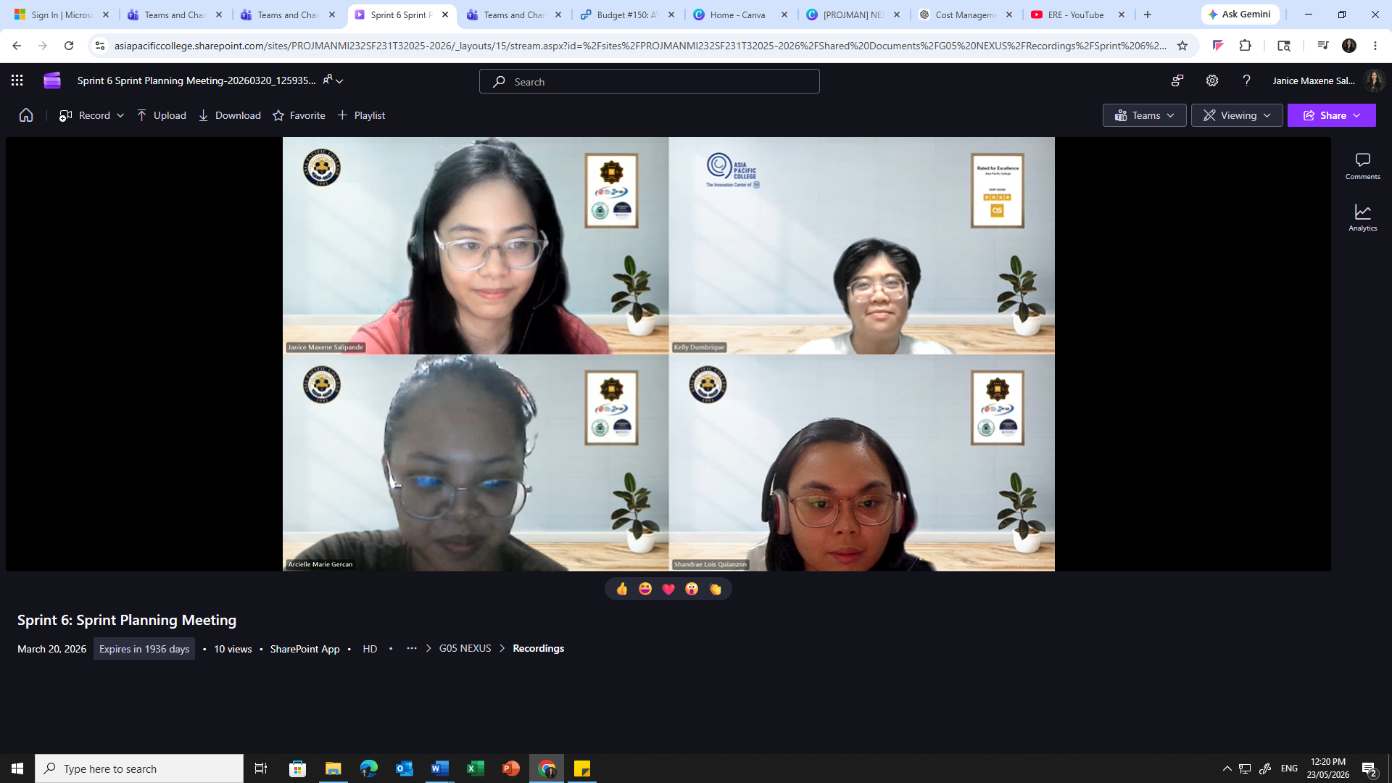
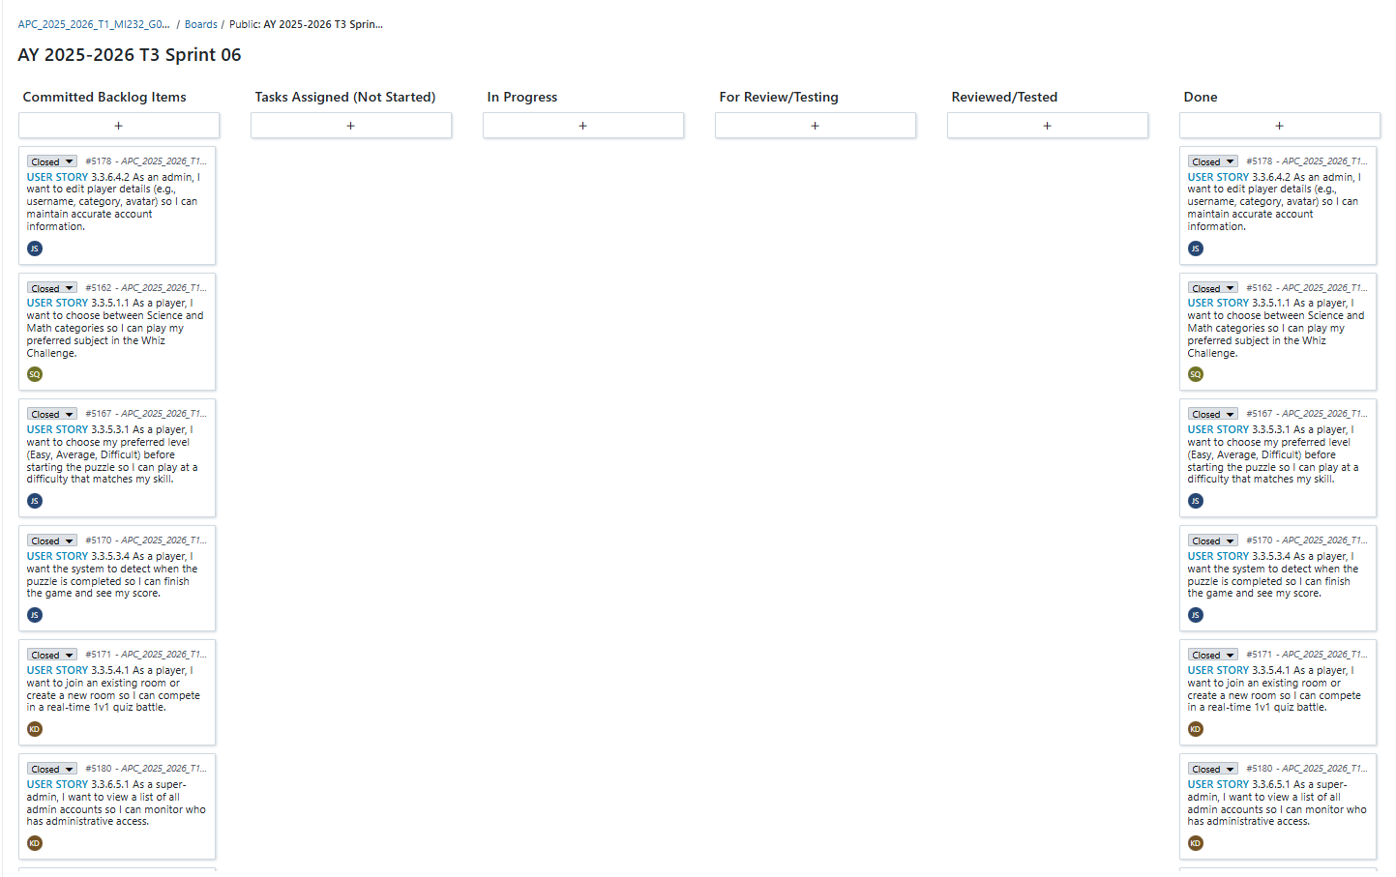

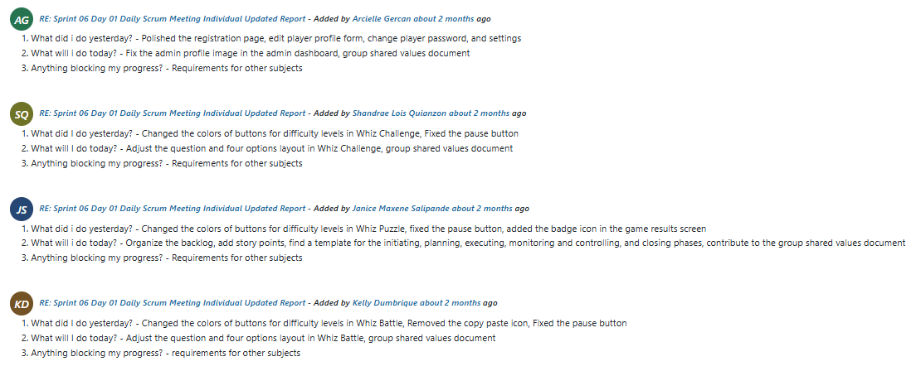
Sprint 6: Daily Standup meeting output (individual summaries)

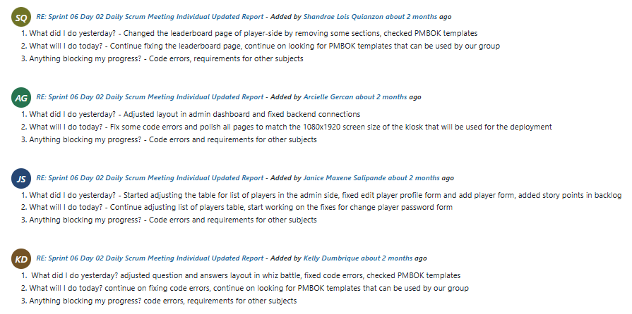
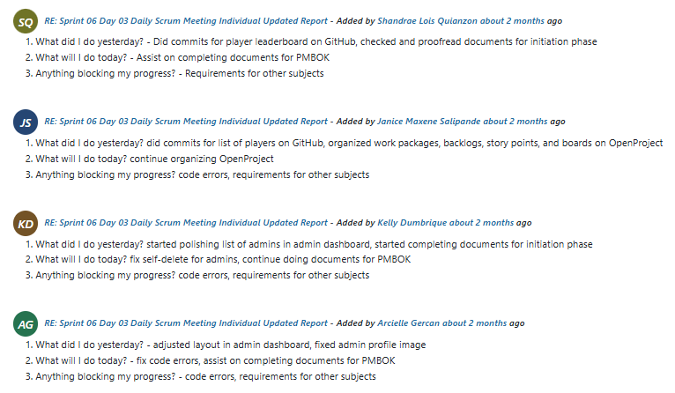
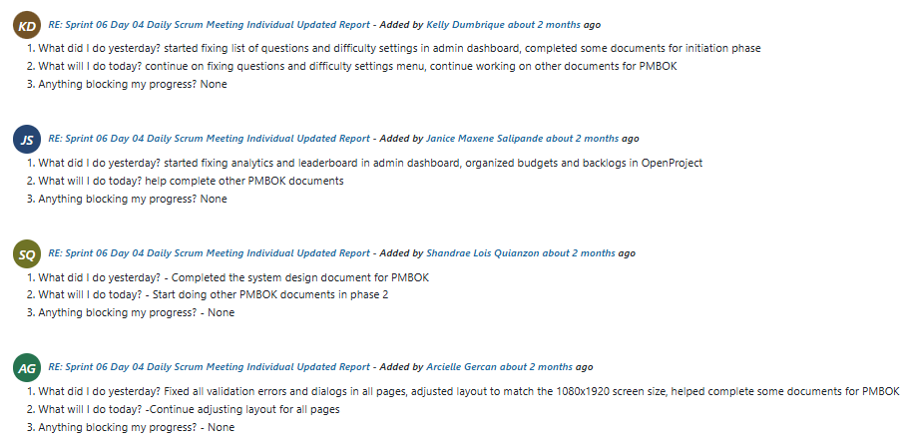
Sprint 6: Backlog refinement meeting output
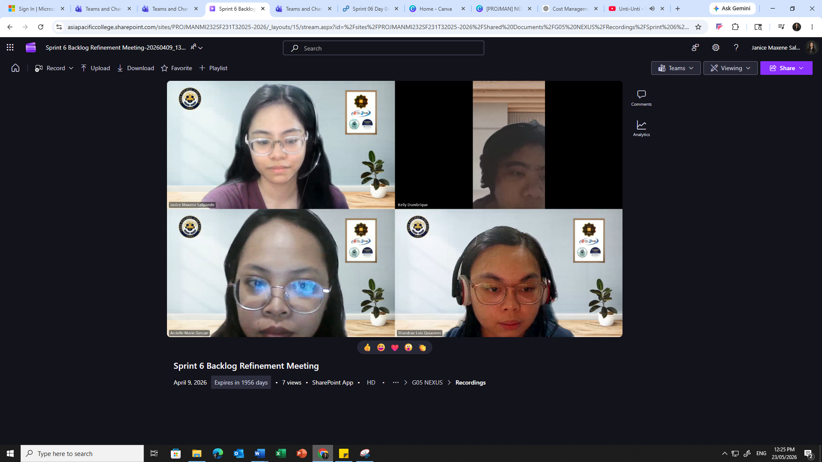
Sprint 6: Sprint Review meeting output
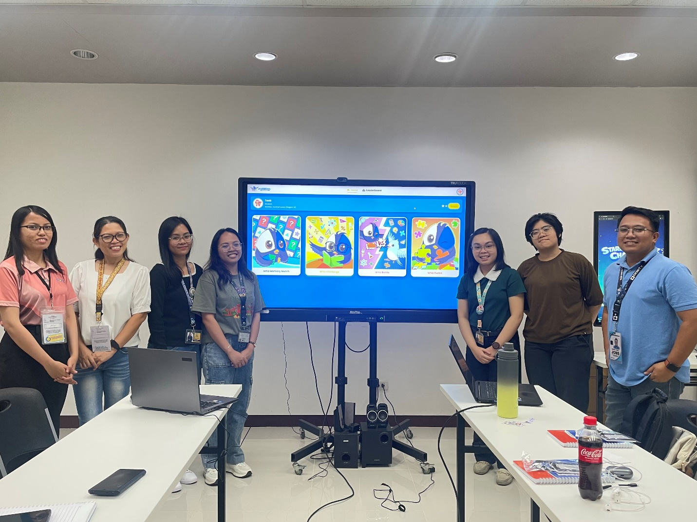

Sprint 6: Sprint Retrospective meeting output
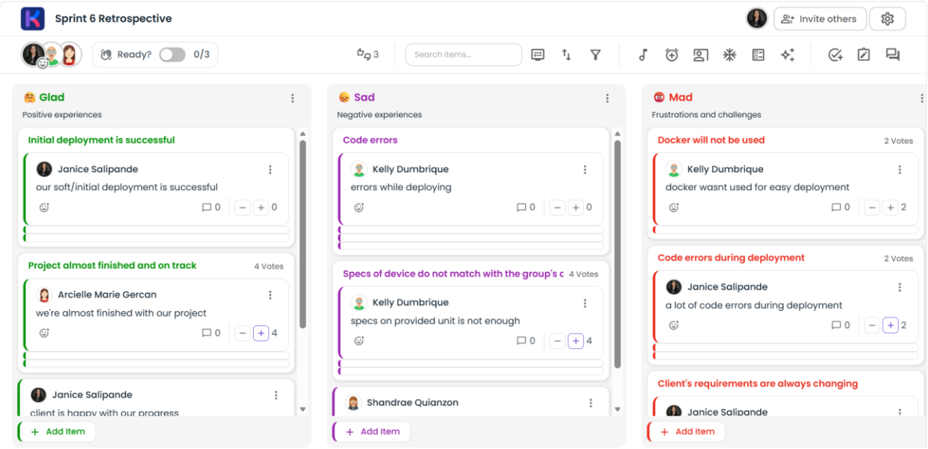
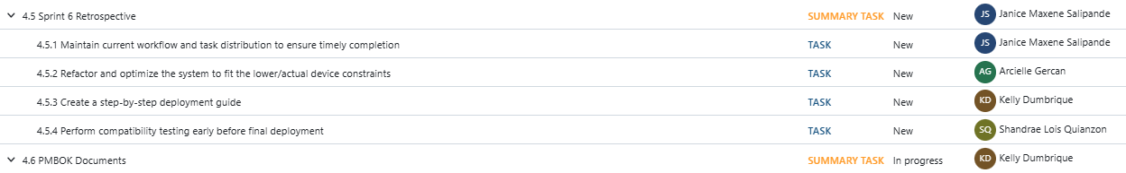

Sprint 7 Ceremonies
Sprint 7: Sprint Planning meeting output
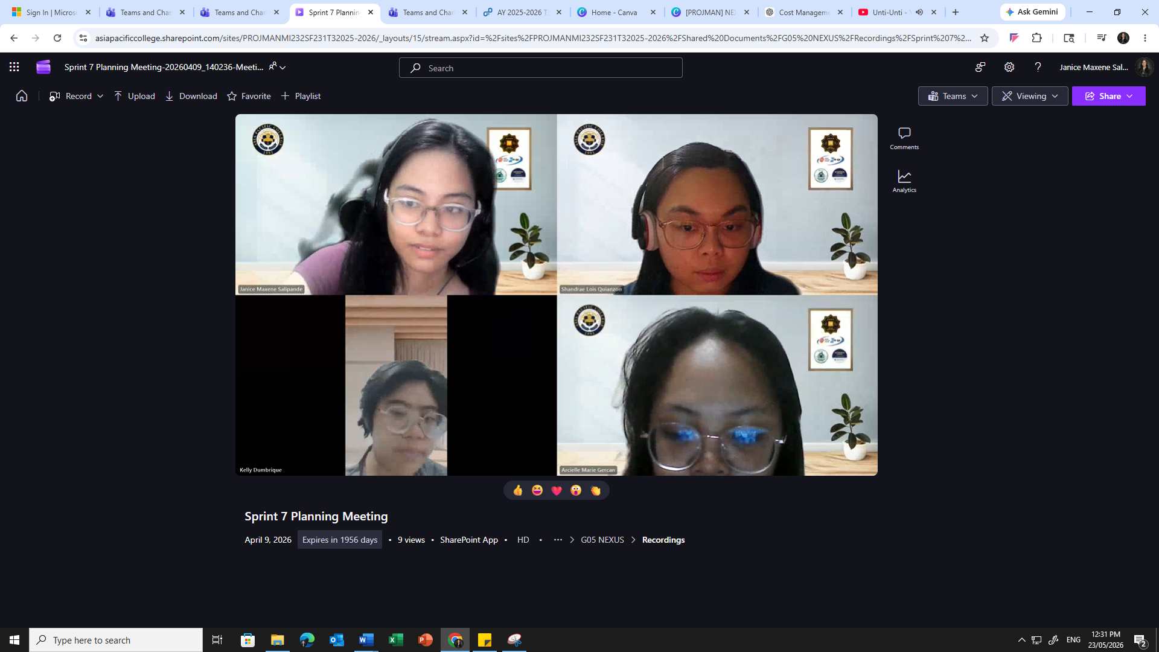
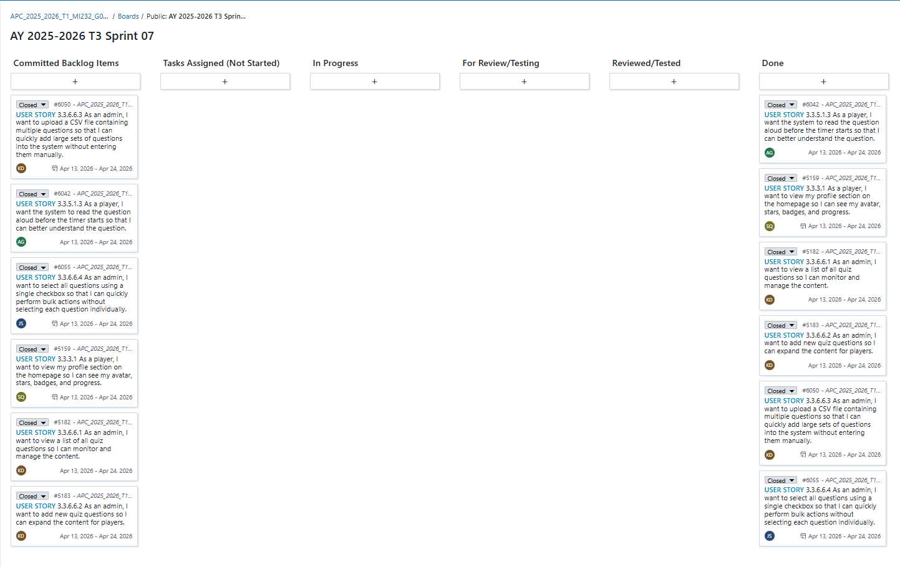

Sprint 7: Daily Standup meeting output (individual summaries)
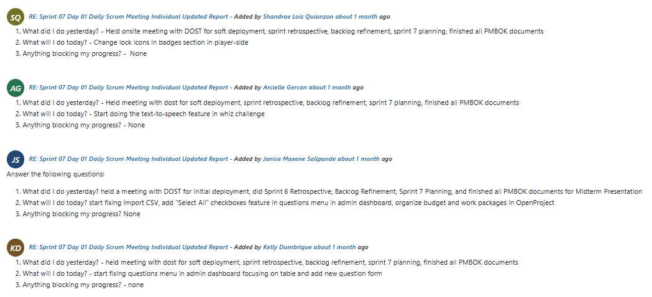
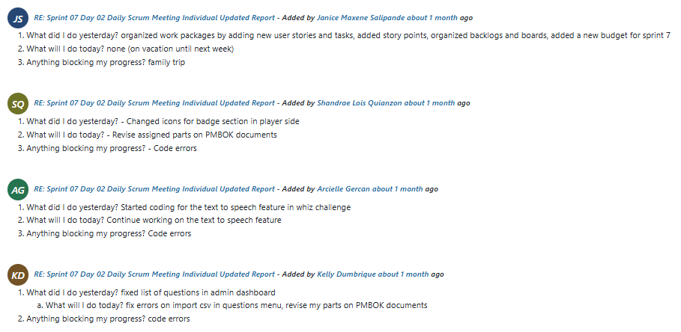
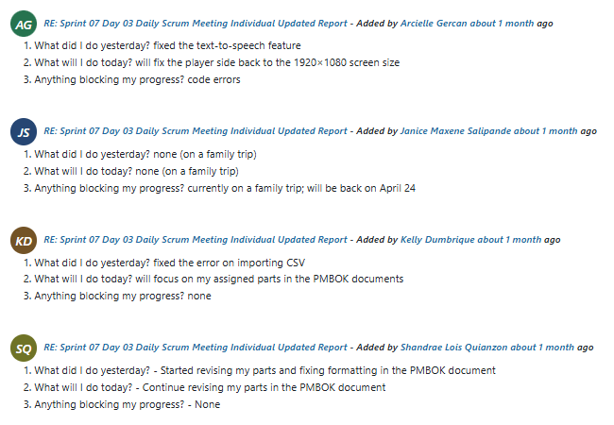
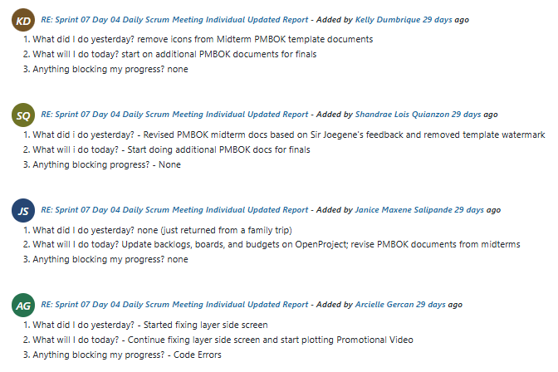

Sprint 7: Backlog refinement meeting output
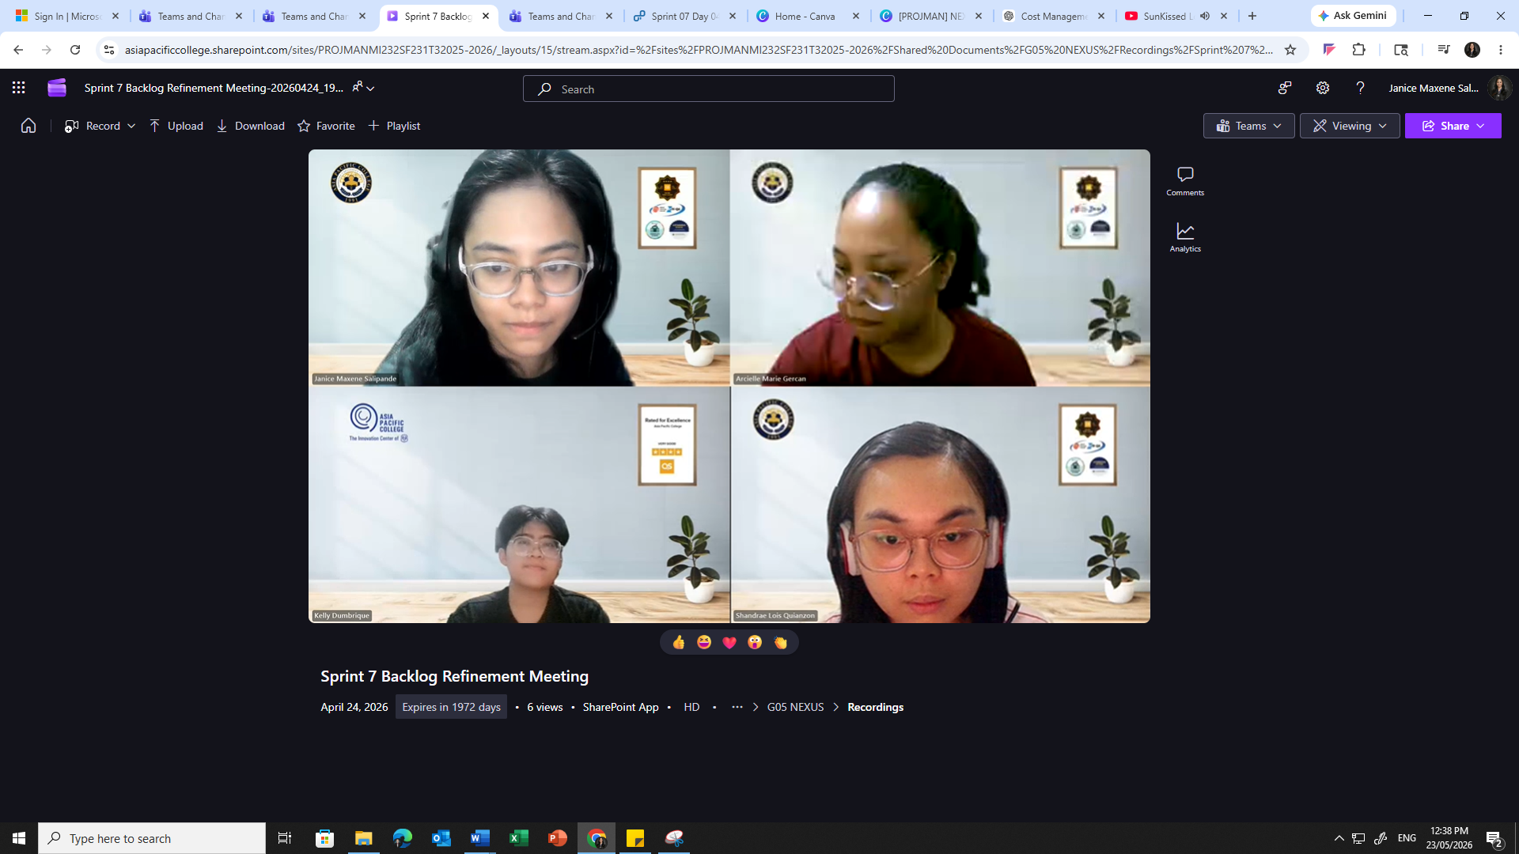
Sprint 7: Sprint Review meeting output
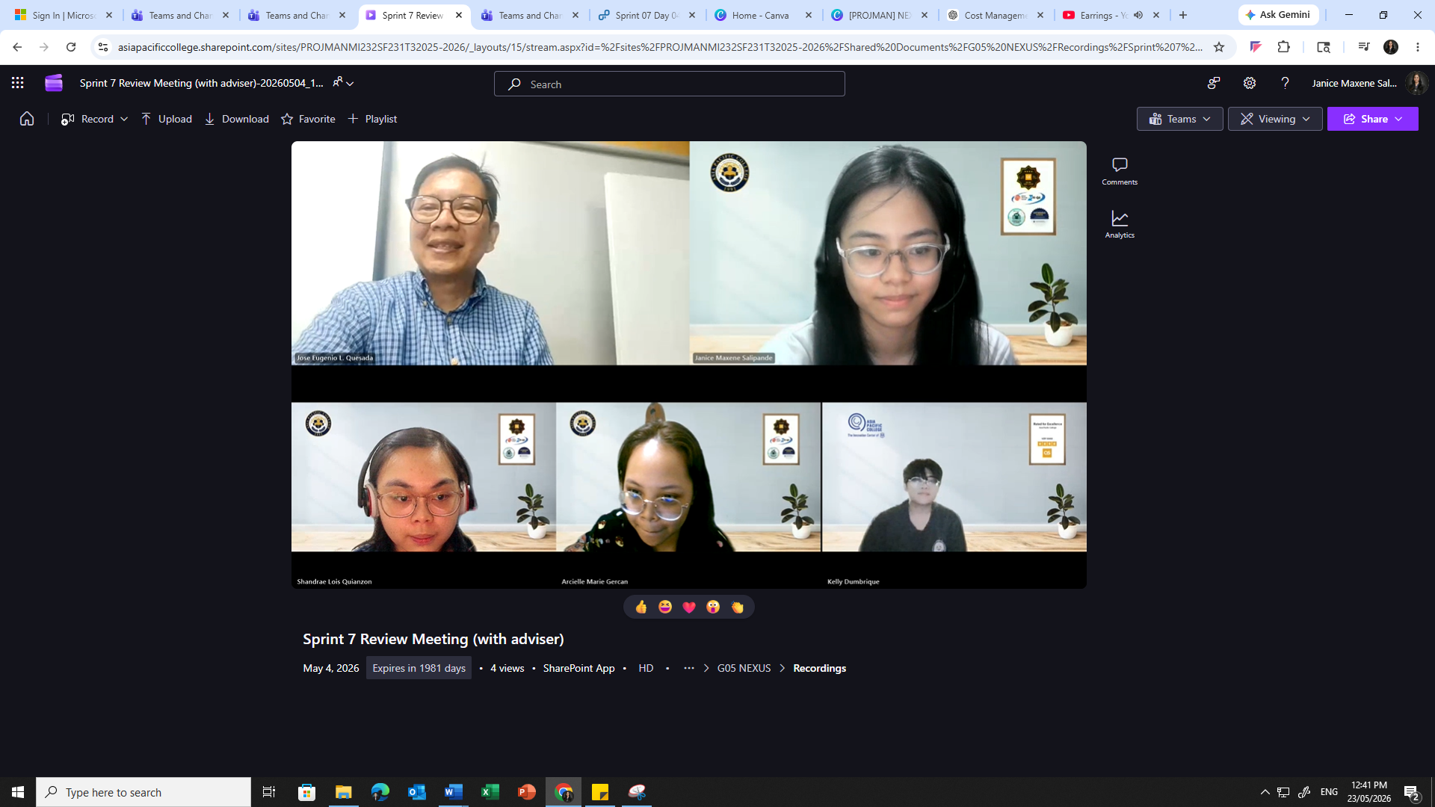

Sprint 7: Sprint Retrospective meeting output
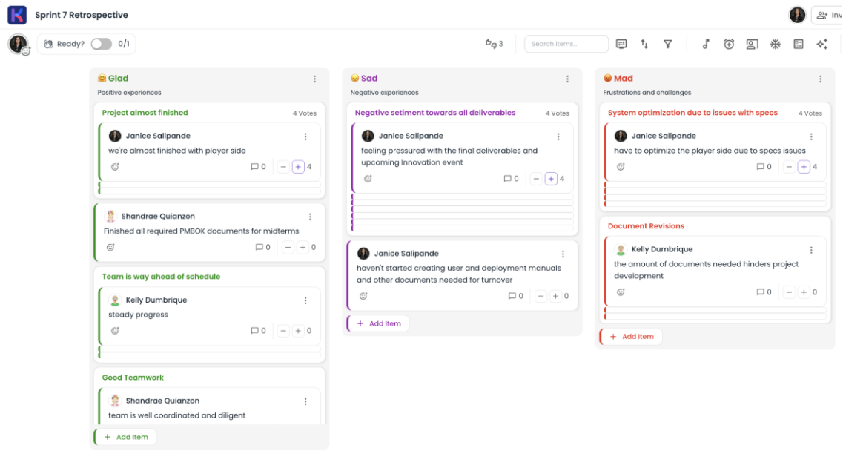
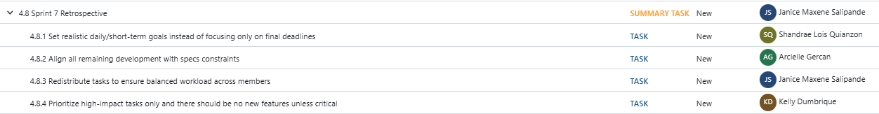

Sprint 8 Ceremonies
Sprint 8: Sprint Planning meeting output
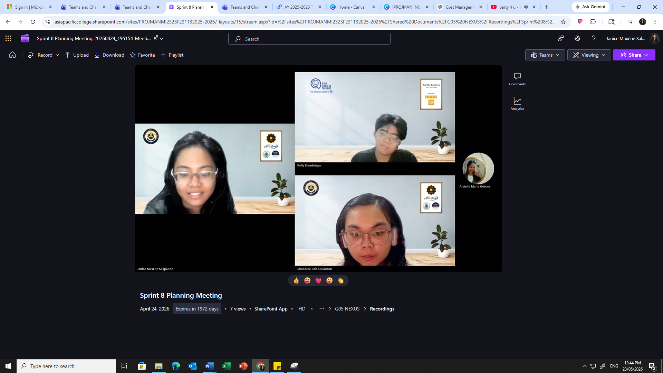
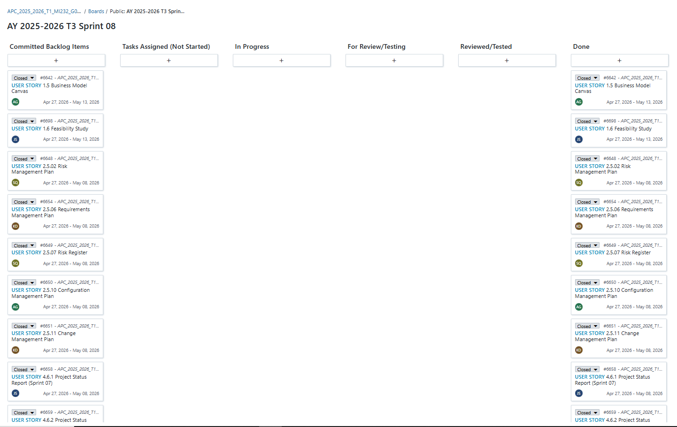

Sprint 8: Daily Standup meeting output (individual summaries)
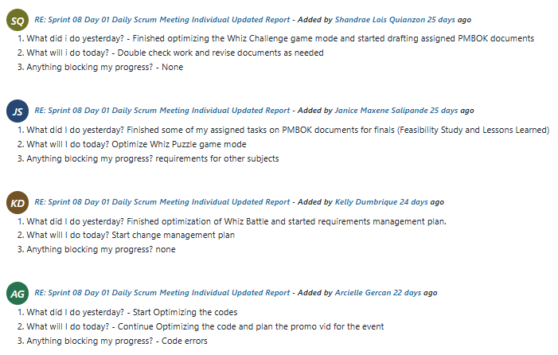
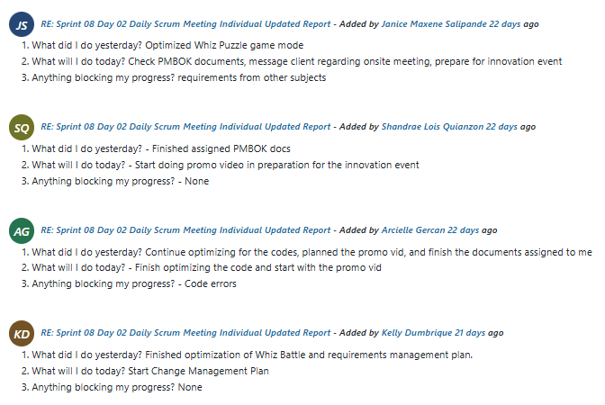
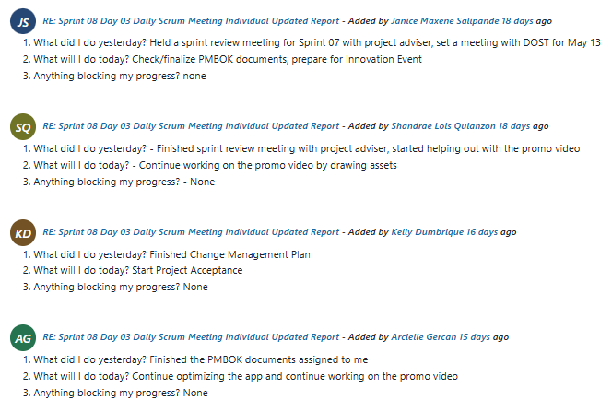
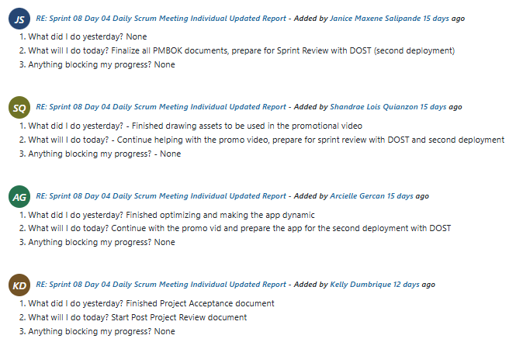
Sprint 8: Sprint Review meeting output
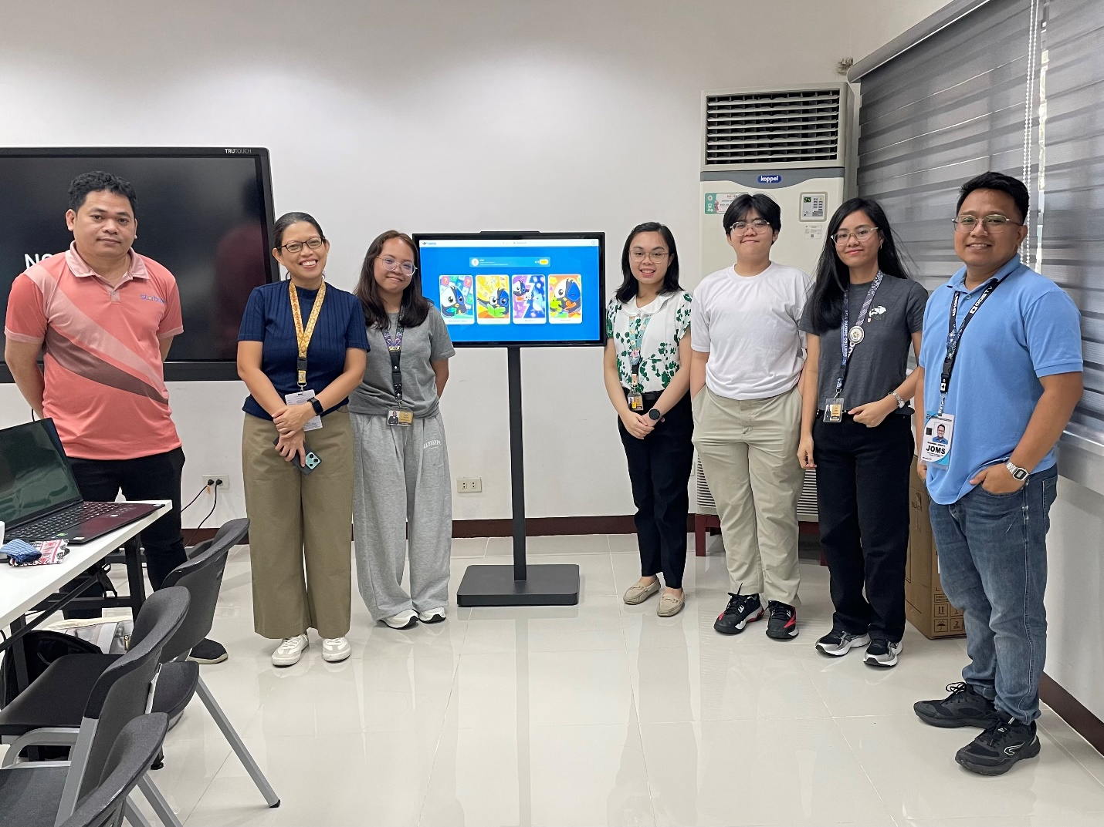

Sprint 8: Sprint Retrospective meeting output
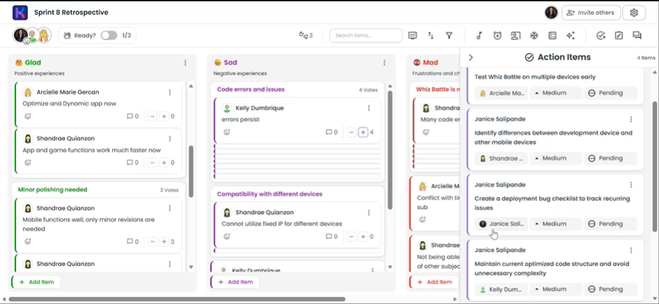
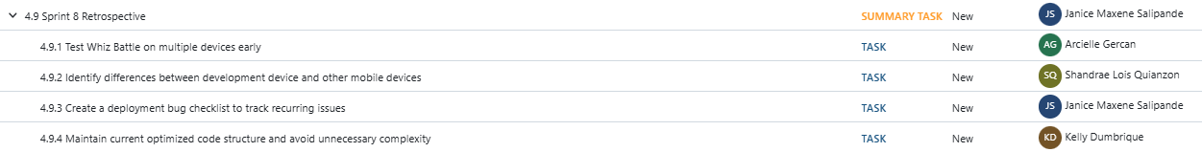

04 MONITORING AND CONTROLLING

Project Status Report for Sprint 6
Duration: March 23, 2026 – April 3, 2026
Percent Complete: 90-95%
Area | Status | Remarks
Scope |  | All tasks aligned with planned UI/UX refinements and system improvements
Schedule |  | Sprint tasks were mostly completed on time
Risks |  | Minor risks due to ongoing admin-side adjustments and system consistency issues
Quality |  | Significant improvements in UI consistency, usability, and responsiveness
This sprint focused on refining the user interface, improving gameplay layout consistency, and aligning both player-side and admin-side functionalities. Most tasks were completed successfully, particularly across all game modes. Minor delays are present in some admin-side features (e.g., Players and Admins menu adjustments), but these are expected to be resolved in the next sprint. Overall, the project remains on track with no major blockers.
WORK PLANNED FOR LAST SPRINT
- Fix admin profile image functionality
- Improve Players menu (table layout, forms, password handling)
- Implement admin management restrictions (prevent self-delete, ensure at least one admin remains)
- Refine Questions menu (table alignment, CSV import validation, add image support)
- Adjust Difficulty settings (correct color coding)
- Fix and make Analytics dashboard fully dynamic
- Fix and standardize Leaderboard module
- Align UI labels and terminology across admin forms
WORK COMPLETED THIS SPRINT
General UI & System Improvements
- Added DOST-STII logo to splash screen
- Standardized terminology (e.g., “Select Avatar”, “Current Password”) across system
- Implemented session persistence (refresh does not return to splash screen except during games)
- Added Edit Profile access in Settings
Game Mode Enhancements
- Whiz Challenge
  - Improved layout spacing and readability
  - Adjusted timer, question, and answer positioning
  - Implemented responsive question container
  - Standardized difficulty color coding
  - Integrated music control within pause dialog
- Whiz Memory Match & Whiz Puzzle
  - Added centralized music control within pause dialog
  - Fixed missing badge icon in results screen (Puzzle)
  - Standardized difficulty color coding (Puzzle)
- Whiz Battle
  - Removed unnecessary copy-paste icon (kiosk context)
  - Added music control (since no pause menu)
  - Improved layout consistency with Whiz Challenge
  - Added answer selection feedback indicator
  - Improved spacing and readability
Leaderboard Updates
- Redesigned leaderboard structure to match admin data
- Removed per-game rankings; unified into total badges and stars
- Updated sections: Stars, Badges, Memory Match, Puzzle
- Fixed UI alignment issues
Admin Panel Improvements
- Fixed admin profile image update issue
- Updated naming consistency across forms
- Implemented restrictions:
  - Prevent deleting last admin
  - Prevent self-deletion
WORK PLANNED FOR NEXT SPRINT
- Enhance badge display system:
  - Replace lock icons with grayscale badge icons for unearned badges (player side and admin “View Badges”)
- Implement Text-to-Speech (TTS) feature for Whiz Challenge:
  - System reads the question before the timer starts
  - TTS is independent from background music (mute only affects music)
  - Not applied to Whiz Battle
- Continue refinement of Questions menu (Admin Panel):
  - Adjust table layout and column alignment
  - Remove unnecessary status column
  - Improve CSV import validation (duplicates, empty cells, incomplete entries)
  - Add image upload support for question and answer choices (if not yet fully completed)
- Implement bulk selection feature:
  - Add select/select-all checkboxes for batch actions in Questions menu
- Continue admin panel polishing and consistency fixes

OPEN ISSUES
Issue | Status | Action
Players table layout uneven spacing | In Progress | UI adjustment ongoing
Admin self-delete restriction logic | In Progress | Backend validation being implemented
Password form consistency (admin side) | In Progress | Aligning with player-side implementation

OPEN RISKS
Risk | Likelihood | Impact | Mitigation
Remaining admin inconsistencies | Medium | Medium | Prioritize admin module completion next sprint
Time constraints for final testing | High | High | Allocate dedicated testing phase in next sprint
UI issues on actual kiosk device | Medium | High | Conduct early kiosk-based testing

DELIVERABLES AND MILESTONES
Milestone | Planned | Forecasted | Actual | Status
UI/UX Standardization | This Sprint | This Sprint | Completed | Completed
Game Mode Enhancements | This Sprint | This Sprint | Completed | Completed
Admin Panel Fixes | This Sprint | Next Sprint | - | In Progress

OPEN CHANGE REQUESTS
Change | Status
Standardize difficulty color coding across all game modes | Completed
Modify leaderboard structure (remove per-game rankings) | Completed
Adjust UI layout for kiosk usability | Completed
Admin restrictions (delete/self-delete rules) | In Progress

KEY PERFORMANCE INDICATORS (KPI'S)
Schedule Performance – Project is On Schedule
- Total Tasks Planned: ~45
- Completed Tasks: Majority (over 90%)
- In Progress Tasks: 4–5 remaining admin-related tasks
Schedule Completion Rate
Schedule Completion = Completed Tasks / Total Planned Tasks ≈ 90%-95%
Interpretation:
The project is currently on schedule, with most sprint tasks completed within the planned timeframe. A small number of tasks, primarily related to admin panel refinements, are still in progress but are not critical blockers and are expected to be completed in the next sprint.
Cost Performance – Project is Under Budget
- Planned Budget: PHP 100,000.00
- Actual Cost (Spent): PHP 46,500.00
- Remaining Budget: PHP 53,500.00
- Percent Spent: 47%
Cost Variance (CV)
CV = Planned - Actual = 100,000 - 46,500 = PHP 53,500
Interpretation:
The project is currently under budget, with a positive cost variance of PHP 53,500. This indicates that expenses are being managed efficiently, and available resources are sufficient for upcoming development phases.
Cost Performance Index (CPI)
CPI = Planned / Actual =100,000 / 46,500 ≈ 2.15
Interpretation:
A CPI greater than 1 indicates strong cost efficiency. A value of 2.15 means that for every peso spent, the project is gaining more value than expected, reflecting effective resource utilization.

Project Status Report for Sprint 7
Duration: April 13, 2026 – April 24, 2026
Percent Complete: 95-97%
Area | Status | Remarks
Scope |  | All planned UI/UX enhancements and admin refinements completed
Schedule |  | Sprint completed within planned duration
Risks |  | No major risks identified this sprint
Quality |  | Significant improvements in usability, accessibility, and system consistency
This sprint focused on completing remaining UI/UX enhancements and admin-side refinements, particularly improving accessibility, usability, and system interaction consistency. Key features such as badge visualization improvements, text-to-speech integration, and advanced admin question management tools were successfully implemented. The system is now more stable and closer to final production readiness, with no major blockers identified.

WORK PLANNED FOR LAST SPRINT
- Enhance badge display system:
  - Replace lock icons with grayscale badge icons for unearned badges (player side and admin “View Badges”)
- Implement Text-to-Speech (TTS) feature for Whiz Challenge:
  - System reads the question before the timer starts
  - TTS is independent from background music (mute only affects music)
  - Not applied to Whiz Battle
- Continue refinement of Questions menu (Admin Panel):
  - Adjust table layout and column alignment
  - Remove unnecessary status column
  - Improve CSV import validation (duplicates, empty cells, incomplete entries)
  - Add image upload support for question and answer choices (if not yet fully completed)
- Implement bulk selection feature:
  - Add select/select-all checkboxes for batch actions in Questions menu
- Continue admin panel polishing and consistency fixes

WORK COMPLETED THIS SPRINT
- Badge System Enhancement
  - Replaced lock icons with grayscale badge icons for unearned badges
  - Applied changes to both player-side and admin “View Badges” section
- Text-to-Speech (TTS) Feature
  - Implemented question reading before timer starts in Whiz Challenge
  - Ensured TTS operates independently from background music controls
  - Excluded TTS functionality from Whiz Battle (as specified)
- Admin Questions Menu Improvements
  - Improved table layout and column alignment
  - Removed unnecessary status column
  - Enhanced CSV import validation (duplicates, empty cells, incomplete data)
  - Added image upload support for question text and choices
- Bulk Selection Feature
  - Implemented select/select-all checkbox functionality
  - Enabled batch actions for question management

WORK PLANNED FOR NEXT SPRINT
Documentation Phase
- Business Model Canvas
- Feasibility Study
- Risk Management Plan
- Requirements Management Plan
- Risk Register
- Configuration Management Plan
- Change Management Plan
- Project Status Reports
- Transition Out Plan
- Project Acceptance Document
- Post Project Review
- Lessons Learned Document
System Optimization
- Player-side optimization and performance tuning
- Final UI/UX polishing for kiosk deployment readiness
OPEN ISSUES
None identified for this sprint

OPEN RISKS
No active risks currently identified
(System is in stable phase; remaining risks are low and related only to final documentation and optimization phase)

DELIVERABLES AND MILESTONES
Milestone | Planned | Forecasted | Actual | Status
Badge System Enhancement | This Sprint | This Sprint | Completed | Completed
TTS Feature Implementation | This Sprint | This Sprint | Completed | Completed
Admin Questions Menu Upgrade | This Sprint | This Sprint | Completed | Completed
Bulk Selection Feature | This Sprint | This Sprint | Completed | Completed

OPEN CHANGE REQUESTS
Change | Status
Badge grayscale redesign | Completed
Text-to-Speech integration | Completed
Admin question bulk selection feature | Completed
CSV validation improvements | Completed

KEY PERFORMANCE INDICATORS (KPI'S)
Schedule Performance – Project is On Schedule
- Total Tasks Planned: ~50+ cumulative system tasks
- Completed Tasks: Majority (>95%)
- In Progress Tasks: Minimal / none critical
Schedule Completion Rate: ≈ 95% – 97%
Interpretation:
The project remains on schedule with all Sprint 07 deliverables completed successfully. The system is now transitioning from feature development to documentation and final optimization phase.
Cost Performance – Project is Under Budget
- Planned Budget: PHP 100,000.00
- Actual Cost (Spent): PHP 32,500.00
- Remaining Budget: PHP 67,500.00
- Percent Spent: 32.5%
Cost Variance (CV): PHP 67,500.00
Cost Performance Index (CPI): ≈ 3.08
Interpretation:
The project remains significantly under budget, indicating highly efficient resource utilization and minimal operational cost due to the use of free development tools and institutional support from DOST-STII.

Project Status Report for Sprint 8
Duration: April 27, 2026 – May 8, 2026
Percent Complete: 100%
Area | Status | Remarks
Scope |  | All planned Sprint 08 deliverables successfully completed
Schedule |  | Sprint completed within planned timeframe
Risks |  | No major risks or blockers encountered
Quality |  | Documentation and system optimization completed successfully
This sprint focused on completing the project’s documentation requirements and performing final player-side optimizations in preparation for deployment and turnover. All planned deliverables were completed successfully, including project management documents, system planning documents, and optimization tasks.

WORK PLANNED FOR LAST SPRINT
- Badge System Enhancement
  - Replaced lock icons with grayscale badge icons for unearned badges
  - Applied changes to both player-side and admin “View Badges” section
- Text-to-Speech (TTS) Feature
  - Implemented question reading before timer starts in Whiz Challenge
  - Ensured TTS operates independently from background music controls
  - Excluded TTS functionality from Whiz Battle (as specified)
- Admin Questions Menu Improvements
  - Improved table layout and column alignment
  - Removed unnecessary status column
  - Enhanced CSV import validation (duplicates, empty cells, incomplete data)
  - Added image upload support for question text and choices
- Bulk Selection Feature
  - Implemented select/select-all checkbox functionality
  - Enabled batch actions for question management

WORK COMPLETED THIS SPRINT
Documentation Phase
- Business Model Canvas
- Feasibility Study
- Risk Management Plan
- Requirements Management Plan
- Risk Register
- Configuration Management Plan
- Change Management Plan
- Project Status Reports
- Transition Out Plan
- Project Acceptance Document
- Post Project Review
- Lessons Learned Document
System Optimization
- Player-side optimization and performance tuning
- Final UI/UX polishing for kiosk deployment readiness

WORK PLANNED FOR NEXT SPRINT
- Final admin-side refinements and validation
- Conduct final integration testing
- Deploy system in target kiosk environment
- Finalize remaining technical documentation and user guides

OPEN ISSUES
None identified for this sprint

OPEN RISKS
Risk | Likelihood | Impact | Mitigation
Minor deployment environment inconsistencies | Low | Medium | Conduct final kiosk-based deployment testing
Final integration issues during packaging | Low | Medium | Perform final system validation before deployment

DELIVERABLES AND MILESTONES
Milestone | Planned | Forecasted | Actual | Status
Documentation Completion | This Sprint | This Sprint | Completed | Completed
Player-Side Optimization | This Sprint | This Sprint | Completed | Completed
Final System Validation | This Sprint | This Sprint | Completed | Completed

OPEN CHANGE REQUESTS
Change | Status
Final documentation revisions | Completed
Player-side optimization adjustments | Completed
UI/UX consistency refinements | Completed

KEY PERFORMANCE INDICATORS (KPI'S)
Schedule Performance – Project is On Schedule
- Total Tasks Planned: Majority of remaining documentation and optimization tasks
- Completed Tasks: 100%
- In Progress Tasks: None
Schedule Completion Rate
Schedule Completion ≈ 100%
Interpretation:
All planned Sprint 08 deliverables were completed within the scheduled timeframe. The project is now transitioning into the final deployment and turnover phase.
Cost Performance – Project is Significantly Under Budget
- Planned Budget: PHP 100,000.00
- Actual Cost (Spent): PHP 13,000.00
- Remaining Budget: PHP 87,000.00
- Percent Spent: 13%
Cost Variance (CV)
CV = 100,000 - 13,000 = PHP 87,000
Cost Performance Index (CPI)
CPI = 100,000 / 13,000 ≈ 7.69
Interpretation:
The project remains significantly under budget due to the use of free development tools, local deployment infrastructure, and efficient resource utilization. Available resources remain sufficient for final deployment and turnover activities.

05 CLOSING

Transition Out Plan
EXECUTIVE SUMMARY
This Transition Out Plan formally documents the process for the handover of the STARBOOKS Whiz Challenge system including all source code, documentation, data, and operational knowledge from NEXUS (development team) to the Department of Science and Technology – Science and Technology Information Institute (DOST-STII). It describes the approach, team responsibilities, knowledge transfer activities, property transition, and acceptance process required to complete the project's formal closure.
The STARBOOKS Whiz Challenge is a ground-up redevelopment of the existing DOST-STII Whiz Challenge application, built as a gamified, offline-first educational platform for STEM learning. The system features four interactive game modes (Whiz Challenge, Whiz Memory Match, Whiz Puzzle, and Whiz Battle), a badge and reward system, a player leaderboard, and a fully featured administrative dashboard. It was developed by NEXUS under the guidance of Faculty Adviser Sir Jose Eugenio Quesada and in partnership with DOST-STII, represented by Ms. Marievic V. Narquita (STARBOOKS Unit Head) and Mr. McGyver C. Basaya (STARBOOKS Lead Programmer), from project initiation in April 2025 through the targeted deployment date of October 2026.
Upon completion of all transition activities, full ownership of the STARBOOKS Whiz Challenge system — including all intellectual property, source code, database, documentation, and deployment assets — will transfer to DOST-STII.
TRANSITION APPROACH
The overall approach to this transition prioritizes knowledge continuity, documentation completeness, and DOST-STII's operational independence after handover. The goal is to ensure that DOST-STII technical staff can independently deploy, operate, manage, and maintain the STARBOOKS Whiz Challenge system at DOST events without requiring any further involvement from the development team.
The team will maintain its full four-member composition throughout the transition period. No additional staffing is required. All four team members will remain actively available to support knowledge transfer activities, answer technical queries, resolve outstanding issues identified during User Acceptance Testing (UAT), and finalize all documentation deliverables. Active development work will wind down during the transition period, with effort redirected toward documentation, training preparation, deployment rehearsal, and UAT support.
The following assumptions underpin this transition plan:
- DOST-STII will designate a technical point of contact — Mr. McGyver C. Basaya (STARBOOKS Lead Programmer) — to participate in all technical knowledge transfer sessions and receive the deployment package.
- DOST-STII will make the necessary hardware available for the end-to-end deployment rehearsal before the final handover date.
- DOST-STII will provide adequate physical workspace and network access for the team members during on-site knowledge transfer sessions.
- All UAT feedback received during the transition period will be limited to defect corrections and minor adjustments within the approved WBS scope. New feature requests will be formally declined or documented as post-handover enhancement opportunities for DOST-STII.
- The Project Adviser will be available for the final review meeting during the transition period.
TRANSITION TEAM ORGANIZATION
The following table defines all roles and responsibilities for the 30-day transition period. The transition team is composed of members from the development team and DOST-STII, with the Faculty Adviser serving as an independent quality reviewer.
Organization | Name / Role | Title | Responsibilities
DOST-STII | Ms. Marievic V. Narquita | Project Sponsor / STARBOOKS Unit Head | Provide formal acceptance of all transition deliverables; sign the project turnover record; ensure DOST-STII internal resources and workspace are available throughout the transition period
DOST-STII | Mr. McGyver C. Basaya | STARBOOKS Lead Programmer / Technical Transition Lead | Attend all technical knowledge transfer sessions; receive and validate the deployment package; confirm system operability on DOST kiosk hardware; serve as the primary technical point of contact post-handover
DOST-STII | STARBOOKS Unit Staff | End Users | Participate in user acceptance testing; validate player-side and admin-side functionality against operational requirements; provide formal UAT sign-off
APC-SoCIT | Kelly Dumbrique | Project Manager / Product Owner / Transition Lead | Coordinate and schedule all transition activities; provide weekly transition progress reports to DOST-STII and Faculty Adviser; ensure all deliverables are complete before handover; obtain all required signatures on closure documents
APC-SoCIT | Arcielle Marie Gercan | Lead Developer / Backend Transition Lead | Lead all technical knowledge transfer sessions on system architecture, MongoDB administration, and API structure; deliver and validate the deployment package on DOST hardware
APC-SoCIT | Shandrae Lois Quianzon | Frontend Developer | Support knowledge transfer on player-side Flutter application features; assist with UAT defect resolution on game modes and player interface
APC-SoCIT | Janice Maxene Salipande | Frontend Developer / Documentation Lead | Finalize and deliver all documentation including SRS, System Design Document, User Manual, Setup and Deployment Instructions, and archived project records; ensure all documents are uploaded to SharePoint
APC-SoCIT | Sir Jose Eugenio Quesada | Faculty Adviser | Attend the final project review meeting; verify completeness of academic deliverables; provide independent endorsement of project closure

WORKFORCE TRANSITION
All team members will remain engaged and available for the transition period. No team member will disengage from the project until the transition has been formally accepted and signed off by DOST-STII and the Faculty Adviser. After the formal acceptance of the transition, all four team members will conclude their involvement with the project, with no ongoing obligations to DOST-STII for system maintenance or technical support beyond what is documented in the User Manual and deployment instructions.
Post-handover, full operational responsibility for the STARBOOKS Whiz Challenge passes entirely to DOST-STII. Mr. McGyver C. Basaya (STARBOOKS Lead Programmer) will serve as the system's primary technical owner, supported by the comprehensive documentation package delivered by the NEXUS team. DOST-STII management is expected to allocate appropriate staff time and budget for routine system maintenance, content updates, and event deployments, as documented in the system's operational assumptions in the SRS.
WORK EXECUTION DURING TRANSITION
Throughout the transition period, the remaining project work will continue to be executed by the team in accordance with the approved project schedule and WBS. The primary work activities during this period are:
- User Acceptance Testing (UAT): DOST-STII staff will conduct structured testing of all system functions against the test cases defined. The NEXUS team will triage and resolve any defects identified within the UAT period, prioritizing critical and high-severity issues.
- End-to-End Deployment Rehearsal: Arcielle Marie Gercan will lead the full deployment rehearsal on DOST-STII's actual kiosk hardware using the deployment package. This rehearsal validates the complete LAN setup, server configuration, database initialization, and client browser access.
- Documentation Finalization: Janice Maxene Salipande will complete and deliver all remaining documentation: the Software Requirements Specification, System Design Document, User Manual, Deployment and Setup Instructions, and archived project records. All documents will be uploaded to SharePoint and physically delivered to DOST-STII in the handover package.
- Knowledge Transfer Sessions: Technical and operational training sessions will be conducted by the NEXUS team for DOST-STII staff.
The NEXUS team retains full responsibility for all tasks and deliverables throughout the transition period. DOST-STII staff participating in UAT and knowledge transfer activities are acting as recipients and testers, not as owners of the work. Full operational responsibility transfers only upon formal acceptance at the end of the transition period.
SUBCONTRACTS
The STARBOOKS Whiz Challenge project does not involve any subcontract agreements with third-party vendors or service providers. All development work was performed entirely by the four members of team NEXUS using free and open-source technologies (Flutter/Dart, Laravel, MongoDB, Laragon). No external subcontractors were engaged for any component of the system, and no third-party software maintenance contracts, licensing agreements, or service agreements are in place that would require transition actions.
The only external dependency relevant to the transition is the continued availability of the open-source frameworks and tools used in development (Flutter, Laravel, MongoDB, Laragon). These are all maintained by their respective open-source communities and carry no licensing costs or contract obligations that would affect DOST-STII's post-handover operations.
PROPERTY TRANSITION
Government Furnished Equipment (GFE)
DOST-STII provided no Government Furnished Equipment (GFE) to NEXUS during the course of the project. All development work was performed on personally owned laptops and workstations belonging to the four team members, using DOST-STII's office space and internet access during scheduled meetings and sprint reviews only. No DOST-STII hardware, portable electronic devices, or identification credentials were issued to any of the team members and therefore no GFE return process is required.
Upon deployment, all system components including the server PC, client PCs, LAN router, and network equipment, will be provided and owned by DOST-STII, as specified in the SRS hardware section. NEXUS has no ownership claim over any DOST-STII hardware used during deployment or events.
Incumbent Owned Equipment
All personally owned equipment used by NEXUS including development laptops, personal portable devices, and development environment configurations, will remain with the respective team members upon project closure. None of the team's personally owned equipment is required for the ongoing operation of the STARBOOKS Whiz Challenge system; the deployed system is fully self-contained on DOST-STII's kiosk hardware.
The complete deployment package including the application source code, database seed files, and all configuration files, will be delivered to DOST-STII as part of the handover package, ensuring that DOST-STII can independently redeploy or restore the system without any dependency on the team’s equipment.
Intellectual Property
Per the project agreement between NEXUS and DOST-STII, all intellectual property produced as a direct result of the STARBOOKS Whiz Challenge project will be transferred to DOST-STII upon formal project acceptance. This includes:
- All application source code (Flutter/Dart frontend, Laravel backend, WebSocket server, MongoDB schema)
- All system documentation (SRS, System Design Document, User Manual, Deployment Instructions, Test Cases)
- All UML diagrams, data flow diagrams, entity relationship diagrams, and deployment diagrams
- All game assets created for the project
- All project management documentation (WBS, management plans, sprint records, meeting minutes)
DOST-STII will have full ownership rights to modify, extend, deploy, and maintain all transferred intellectual property. NEXUS retains no licensing rights or intellectual property claims over any project deliverable after formal acceptance. Any of the team members who continue to work on DOST-STII projects in future academic terms will do so under a new, separate project agreement.
User Accounts and Passwords
The following table documents all system accounts and access credentials that must be transferred or disabled as part of the project handover. All NEXUS team member accounts on DOST-STII systems will be disabled or removed upon completion of the transition. DOST-STII will create new administrator accounts for their own staff using the admin management interface provided in the system.
Account / System | Current Access Holder | Transition Action | New Owner
OpenProject Project Account | Kelly Dumbrique (Project Manager) | Export all project data to SharePoint; archive project in OpenProject; transfer account access to Faculty Adviser for academic record | SoCIT / Faculty Adviser
GitHub Repository | All NEXUS team members | Transfer repository ownership to DOST-STII GitHub account or deliver as a ZIP archive on physical media; revoke NEXUS team commit access after handover | DOST-STII (Mr. McGyver C. Basaya)
SharePoint Project Folder | All NEXUS team members | Deliver final document archive to DOST-STII; disable NEXUS team member access after confirmation of receipt | DOST-STII / Ms. Marievic V. Narquita
System Admin Account (STARBOOKS Whiz Challenge) | Arcielle Marie Gercan (created during development) | Reset admin credentials; create new admin accounts for designated DOST-STII staff during knowledge transfer; disable all NEXUS-created admin accounts | DOST-STII (Mr. McGyver C. Basaya)
MongoDB Database Admin Access | Arcielle Marie Gercan (Lead Developer) | Deliver database admin credentials; document all database admin procedures in the Deployment Instructions | DOST-STII (Mr. McGyver C. Basaya)

KNOWLEDGE TRANSFER
Knowledge transfer is the most critical component of this transition, as it determines DOST-STII's ability to independently operate, maintain, and update the STARBOOKS Whiz Challenge system after the NEXUS team disengages.
Session 1 — System Architecture and Deployment (Week 1) Led by Arcielle Marie Gercan (Lead Developer). This session covers the complete system architecture including the Docker-based deployment stack, LAN network configuration, MongoDB database setup, Laravel backend API structure, and WebSocket server operation. DOST-STII's technical lead (Mr. McGyver C. Basaya) is the primary audience. The session will include a hands-on deployment rehearsal on DOST kiosk hardware, walking through the full deployment procedure step by step against the written Deployment Instructions. Duration: half-day session.
Session 2 — Admin Dashboard Operations (Week 1) Led by Kelly Dumbrique (Project Manager) and Shandrae Lois Quianzon (Frontend Developer). This session covers all administrative dashboard functions: admin account management, player management, quiz content management, difficulty settings configuration, reward claim processing, leaderboard management, and analytics export. This session is targeted at DOST-STII administrative staff and the STARBOOKS Unit Lead. Duration: two-hour session with hands-on walkthrough.
Session 3 — Database Administration and Backup Procedures (Week 2) Led by Arcielle Marie Gercan (Lead Developer). This session covers MongoDB database administration including backup procedures, data restoration, basic query operations, and error recovery. This is a critical knowledge transfer given Risk R06 (MongoDB data loss) in the Risk Register. DOST-STII staff will practice the backup and restoration procedure independently before the session concludes. Duration: two-hour session.
Session 4 — Documentation Walkthrough and Q&A (Week 2) Led by Janice Maxene Salipande (Documentation Lead). This session walks through all delivered documentation — the SRS, System Design Document, User Manual, and Deployment Instructions — ensuring DOST-STII staff can locate relevant information independently. All outstanding documentation questions will be addressed. Any gaps identified during this session will be corrected before the final handover date. Duration: one-hour session.
Ongoing Support (Weeks 1–3) In addition to the formal sessions above, all NEXUS team members will be available via Viber throughout the transition period to respond to technical queries, assist with UAT defect resolution, and provide clarification on any documentation. Response to queries is expected within one working day during the transition period.
The Project Manager will convene a final transition readiness meeting with DOST-STII's technical lead and the Faculty Adviser no later than five days before the end of the transition period to confirm that all knowledge transfer activities have been completed adequately and that no further training is required before formal acceptance.
HANDOVER AND ACCEPTANCE
Formal acceptance of the project handover will be determined by DOST-STII, represented by Ms. Marievic V. Narquita (STARBOOKS Unit Head). The acceptance process will proceed as follows:
Step 1 — UAT Sign-Off: DOST-STII operational staff confirm that all functional and non-functional requirements defined in the SRS have been validated through User Acceptance Testing, and that no critical or high-severity defects remain unresolved. The UAT completion record is signed by Mr. McGyver C. Basaya (STARBOOKS Lead Programmer) on behalf of DOST-STII.
Step 2 — Documentation Completeness Check: Janice Maxene Salipande presents the complete documentation package to the DOST-STII technical lead. DOST-STII confirms receipt of all required documents: SRS, System Design Document, User Manual, Deployment and Setup Instructions, Test Cases, and the archived project management records. Missing or incomplete items must be resolved before proceeding to Step 3.
Step 3 — Knowledge Transfer Confirmation: The NEXUS Project Manager and DOST-STII technical lead confirm that all four knowledge transfer sessions have been completed and that DOST-STII staff can independently perform all required operational tasks — deployment, admin operations, database backup, and basic troubleshooting.
Step 4 — Account and Credentials Transfer: Kelly Dumbrique and Arcielle Marie Gercan confirm that all system accounts have been transitioned, all NEXUS team access has been revoked, and new DOST-STII admin accounts are operational.
Step 5 — Faculty Adviser Academic Review: Sir Jose Eugenio Quesada confirms that all academic deliverables are complete and meet the course requirements. This step runs in parallel with Steps 1–4.
Step 6 — Formal Sign-Off: Upon confirmation that all preceding steps are complete, the following parties will sign the Project Turnover Record, which constitutes the formal acceptance of the transition:
- Ms. Marievic V. Narquita — DOST-STII Project Sponsor
- Mr. McGyver C. Basaya — DOST-STII Technical Lead
- Kelly Dumbrique — NEXUS Project Manager
- Sir Jose Eugenio Quesada — Project Adviser
It is only after all four signatures are obtained that the transition will be considered formally complete and the project officially closed. The signed Project Turnover Record will be archived on SharePoint and submitted as part of the academic project closure documentation.

Project Acceptance
This document establishes formal acceptance of all the deliverables for the STARBOOKS Whiz Challenge project. The STARBOOKS Whiz Challenge project has met all the acceptance criteria as defined in the requirements document and project scope statement. A project audit has been performed to verify that all deliverables meet performance and product requirements. Additionally a product evaluation has been performed and determined that all products meet the quality and functional requirements defined within this project.
Transition to Operations has been completed. The live system has been handed over to Operations and the transfer of knowledge from the Project Team to Operations has also been completed. All training has concluded and the System Operations Guide has been handed over to Operations.
The Project Manager is authorized to continue with the formal close out of this project. The closeout process will include a post-project review, documentation of lessons learned, release of the Project Team, close out all procurements and archive all relevant project documents. Once the closing process is completed the Project Sponsor will be notified and the Project Manager will then be released from the project.

Post Project Review
PROJECT SUMMARY
The STARBOOKS Whiz Challenge Project has been successfully completed and transitioned for deployment within the STARBOOKS platform under the Department of Science and Technology – Science and Technology Information Institute (DOST-STII). This project represents a significant initiative in enhancing digital learning experiences by integrating gamification into educational content accessible through STARBOOKS kiosks.
The primary objective of this project was to design and develop an interactive, gamified learning system that increases student engagement and improves knowledge retention. The system aimed to transform traditional access to educational resources into a more dynamic and competitive experience through features such as Memory Match, Puzzle Games, Whiz Challenge quizzes, and 1v1 Battle modes. Additionally, the project sought to support data-driven insights through leaderboard tracking and basic analytics, enabling educators and stakeholders to monitor participation and performance.
The purpose of the STARBOOKS Whiz Challenge Project was to maximize the value of existing STARBOOKS infrastructure by introducing an engaging, student-centered application without requiring additional financial investment. By leveraging open-source tools, student-led development, and existing kiosk systems, the project maintained a zero-cost implementation while delivering high-impact educational benefits.
The scope of the project included a structured, phased approach covering requirements gathering, system design, development, testing, and deployment. Key deliverables included user authentication, multiple game modules, leaderboard systems, and an administrative dashboard for monitoring usage and performance. The system was specifically designed to function in low-connectivity or offline environments, ensuring accessibility across various deployment locations.
Project success was defined by the system’s ability to meet functional and performance requirements, operate effectively within STARBOOKS kiosks, achieve high user engagement, and receive positive feedback from stakeholders. Furthermore, success included delivering a stable and user-friendly platform that could be deployed without significant changes to existing infrastructure.
PROJECT TEAM AND STAFFING

The STARBOOKS Whiz Challenge Project was carried out by a student-led development team in coordination with stakeholders from the Department of Science and Technology – Science and Technology Information Institute (DOST-STII). The team was composed of individuals fulfilling multiple roles across development, design, testing, and documentation, enabling efficient resource utilization while maintaining project quality. The table below provides details of the project team members:
Name | Title | Project Role | Contact
A. Marievic V. Narquita | ISS Head of DOST-STII | Project Sponsor | a. mavie.narquita@stii.dost.gov.ph
B. Kelly Dumbrique | Project Manager | Project Manager / Frontend Developer | b. ksdumbrique2@student.apc.edu.ph
C. Arcielle Marie Gercan | Backend Developer | Technical Lead / Backend Development | c. acgercan@student.apc.edu.ph
D. Shandrae Lois Quianzon | UI/UX Designer | Frontend Developer / UI/UX Designer | d. saquianzon@student.apc.edu.ph
E. Janice Maxene Salipande | QA Lead | Frontend Developer / QA Lead / Documentation Lead | e. jdsalipande2@student.apc.edu.ph
F. DOST-STII Representatives | Management | Customer / Key Stakeholders | f. dost@dost.gov.ph

The project team followed standard project management practices, including structured planning, iterative development, and continuous stakeholder engagement. Despite limited resources, the team effectively distributed responsibilities, with members taking on multiple roles to ensure all aspects of the project were addressed.
The team operated in a collaborative and flexible environment, allowing for efficient communication and quick decision-making. Regular coordination among team members and stakeholders ensured alignment with project goals and timely resolution of issues. The involvement of DOST-STII as both project sponsor and customer provided clear direction and ensured that the system met organizational and user requirements.
In terms of staffing strategy, the project adopted a lean approach by assigning essential roles only, avoiding over-allocation of resources. Each member was responsible for specific functional areas while also contributing to cross-functional tasks when necessary. This approach proved effective in maintaining efficiency while delivering all required project outputs within the defined constraints.
TRANSITION TO OPERATIONS
Transitioning the system into an operational setting required close coordination between the project team, DOST-STII representatives, and participating schools. One of the key strengths of the transition process was the early and continuous involvement of stakeholders, particularly administrators and educators who would directly interact with the system. Their participation during testing and validation ensured that the system aligned with real-world educational use cases, minimizing deployment issues.
The transition process benefited significantly from the project’s low-cost and infrastructure-ready approach. Since the system was designed to run on existing STARBOOKS kiosks without requiring additional hardware or complex installations, deployment was efficient and did not disrupt ongoing operations. The use of open-source technologies and a web-based architecture further simplified system integration and reduced technical barriers. Key deliverables that supported a smooth transition included:
- Completed system documentation and user guides for administrators and educators
- Functional admin dashboard for managing content, users, and analytics
- Fully tested game modules (Memory Match, Puzzle, Whiz Challenge, 1v1 Battle)
- Analytics and leaderboard systems for monitoring engagement and performance
These deliverables ensured that operational users had both the tools and knowledge required to effectively utilize the system upon deployment.

Despite the overall success, some challenges were encountered during the transition. Connectivity limitations in certain deployment environments required additional optimization to ensure offline or low-bandwidth functionality. Additionally, minor user interface adjustments were necessary based on feedback from initial users to improve usability and accessibility for students. Several best practices emerged from this transition:
- Early stakeholder involvement greatly improved system relevance and acceptance
- Iterative testing with real users ensured smoother deployment and reduced post-launch issues
- Leveraging existing infrastructure minimized costs and implementation complexity
- Clear documentation and training materials enabled faster adoption by end users
For future projects, it is recommended to involve operational users even earlier during the prototype development stage and to conduct pilot deployments in multiple environments to better anticipate infrastructure-related challenges.
PROJECT COSTS
Unlike traditional projects with significant financial allocations, this project focused on maximizing available resources, including student expertise, existing STARBOOKS kiosks, and freely available development tools. This approach eliminated the need for expenditures related to software licensing, hardware procurement, and external services.
The project successfully achieved all planned deliverables without incurring financial expenses. This is primarily attributed to:
- Student-led development model, eliminating labor costs
- Use of open-source tools, removing licensing fees
- Existing infrastructure utilization, avoiding hardware and deployment costs
- Efficient planning and scope control, preventing cost overruns
There were no instances of scope creep, budget overruns, or unexpected expenses throughout the project. However, it is important to note that while no financial costs were incurred, the project required significant time investment, technical effort, and coordination, which can be considered as non-monetary resources.
From a project management perspective, this initiative demonstrates that high-impact digital solutions can be delivered with minimal financial resources, provided that planning, stakeholder collaboration, and resource utilization are effectively managed.
For future implementations or scaling of the project (e.g., nationwide deployment), potential costs may arise in areas such as infrastructure upgrades, maintenance, and training. These should be considered in subsequent project phases or expansions.
RECOMMENDATIONS
The STARBOOKS Whiz Challenge Project was a well-planned and successfully executed initiative which delivered an engaging educational platform ahead of schedule and at zero financial cost. However, several recommendations and lessons learned were identified which can further strengthen future projects.
Recommendation #1: Engage End Users Earlier During Initial Planning and Prototyping
While stakeholder participation was present throughout the project, future initiatives would benefit from involving students, teachers, and administrators even earlier during the concept and prototype stages. Early user feedback can improve feature prioritization, usability, accessibility, and alignment with actual learning needs before development begins. This would allow project teams to validate assumptions sooner and reduce the need for later design revisions.
Recommendation #2: Conduct Multi-Environment Pilot Testing Before Full Deployment
The project successfully completed soft deployment and kiosk testing; however, future implementations should expand pilot testing across multiple schools or locations with varying technical environments. Differences in hardware specifications, network availability, and user behavior may reveal issues not visible in controlled testing environments. Testing in diverse real-world environments can improve readiness for broader rollout and reduce post-deployment adjustments.
Recommendation #3: Maintain a Central Repository of Project Documents and Templates
The project generated valuable materials such as schedules, requirements documents, technical references, user manuals, testing results, and management plans. Future teams should maintain these in a centralized repository for easy access and reuse. Studying past project documentation can help future teams more accurately estimate schedules, identify risks, reuse templates, and avoid repeating common mistakes.
Recommendation #4: Continue Using Incremental Development and Parallel Testing
One major success factor of the project was the ability to develop modules in phases while simultaneously conducting testing and refinement. This reduced delays and enabled the project to finish ahead of schedule. Future projects should continue using phased development models with overlapping testing cycles to improve speed, quality, and responsiveness.
Recommendation #5: Plan Around Academic and Resource Constraints
Because the project team consisted of student developers, academic schedules, examinations, and limited availability created potential risks. Future academic-based projects should formally include contingency buffers for peak academic periods and assign backup responsibilities where possible. This will help maintain momentum even during periods of reduced team availability.
Recommendation #6: Expand Analytics and Reporting Features for Long-Term Use
The STARBOOKS Whiz Challenge system includes leaderboards and analytics features. Future versions should further enhance reporting capabilities such as learning progress trends, participation rates, content difficulty analysis, and school performance dashboards. These insights can support data-driven decision-making for educators and DOST-STII management.

Lessons Learned
INTRODUCTION
Capturing lessons learned is an important part of every software development project because it helps improve future systems, avoid repeated mistakes, and strengthen successful practices. Although the formal documentation of lessons learned is usually completed during project closeout, it is ideal to record insights continuously throughout the development lifecycle to ensure accuracy and completeness.
For the STARBOOKS Whiz Challenge project, this document aims to capture key experiences, challenges, and successes encountered during the design and development of the system. The goal is to provide valuable references for future developers, DOST-STII implementers, and similar educational technology projects.
This document highlights both positive and negative experiences. It identifies what worked well, what challenges were encountered, and what improvements can be made for future deployments of kiosk-based gamified learning systems.
The lessons learned will be shared with stakeholders and project supervisors and may be included in organizational knowledge resources to support future STARBOOKS-related initiatives.
LESSONS LEARNED APPROACH
The lessons learned for the STARBOOKS Whiz Challenge project were gathered throughout the development lifecycle using multiple methods:
- Development logs and weekly progress updates
- Team discussions and sprint reflections
- Testing and debugging observations
- Adviser and stakeholder feedback sessions
- System deployment simulation (LAN kiosk testing)
Lessons were categorized based on relevant software development knowledge areas such as scope management, technical implementation, user experience design, testing, and project coordination.
Both successful practices and encountered issues were documented to ensure a balanced perspective. These lessons aim to serve as a guide for improving future versions of the system or similar educational kiosk applications.
LESSONS LEARNED FROM THIS PROJECT
The following chart lists the lessons learned for the STARBOOKS Whiz Challenge project. These lessons are categorized by project knowledge area and descriptions, impacts, and recommendations are provided for consideration on similar future new construction projects. It is important to note that not only failures or shortcomings are included but successes as well.
Category | Issue Name | Problem / Success | Impact | Recommendation
Scope Management | Scope Creep / Client-Driven Changes | The project experienced frequent changes in initial requirements based on client feedback and evolving expectations. | Caused delays in development, rework of modules, and adjustments in UI/UX and system logic. | Establish a clear scope baseline early and require formal approval for any feature changes after development starts.
Human Resource Management | Task Distribution | Some tasks were initially concentrated on a few members. | Uneven workload caused stress and delays in certain modules. | Distribute tasks evenly based on specialization (frontend, backend, UI/UX, documentation) and enforce accountability per module.
System Design & Performance | Hardware–Software Spec Misalignment | Initial system design did not fully match the actual kiosk hardware performance limitations, requiring optimization of animations, loading times, and memory usage. | Some features needed optimization and refactoring to ensure smooth performance on kiosk devices. | Always conduct early testing on actual deployment hardware and design with minimum system specs in mind.
Technology Implementation | Flutter Web in Kiosk Mode | Using Flutter Web in kiosk browsers required optimization for full-screen interaction and input handling. | Some UI responsiveness issues appeared during early testing. | Always test early on actual kiosk setup, not just development environment, to detect UI/UX issues.
System Integration | Backend API Communication | Initial integration between Flutter frontend and Laravel backend had inconsistent data handling. | Caused delays in syncing game data and leaderboard updates. | Define API structure early and maintain consistent data formats (JSON schema) across all modules.
Quality Management | Game Balance Testing | Difficulty levels and scoring system were not balanced during early testing. | Some games were too easy or too hard, affecting user engagement. | Conduct iterative testing with real users (students) to calibrate difficulty and reward systems.
Risk Management | Offline Deployment Constraint | System needed to function fully offline after initial setup. | Required redesign of data flow and storage strategy. | Always consider deployment environment early (kiosk/LAN/offline) before system design begins.
Testing & Deployment | Limited Real-World Testing Time | Due to time constraints, full-scale user testing in actual kiosk environments was limited. | Some usability issues only appeared during late-stage testing. | Simulate real exhibit conditions earlier (multiple users, rapid interaction, kiosk stress testing).
Communication Management | Evolving Client Expectations | Stakeholder feedback (DOST-STII) occasionally introduced new expectations mid-development. | Required repeated adjustments in UI, features, and reporting structure. | Improve requirement validation early through finalized mockups and agreed feature sign-off before coding.
Documentation Management | Delayed Documentation Updates | System documentation was not consistently updated alongside development progress. | Led to inconsistencies between actual system implementation and written documentation, requiring late revisions. | Adopt continuous documentation practices where updates are made immediately after feature completion.
Time Management | Constrained Development Timeline | The project was developed under strict academic deadlines with overlapping documentation, development, and testing tasks. | Resulted in workload pressure, limited iteration cycles, and reduced time for extended user testing. | Improve sprint planning and allocate buffer time specifically for testing and revisions.

LESSONS LEARNED KNOWLEDGE BASE / DATABASE
All documented lessons learned from the STARBOOKS Whiz Challenge project will be stored as part of the project’s development documentation and may be included in a centralized repository maintained by the project team or DOST-STII (if adopted).
These lessons are organized by category (e.g., scope, technology, testing, UX design) to allow future developers and project teams to easily reference them when developing similar kiosk-based educational systems.
This repository may serve as a reference for:
- Future STARBOOKS Whiz Challenge enhancements
- Other DOST-STII gamified learning projects
- Kiosk-based educational systems in exhibit environments
LESSONS LEARNED APPLIED FROM PREVIOUS PROJECTS
Since the STARBOOKS Whiz Challenge is the team’s first major software engineering project, the development process was primarily guided by academic coursework in Computer Science, recommendations from the project adviser, and technical insights provided by the DOST-STII STARBOOKS technical team and IT support staff. The following practices were applied based on these sources of guidance:
- Early scope definition was emphasized through software engineering courses and adviser consultations, helping the team establish clear boundaries of system functionality and reduce uncontrolled feature expansion during development.
- Modular system design principles learned from programming and software engineering subjects were applied to ensure that each game mode (Whiz Challenge, Memory, Puzzle, and Battle) functions independently, improving maintainability and reducing integration complexity.
- Iterative development and testing were practiced based on standard agile-inspired methodologies introduced in coursework and reinforced by adviser feedback, particularly important in refining gameplay balance, usability, and engagement.
- Offline-first system design considerations were guided by discussions with the DOST-STII STARBOOKS technical team, ensuring that the system would function reliably in kiosk and exhibit environments with limited or no internet connectivity. User-centered design principles from UI/UX coursework and adviser recommendations were applied to improve accessibility and engagement for student users across different grade levels.
- Performance awareness for constrained hardware environments was reinforced through guidance from DOST-STII IT personnel, ensuring that the system remains responsive on kiosk devices with limited processing and memory capacity.
PROCESS IMPROVEMENT RECOMMENDATIONS
Based on the lessons learned, the following improvements are recommended for future iterations of the STARBOOKS Whiz Challenge or similar kiosk-based educational systems:
- Establish a strict scope definition before development begins and enforce a formal change request and approval process for any new feature additions after baseline requirements are finalized.
- Conduct early-stage kiosk environment testing using actual deployment hardware or equivalent specifications instead of relying solely on development machines to ensure performance stability and UI responsiveness.
- Improve API documentation and enforce standardization between frontend and backend teams, including consistent naming conventions, response formats, and error handling structures to reduce integration issues.
- Increase early user testing with actual target users (students across different grade levels) to better evaluate gameplay balance, difficulty progression, and overall engagement effectiveness.
- Maintain a modular system architecture but improve inter-module communication planning, especially for shared systems such as leaderboard updates, reward tracking, and analytics aggregation.
- Implement structured sprint reviews and milestone-based evaluations to reduce last-minute revisions during adviser feedback cycles and improve development predictability.
- Enforce continuous documentation updates as part of the development workflow (documentation updated per feature completion rather than end-phase writing) to ensure consistency between system behavior and written records.
- Allocate buffer time in the project timeline specifically for system optimization, debugging, and revision cycles to reduce pressure caused by constrained academic deadlines.
- Prioritize performance optimization early in development (especially for animations, transitions, and data loading in kiosk mode) to minimize late-stage refactoring.
- Strengthen stakeholder requirement validation through early prototype demonstrations and signed-off mockups to reduce mid-development expectation changes.

Agile Team Charter
OVERVIEW
The Agile Team Charter serves as the foundation upon which all the team's work, agreements, tools, and behaviors are built for the STARBOOKS Whiz Challenge project. This document was built and agreed upon collectively by the project team, ensuring immediate buy-in and a shared sense of ownership over the project's direction and outcomes.
The charter incorporates both project-specific information — including the team's vision, mission, and success criteria — and interpersonal team dynamics covering team composition, rules of behavior, and communication norms. It is intended to remain a living reference throughout the project and should be accessible to all team members at any time during sprints, reviews, and retrospectives.
PROJECT SPECIFIC INFORMATION
Project Name: STARBOOKS Whiz Challenge
Project Sponsor: Department of Science and Technology – Science and Technology Information Institute (DOST-STII)
Project Adviser: Sir Jose Eugenio Quesada
Methodology: Agile/Scrum — two-week sprints
Target Completion: October 2026
Vision: To transform the existing DOST-STII STARBOOKS Whiz Challenge into a modern, engaging, and offline-capable gamified learning platform that makes STEM education more interactive, accessible, and enjoyable for students across the Philippines — particularly those in underserved communities attending DOST events, science fairs, and public exhibits.
Mission: To design, develop, test, and deploy an improved STARBOOKS Whiz Challenge application featuring four game modes (Whiz Challenge, Whiz Memory Match, Whiz Puzzle, and Whiz Battle), a badge and reward system, a player leaderboard, and a fully featured administrative dashboard — all built on a LAN-based architecture using Flutter/Dart, Laravel, and MongoDB, and delivered to DOST-STII by October 2026.
Success Criteria:
- All four game modes operate correctly on DOST kiosk hardware with stable, bug-free gameplay and reliable offline functionality by the target deployment date of October 2026.
- The administrative dashboard enables non-technical DOST-STII staff to manage quiz content, monitor player activity, and process reward claims independently and without errors.
- The application passes user acceptance testing with DOST-STII, receiving formal sign-off confirming that all deliverables meet their operational standards and educational goals.
- Pilot testing with target student users yields positive feedback on usability, engagement, and educational value of the game modes.
- All five project phases — Initiation, Planning, Executing, Monitoring & Controlling, and Closing — are completed and delivered on schedule.
- The complete system, including source code, documentation, user manuals, and deployment package, is formally handed over to DOST-STII upon project closure.
INTERPERSONAL TEAM DYNAMICS INFORMATION
Name | Role | Primary Responsibilities
Kelly Dumbrique | Project Manager / Product Owner / Liaison to DOST-STII | Overall project oversight; sprint backlog management; client communication with DOST-STII; administrative dashboard frontend development; change request management
Arcielle Marie Gercan | Lead Developer / Backend Developer | Server-side API development (Laravel); database integration (MongoDB); WebSocket server for Whiz Battle; Registration Page and Player Login Page frontend
Shandrae Lois Quianzon | Frontend Developer | Player-side game client development (Flutter/Dart); Whiz Challenge, Homepage, and Player Leaderboard implementation; design thinking documentation
Janice Maxene Salipande | Frontend Developer / Lead Tester / Documentation Lead | Whiz Puzzle and Whiz Memory Match implementation; system diagrams; SRS compilation; OpenProject tracking and budget management
Mr. Jose Eugenio Quesada | Faculty Adviser | Technical guidance; sprint reviews; scope and design validation
DOST-STII Representatives | Project Sponsor | Requirements validation; educational content provision; sprint review participation; final deliverable acceptance

RULES OF BEHAVIOR:
- All team members will always treat each other with respect, regardless of workload pressure, differing opinions, or the outcome of sprint reviews.
- Constructive feedback is a valued and expected part of our process. All critique must be directed at work and ideas, never at individuals, and must include actionable suggestions for improvement.
- Every team member is accountable for the work they commit to in sprint planning. If a task is at risk of not being completed, the responsible member will raise it immediately — not at the sprint review.
- No team member will make unilateral decisions on features, architecture, or scope changes. All significant decisions require discussion and team consensus before implementation.
- Client and stakeholder feedback from DOST-STII is treated as a priority input. The team will document all feedback from sprint reviews and retrospectives and address it in the next sprint where applicable.
- All personal devices will be silenced or put away during daily standups, sprint reviews, sprint planning, and meetings with the faculty adviser or DOST-STII.
- Team members will acknowledge their mistakes openly and focus on resolution rather than blame. Lessons learned are documented in sprint retrospectives for continuous improvement.
- Accomplishments — both individual and collective — will be recognized and celebrated as the team progresses through each sprint and phase milestone.
- All team members are expected to attend scheduled meetings on time. Absences must be communicated in advance with sufficient notice and must not result in blocked work for other team members.
COMMUNICATION NORMS:
- A daily standup will be held every Tuesday at 9:00 AM and Friday at 1:00 PM. Each standup covers: what was done yesterday, what will be done today, and any blockers.
- Weekly adviser meetings will be held as needed from 5:00 PM to 5:30 PM with Sir Jose Eugenio Quesada to review sprint progress, discuss technical decisions, and align on deliverables.
- Sprint reviews with DOST-STII will be scheduled at the end of each sprint or at a mutually agreed date with the client. The Product Owner is responsible for coordinating availability and sending invitations at least three days in advance.
- Sprint retrospectives will be conducted at the close of each sprint using the Glad / Sad / Mad format in Kollabe, ensuring all team members contribute equally to identifying what went well and what needs to improve.
- All sprint review outcomes, client feedback, and meeting key discussion points will be documented in the Group Log within 24 hours of the meeting and uploaded to the shared SharePoint folder.
- The primary communication channel for day-to-day team coordination is the group's designated messaging platform (MS Teams). Time-sensitive matters must be flagged clearly and acknowledged within the same working day.
- All task updates, including time logs, status changes, and cost entries, must be reflected in OpenProject by the end of each working day to maintain accurate sprint tracking and budget visibility.
- If a scheduled meeting needs to be cancelled or rescheduled, the Product Owner will notify all participants as early as possible and propose an alternative date within the same week.
- All communications with DOST-STII are routed through the Product Owner to ensure consistent messaging and proper documentation of all client decisions and requests.
- The team will use the GitHub repository for all source code commits, with meaningful commit messages per the agreed coding conventions. Individual commits are required — no batch commits on behalf of other team members.

Agile Team Values
I, as a member of NEXUS promise to do my very best to abide by the values of our group listed below. We have discussed and agreed to follow the values listed below.
I understand that I will evaluate myself and my peers based on the agreed upon values in an objective manner during the midterms and finals of the term.
Group Leader:
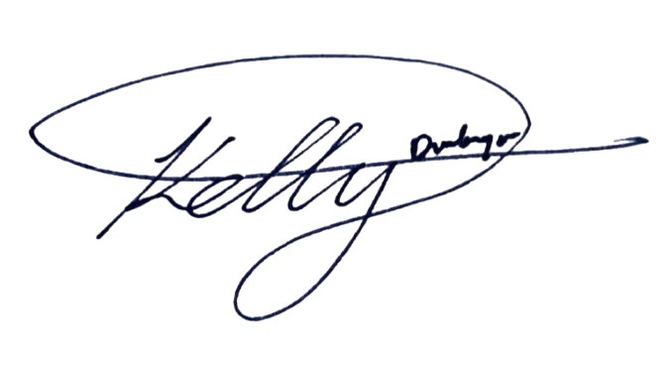
__________________________________
Kelly Dumbrique


Members:

__________________________________

Arcielle Marie Gercan

__________________________________
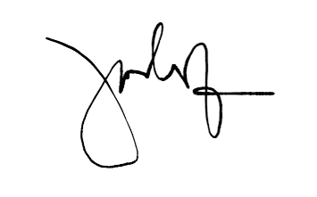
Shandrae Lois Quianzon

__________________________________
Janice Maxene Salipande

1. DEPENDABILITY = 3
a. We are always active in communication channels = 1
-1: Often unresponsive or requires multiple follow-ups
0: Weekday replies <24h. Weekend no reply
1: Weekday replies <12h. Weekend <24h
b. We follow through on commitments = 1
-1: Most work takes longer than expected
0: Consistently delivers work in expected time
1: Delivers work early and makes progress in other areas
c. We are consistent and predictable = 1
-1: Performance is erratic and others cannot plan around them
0: Consistent level of output week to week. Maintains steady, reliable work habits
1: Delivers predictable results and helps create consistency in the team

2. ACT LIKE AN OWNER = 2
a. We are self-driven, we don't need nudging in order to perform = 1
-1: You are not motivated to work unless someone is checking up on you
0: You don't need nudging, but you don't push others or your manager forward
1: You nudge other team members and push your work and the whole organization forward
b. We take 120% responsibility for everything we do = 0
-1: Completes tasks to 80% (Gets help from others to complete it)
0: Completes tasks to 100%
1: Completes tasks to 120% (Finds extra problems, fixes some, creates new tasks, and starts tackling the most important ones)
Example: Designer, after designing, checking the development process, checking the user sentiment after release, creating a report and learnings to share with team.
Example: Asking questions like "should I do X or Y" is a sign of -1 ownership. It means they haven't put in the thought. +1 ownership version of this would be "I looked in to all the data, read a few articles online and decided to go with X, here is my game plan, let me know if I'm missing anything, otherwise I'll start execution tomorrow."
Example: "Here is my submission is it good? bad?" is a sign of -1 ownership. It means they are submitting a work. The job is more than the work. "Here is my work and here is my plan. I explored 4 options. I'll go with option X. Next, I will create issues, create dashboard for analytics, create reminder to check and give a weekly update on the success of the feature. Write learnings in 3 weeks and share with the team. I'll start executing tomorrow unless I'm told something missing." is a sign of +1 ownership.
c. We improve the company beyond the scope of our job = 1
-1: Completes assigned tasks
0: Upgrades systems around their assigned tasks
1: Upgrades & creates systems extending their tasks (seeking ways to create value extending their role)
Example: Goku had the time to go through dozens of github issues that he needed to review and found that all of them had already been reviewed better than he could've by Juan.
Example: Jeff was working on backend game development, decided we needed better analytics, learned and setup Metabase which now became the default analytics tool of the company.
Bad Example: Doing their assigned job 80% and jumping around to help out other parts is -1 ownership and -1 efficient execution.
Example: Doing their assigned job 120% and tackling the first degree problems is +1 ownership.
d. We make sure others live up to our standards = 0
-1: Doesn't review others work
0: Reviews others work
1: Trains others to level up
Example: Struggling to provide feedback to others is a sign of -1.
e. We build for players = 0
-1: Implement without interacting with players
0: Asks if players want A or B
1: Talks with players during implementation, staging, after release, optimization

3. CLEAR COMMUNICATION = 3
a. We communicate openly = 0
-1: Doesn't speak up, lacks transparency, avoids conversations
0: Withholds information, avoids tough conversations
1: Proactive communicator, embraces tough conversations, expresses thoughts honestly and completely
b. We are direct and concise = 0
-1: Uses +30% filler words
0: Uses ~0% filler words
1: Doesn't write full sentences
c. We communicate clearly & well structured = 1
-1: Needs multiple reads to understand basics
0: Basics are understood on a single glance. Needs multiple reads to understand complex ideas
1: Complex ideas are understood on a single glance
Example: Long message with several components that is clear and well structured.
d. We align expectations = 1
-1: Doesn't update status of tasks and changes
0: Sometimes updates status of tasks and changes
1: Clearly and consistently updates status of tasks and changes. Everyone knows where they stand
e. We are easy to work with = 1
-1: Selfish or nitpicks or unresponsive or uncooperative or annoying
0: Does some work towards being easy to work with
1: Tries to understand where other party is coming from and finds win-wins in situations

4. EFFICIENT EXECUTION = 1
a. We deliver results = 0
-1: Delivers less or slower than expected
0: Delivers expected results
1: Over delivers
b. We execute quickly = 0
-1: Has resistance and cannot execute
0: Executes decently
1: Executes so fast that others have a hard time catching up
c. We focus on high impact = 1
-1: Can't gauge impact
0: Sometimes identifies impact
1: Prioritizes impactful tasks
d. We don't get stuck. We have a way forward = 0
-1: Will get stuck and ask questions in low tier problems
0: Will slowly figure things out occasionally asks questions on how to move forward
1: Always has a sound plan on what to do next
Example:
-1: No progress for more than 30 minutes, asks basic questions to other people
0: Does some research but sometimes in an unstructured manner
1: Has a plan, e.g. Check Docs -> Google -> ChatGPT -> Stack Overflow -> Ask the right person -> Create thread to ask team
e. We are pragmatic and value simple solutions = 0
-1: Uses custom solutions that have lots of moving parts
0: Uses a few libraries that achieve the goal
1: Discards the whole project or creates a simple solution a level above getting rid of all such problems

5. CONTINUOUS LEARNING = 2
a. We are curious = 0
-1: When asked, they don't know how it works or why the actions were taken
0: They know their work inside and out
1: They know the extension of their work inside and out
b. We introduce new tools and methods to the team = 0
-1: They don't learn outside of Colonist
0: They rarely try out new tools and methods, and when they do, they apply them at Colonist
1: They actively try out new tools and methods and introduce them to Colonist
Examples: Devs follow npm blogs and attend hackathons. Ops join Deel meetups. Everyone reads related books and bring in methods to optimize processes in Colonist.
c. We unlearn wrong methods = 0
-1: Struggles to let go of wrong methods from previous experiences
0: Is able to update wrong methods when identified
1: Self identifies wrong methods and takes ownership of adapting
d. We take feedback and improve = 1
-1: Must be told same feedback multiple times
0: Never told same feedback twice
1: Seeks out feedback
e. We overcome challenging problems = 1
-1: Consistently chooses easy tasks, avoiding or postponing difficult ones. Read this.
0: Tackles difficult problems but struggles to solve them
1: Overcomes difficult and complex problems, learning and growing in the process

System Design Document
INTRODUCTION
This System Design Document has been created to outline the proposed system design for the STARBOOKS Whiz Challenge; a gamified educational platform developed for the Department of Science and Technology – Science and Technology Information Institute (DOST-STII). The STARBOOKS Whiz Challenge is a ground-up redevelopment of the existing DOST-STII Whiz Challenge application, which was limited to a single solo quiz format with minimal engagement features and no administrative management tools.
This new version addresses the identified limitations of the legacy application by introducing four distinct game modes (Whiz Challenge, Whiz Memory Match, Whiz Puzzle, and Whiz Battle), a comprehensive rewards and leaderboard system, and a fully featured web-based administrative dashboard. The system is designed to operate in an offline, Local Area Network (LAN) environment to ensure accessibility in DOST event venues without reliable internet connectivity. This document and the technical specifications described herein have been developed in alignment with the project's Software Requirements Specification and the development standards agreed upon with DOST-STII.
PURPOSE
The purpose of this System Design Document is to provide a clear and comprehensive description of how the STARBOOKS Whiz Challenge system will be constructed, structured, and deployed. It translates the functional and non-functional requirements defined in the Software Requirements Specification (SRS) into concrete architectural, hardware, software, database, and security design decisions.
This document serves as the authoritative technical reference for the development team and a communication tool for DOST-STII stakeholders, faculty advisers, and future maintainers of the system. It ensures that the system design aligns with DOST-STII's mission to make quality STEM education accessible, engaging, and measurable for students from elementary through senior high school. It also establishes the design framework necessary to support future enhancements and content updates by DOST-STII technical staff after project handover.
SYSTEM OVERVIEW
The STARBOOKS Whiz Challenge is a standalone, LAN-based gamified learning platform designed to complement DOST-STII's existing STARBOOKS initiative. The system targets students attending DOST events, science fairs, and public exhibits, offering interactive STEM learning through multiple game modes that accommodate different learning styles and promote sustained engagement.
The system is architected as a three-component client-server application deployed within an isolated local area network. The three primary components are a Flutter/Dart web-based game client accessed by players through standard browsers, a web-based administrative dashboard for DOST-STII staff, and a centralized backend server running the Laravel PHP framework with a MongoDB database. All components communicate exclusively within the LAN environment, with no internet connectivity required during deployment at events.
At a high level, the system supports two primary user roles. Players can register accounts, select from four game modes, earn badges and stars, view leaderboards, and submit reward claims. Administrators can manage player accounts, configure game settings and question content, monitor reward redemptions, and access a comprehensive analytics dashboard covering player demographics, game mode preferences, and reward distributions.
The system is designed to support a minimum of 10 concurrent active player sessions while maintaining acceptable response times under standard LAN conditions. It is intended to be self-contained and portable, deployable at any DOST venue by transferring the application and starting the services with no internet downloads or complex installations required on-site.
DESIGN CONSTRAINTS
The STARBOOKS Whiz Challenge development team identified several constraints that directly influence and limit the system design. These constraints arise from the operational environment, organizational requirements, technology selections, and regulatory obligations, and must be carefully factored into every aspect of the system architecture.
Hardware Constraints. The system must operate on standard Windows-based personal computers commonly available at DOST event venues. Minimum hardware specifications include an Intel Core i3 or equivalent processor, 4GB RAM, and at least 50GB of available storage. The system design cannot assume higher-end hardware, which places limits on computational complexity, in-memory data processing, and the number of concurrent users the server can reliably support. The design targets a maximum of 15 concurrent users (players and administrators combined) under these constraints.
Network Constraints. The system must operate exclusively within an offline LAN environment. All client-server communication occurs through a local router using standard Ethernet connectivity (100 Mbps or higher). The design cannot rely on any cloud services, external APIs, or internet-based resources during event operation. This constraint drives the requirement for self-contained deployment packages and local data storage through MongoDB.
Technology Constraints. The frontend must be developed using the Flutter/Dart framework compiled for web deployment. The backend must use the Laravel PHP framework running on the Laragon development stack (or Docker for production deployment). The database must be MongoDB. These technology selections are fixed requirements that constrain the design team from using alternative frameworks or databases, and all design decisions must remain compatible with these specified technologies.
Regulatory Constraints. The system must comply with the Philippine Data Privacy Act of 2012 (Republic Act No. 10173) regarding the collection, storage, and processing of personal information from players, the majority of whom are minors. This restricts what data can be collected to the minimum necessary (username, age, gender, school, region, province, city), prohibits collection of sensitive personal information such as full names or contact numbers, and requires that data remain stored locally within DOST-controlled infrastructure.
Organizational Constraints. The complete system, including source code, documentation, and deployment instructions, must be delivered to DOST-STII upon project completion. The design must therefore prioritize maintainability, with well-documented modular code that DOST-STII technical staff can manage without involvement from the original development team. The administrative interface must also be usable by non-technical DOST staff for routine content management tasks such as adding questions and reviewing analytics.
Content Constraints. All educational content including quiz questions, correct answers, difficulty classifications, subject categories, and puzzle images must be provided by and validated by DOST-STII content specialists. The system design accommodates this dependency by separating content management from the application logic through the administrative dashboard, enabling DOST staff to independently manage and update content post-deployment.
ROLES AND RESPONSIBILITIES
The following table defines the roles and responsibilities. This matrix also serves as the list of points of contact for issues and concerns.
Name | Role | Responsibility
Kelly Dumbrique | Project Manager / Product Owner | Overall project oversight; client communication with DOST-STII; administrative dashboard frontend development
Arcielle Marie Gercan | Backend Developer | Server-side API development using Laravel; database integration; WebSocket server for Whiz Battle
Shandrae Lois Quianzon | Frontend Developer | Player-side game client development using Flutter/Dart; Whiz Challenge and Homepage implementation
Janice Maxene Salipande | Scrum Master / QA Lead | Whiz Puzzle and Whiz Memory Match implementation; system diagrams; UAT; OpenProject tracking
Mr. Jose Eugenio Quesada | Faculty Adviser | Project guidance; sprint reviews; design feedback
Mavie Narquita  Mc Gyver Basaya  Jonathan Abalon  Ella Pestano | DOST-STII Stakeholders | Requirements validation; content provision; sprint reviews; final acceptance

SYSTEM ARCHITECTURE
The STARBOOKS Whiz Challenge system is built on a client-server architecture designed for offline LAN-based deployment. All components operate within an isolated local area network, with no internet connectivity required during events.
Hardware:
The hardware architecture consists of two types of nodes: a centralized server for PC and multiple client PCs — all interconnected through a LAN router.
The Server PC hosts all backend services and acts as the central node for the entire system. It requires the following:
- An Intel Core i3 or equivalent processor, a minimum of 4GB RAM, at least 50GB of available storage, and a Network Interface Card (NIC) supporting Ethernet connectivity.
- The server runs the Docker Engine as its execution environment, which orchestrates three containerized services defined through a docker-compose.yml configuration file: the Laravel Backend API container, the WebSocket Server container, and the MongoDB Database container.
Client PCs serve as player and administrator terminals. Each requires the same minimum hardware specifications as the server:
- Intel Core i3, 4GB RAM, 50GB storage
- A display monitor, a standard USB keyboard and mouse, and a network interface card for LAN connectivity.
- Players and administrators must access the system exclusively through a web browser (Chrome or Edge).
The LAN Router provides network connectivity between the server and all client machines using standard Ethernet (100 Mbps or higher), with sufficient ports to accommodate all connected PCs.
Software:
The software architecture is organized into three primary components:
- The Flutter/Dart Web Application (Game Client) runs within the browser on each client PC. It serves as the presentation layer for both the player-facing game interface and the administrative dashboard. The web application communicates with the Laravel backend through RESTful HTTP API calls for standard operations, and via WebSocket connections for real-time Whiz Battle functionality. Key application artifacts include main.dart, login.dart, home.dart, game.dart, and admin_dashboard.dart, along with associated asset folders for images, sounds, and fonts.
- The Laravel Backend API is containerized and runs on the server PC and handles all business logic including user authentication and session management, game state processing, reward and badge management, leaderboard ranking, analytics data aggregation, and administrative content management. It exposes RESTful API endpoints consumed by the Flutter frontend and manages all interactions with the MongoDB database.
- The WebSocket Server is a separate containerized component running alongside Laravel on the server. It manages real-time bidirectional communication specifically for the Whiz Battle game mode, enabling two players to create and join battle rooms using generated game codes, synchronize question delivery, and exchange real-time score updates.
DATABASE DESIGN
The STARBOOKS Whiz Challenge system uses MongoDB as its primary database management system. MongoDB's document-oriented, flexible schema design is well-suited to the system's varied data structures, which range from player profiles and game session records to question banks and analytics data.
All data is stored locally on the server PC within the MongoDB container's persistent data/db/ volume, ensuring that player records and game data are retained across system restarts and between event days. The database communicates with the Laravel backend through native MongoDB PHP drivers, which handle all CRUD operations.
The database is organized around the following primary collections, as defined in the Entity Relationship Diagram included in the SRS:
PLAYER_INFO stores all registered player profile data including username, hashed password, age, sex, school, student category, region, province, city, selected avatar, and account timestamps. This collection is the central reference point for player identity across all other collections.
PLAYER_STATS tracks individual player gameplay statistics including total session counts, game mode preferences, and session durations, feeding into the analytics dashboard.
PLAYER_BADGES records all badges earned by each player, organized by game mode (Whiz Challenge and Whiz Battle), difficulty level (Easy, Average, Difficult), and category. This collection drives both the reward redemption eligibility check and the leaderboard ranking system.
PLAYER_STARS stores star-based performance records from Whiz Memory Match and Whiz Puzzle sessions, including performance metrics used for leaderboard display.
PLAYER_REWARDS logs all reward claim transactions, capturing player ID, difficulty level claimed, claim timestamp, claim status (pending or granted), and the administrator who processed the grant.
QUIZ_QUESTIONS contains the full question bank for Whiz Challenge and Whiz Battle, with each document storing question text, four answer options, the correct answer designation, subject category (Science or Math), and difficulty level.
QUIZ_DIFFICULTY_SETTINGS stores configurable game parameters per difficulty level, including the number of questions per session and the time limit per question, as managed through the administrative dashboard.
BATTLE stores active and completed Whiz Battle session records, including battle room codes, participating player IDs, question sets, individual scores, and outcome data.
FASTEST_TIME_MEMORY_MATCH and FASTEST_TIME_PUZZLE record best completion times for each player in their respective game modes, used for personal and overall leaderboard display.
ANALYTICS serves as an aggregated data store supporting the analytics dashboard visualizations, including total player counts, game mode usage frequency, demographic distributions, and reward distribution patterns.
ADMIN_INFO stores administrator account records including username and hashed password, with role-based access flags distinguishing admin accounts from player accounts.
All password fields across player and admin collections are stored using strong one-way cryptographic hashing with unique salts, in compliance with the system's security requirements. The database schema is fully documented in the SRS's Entity Relationship Diagram and the associated data dictionary, which provide field-level descriptions, data types, and collection relationships.
HARDWARE AND SOFTWARE DETAILED DESIGN
Hardware:
The STARBOOKS Whiz Challenge system leverages standard Windows-based PC hardware available at DOST event venues. No custom or proprietary hardware is required. The server PC and client PCs share the same minimum hardware profile (Intel Core i3, 4GB RAM, 50GB storage) to simplify procurement and compatibility management for DOST-STII.
The server PC is distinguished by its role, not its hardware configuration — it is the machine on which Docker Engine is installed and from which the three backend containers are launched. Client PCs require only a compatible web browser (Chrome or Edge with HTML5 and JavaScript support) to access the system. The LAN router connects all devices using standard Ethernet cabling and requires no specialized configuration beyond standard IP address assignment within the local network.
Software:
The STARBOOKS Whiz Challenge software is custom-developed by Group NEXUS to meet the specific educational, operational, and engagement requirements of DOST-STII. No commercial off-the-shelf (COTS) product was identified that could adequately address the combination of offline deployment, multi-game functionality, rewards management, and STEM content administration required by the client.
The software is organized into the following modules:
Player Account Management Module handles all player-facing authentication and profile operations. It is coded to support multi-step registration (privacy notice acknowledgment followed by profile information entry), credential-based login with session management, profile editing, password change with current password verification, and session logout. Input validation is enforced at both the frontend (Flutter) and backend (Laravel) layers for all account operations.
Game Engine Module encompasses the four game mode implementations. The Whiz Challenge sub-module manages question retrieval from the database based on selected category and difficulty, countdown timer operation, answer validation with immediate visual feedback, score calculation, and badge award logic upon perfect score achievement. The Whiz Memory Match sub-module manages card grid generation with randomized image pairs, card flip logic, match detection, elapsed time tracking, move counting, and star-based scoring. The Whiz Puzzle sub-module manages image selection and jigsaw piece generation by difficulty level, drag-and-drop piece movement, proximity-based snap detection, and completion validation. The Whiz Battle sub-module manages unique game code generation, player matchmaking through code entry, synchronized question delivery to both players via WebSocket, real-time score display, and badge award for the winning player.
Reward Redemption Module manages the full badge-to-reward pipeline. It enforces the eligibility rule that a player must accumulate exactly three badges within a single difficulty level before a claim request is permitted. Player-side claim submission, administrator-side claim verification and grant processing, badge count reset upon successful grant, and permanent transaction logging are all handled within this module.
Administrative Content Management Module provides DOST-STII staff with tools to manage the question bank (add, edit, delete questions with full field validation), configure game parameters per difficulty level (number of questions and time limit per question), manage player and administrator accounts, and process reward claims.
Analytics and Leaderboard Module aggregates player data across all collections to generate the visualizations displayed on the administrative dashboard, including gender distribution, age distribution, regional distribution, game mode popularity by demographic, and reward distribution patterns. Leaderboard rankings are computed in real time based on total rewards claimed, with the most recent claim timestamp used as a tiebreaker. Both analytics data and leaderboard data support export functionality for DOST-STII reporting purposes.
SYSTEM SECURITY AND INTEGRITY CONTROLS
The STARBOOKS Whiz Challenge system incorporates a multi-layered approach to security and data integrity, designed to protect player data, particularly that of minors, and ensure consistent, reliable system operation during DOST events.
User Authentication and Role-Based Access Control. All system users, both players and administrators, must authenticate with valid username and password credentials before accessing any system functionality. The system maintains a strict separation between player accounts and administrator accounts through separate authentication pathways and role-based access control. Players are restricted to game functionality and their own profile management. Administrators have exclusive access to the management dashboard, analytics, content configuration, and reward processing. No player account, regardless of credentials, can access administrative functions.
Password Security. All passwords are stored using strong one-way cryptographic hashing algorithms with unique salts per user account. Plaintext and reversible encrypted password storage are explicitly prohibited in the system design. Password creation is enforced to require a minimum of eight characters, including a combination of uppercase and lowercase letters, numbers, and special characters.
Data Privacy Compliance. The system is designed in full compliance with the Philippine Data Privacy Act of 2012 (Republic Act No. 10173). A mandatory Privacy Notice is displayed and must be acknowledged during player registration before any personal information is entered. Data collection is limited to the minimum fields necessary for system functionality: username, age, gender, school, region, province, and city. No sensitive personal information such as full names, contact numbers, or email addresses is collected. All collected data is stored exclusively within DOST-controlled local infrastructure and is never transmitted to external parties.
Network Isolation. The system operates on an isolated LAN with no internet connectivity during events. All client-server communication occurs within the closed local network. The server exposes only the necessary HTTP/HTTPS and WebSocket ports for client communication. All other network ports are closed or filtered to minimize the attack surface. MAC address filtering or equivalent access control mechanisms on the LAN router to prevent unauthorized devices from joining the network.
Data Integrity and Audit Controls. The system enforces input validation at both the frontend and backend layers for all data entry operations, preventing malformed or incomplete data from being saved to the database. Confirmation dialogs are required before any destructive operations such as account deletion or question removal. All reward claim transactions are permanently logged with timestamps, player identity, difficulty level, and administrator identity, providing a complete audit trail of the reward system.
Operational Stability and Backup. The system is designed to handle errors gracefully without exposing sensitive information, corrupting data, or requiring a full system restart in most failure scenarios. DOST-STII administrators are responsible for implementing regular database backup procedures, particularly before and during multi-day events. Backup and restoration procedures are documented in the system documentation delivered with the completed application. The Docker-based deployment architecture also allows the server to be restored to a known-good state by restarting the containers from the last valid backup.

Sponsor Acceptance
Approved by the Project Sponsor:


___________________________________________
Marievic V. Narquita
Information Services Section (ISS) Head of DOST-STII

Date: May 22, 2026

